**Basic Probability Problems**

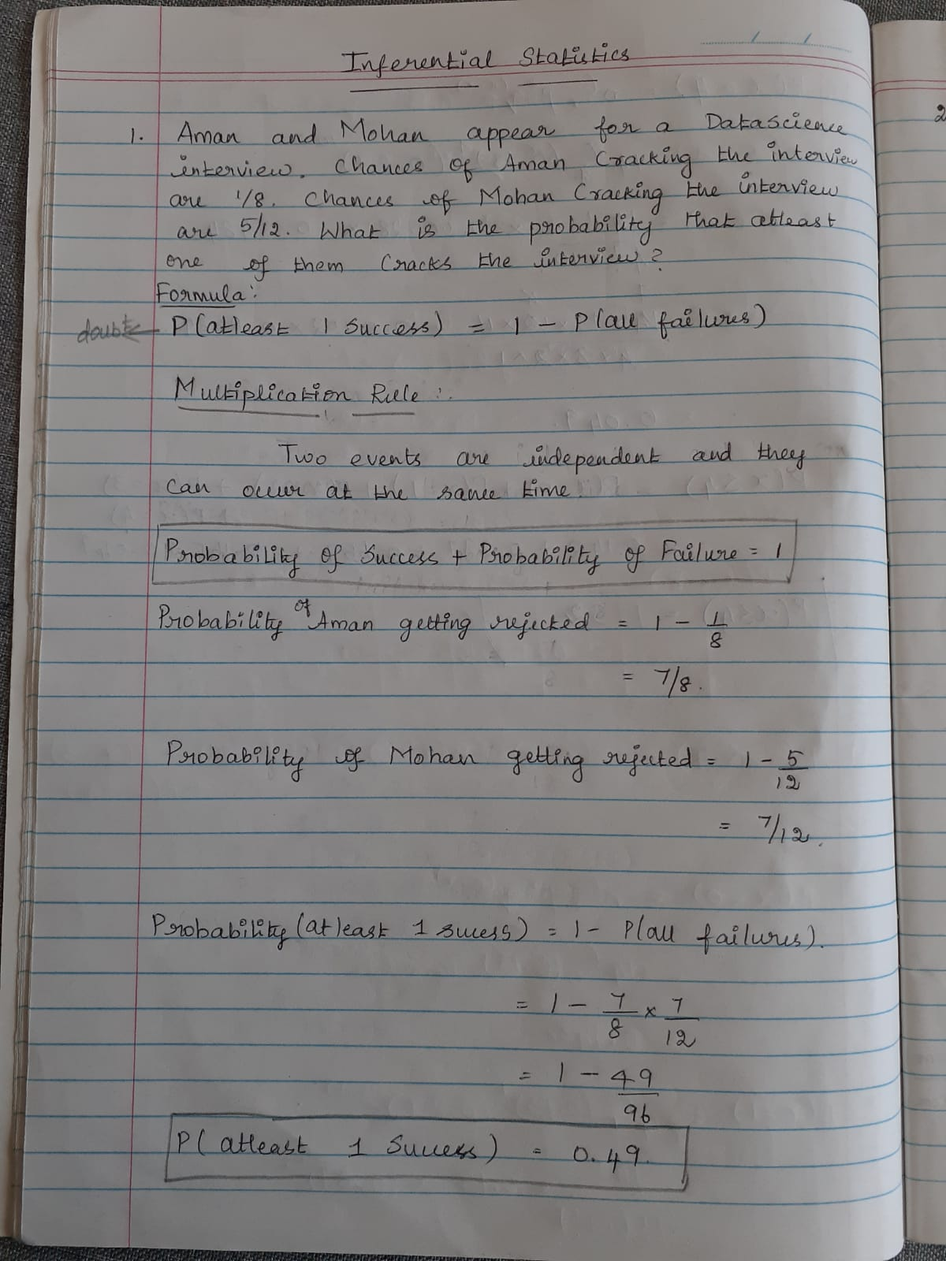

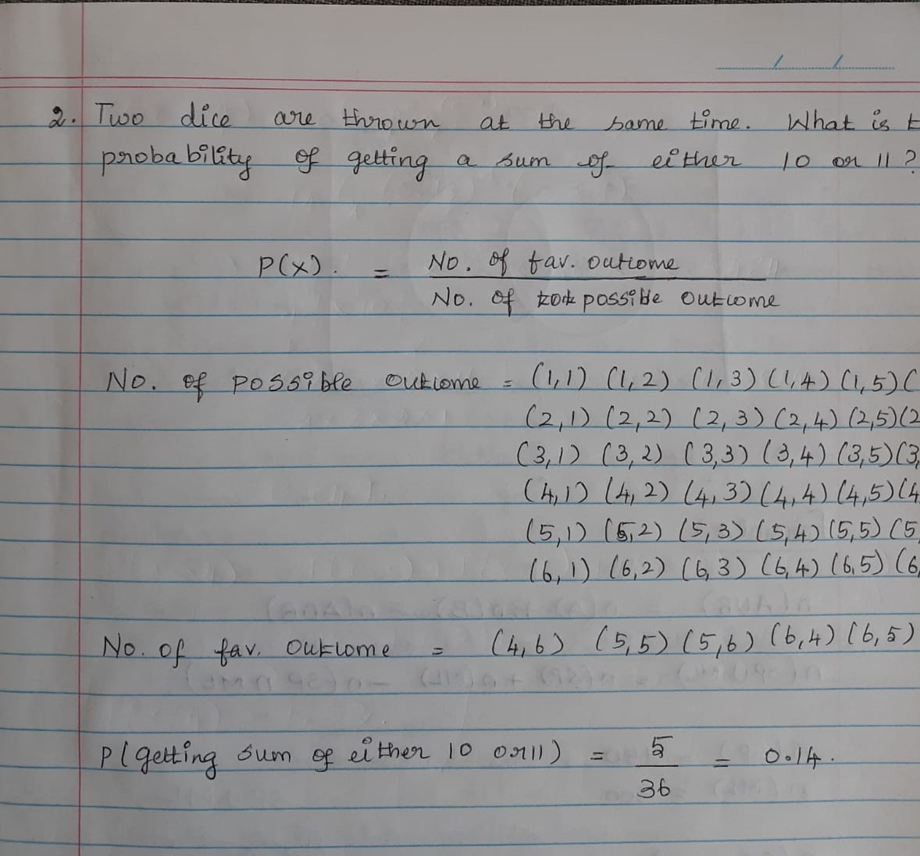

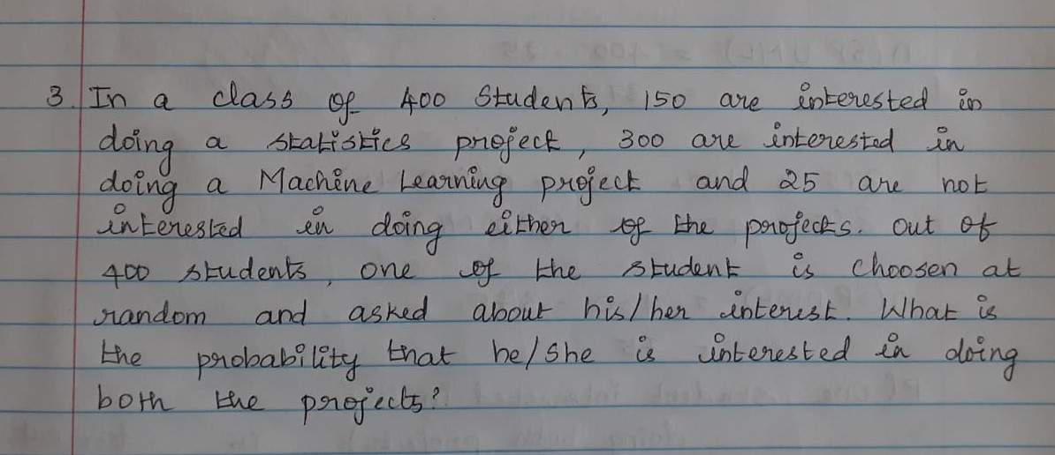

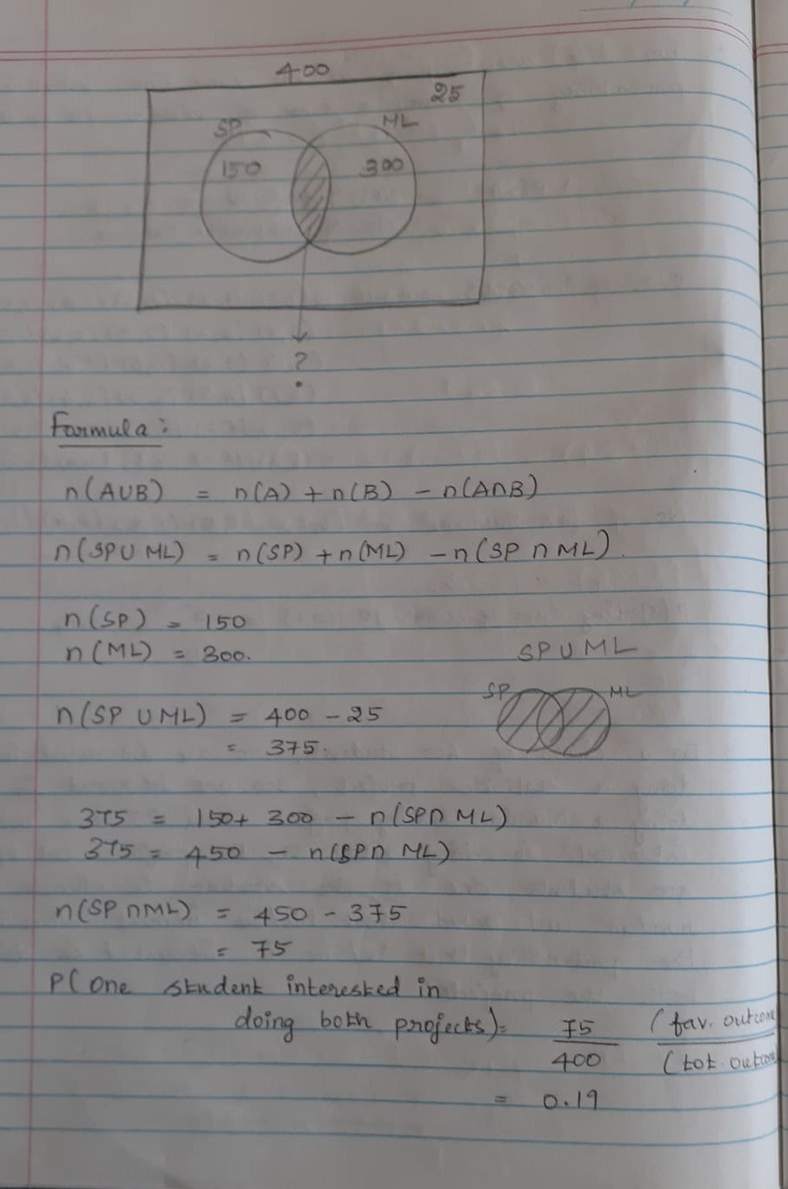

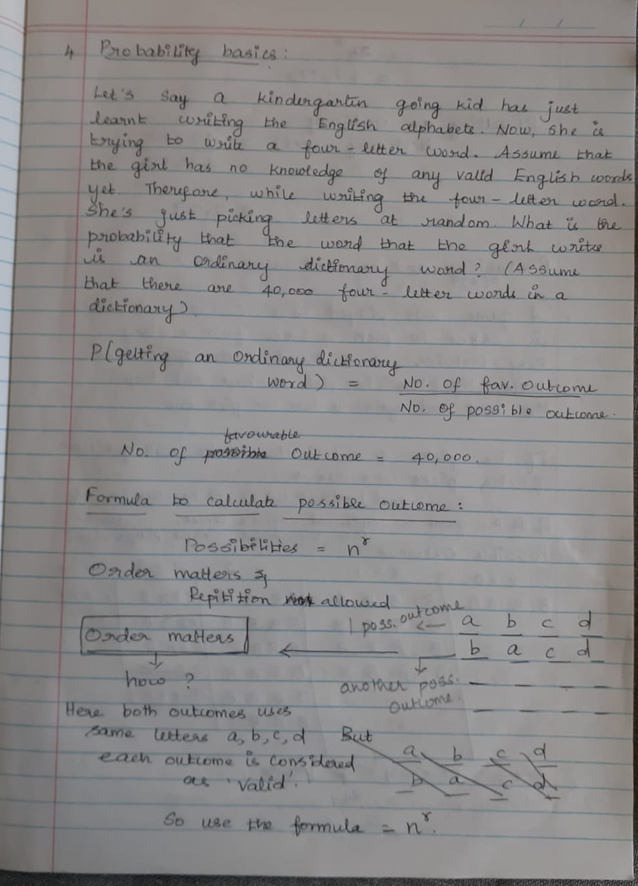

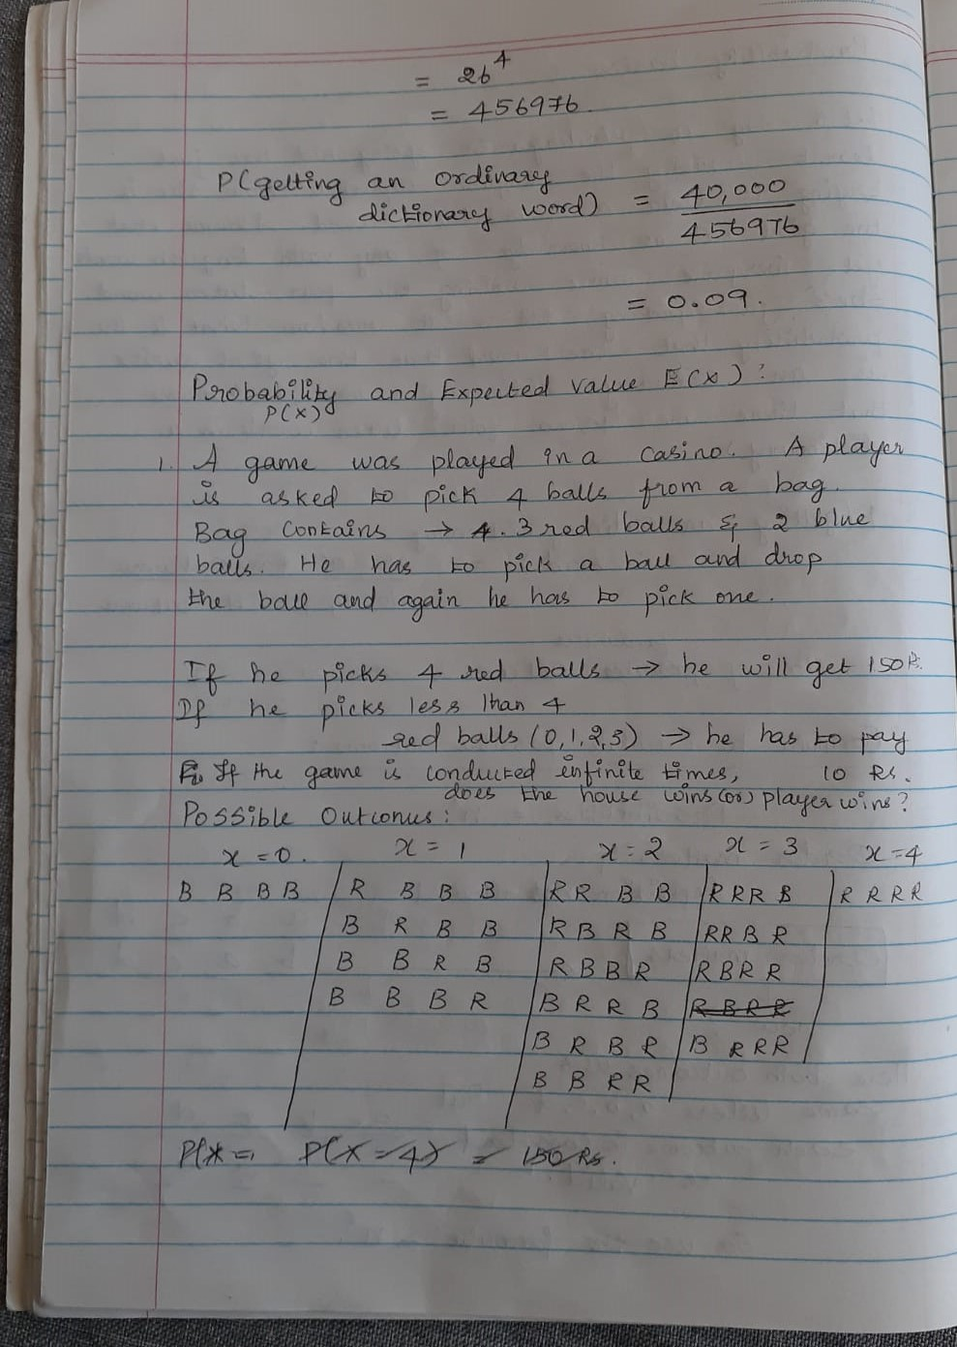

**Introduction**

Exploratory data analysis helped you understand how to **discover patterns in data**using various techniques and approaches. As you learnt, EDA is one of the most important parts of the data analysis process. It is also the part on which data analysts spend most of their time.

However, sometimes, you may require a very large amount of data for your analysis, which may need too much time and resources to acquire. In such situations, you are forced to work with a **smaller sample of the data** instead of having to work with the entire data.

Situations like these arise all the time at big companies like Amazon. For example, let's say the Amazon QC department wants to know what proportion of the products in its warehouses are defective. Instead of going through all of its products (which would be a lot!), the Amazon QC team can just check a small sample of 1,000 products and then find, for this sample, the defect rate (i.e., the proportion of defective products). Then, based on this sample's defect rate, the team can **"infer"** what the defect rate is for all the products in the warehouses.

**This process of “inferring” insights from sample data is called 'inferential statistics'.**

Let us consider the Exit Polls. Purpose of this polls is to identify the number of people who vote for a candidate. To find this, a small sample is randomly taken and the results from these samples are extraploted for the entire sample.

**Smaller samples are used to infer for larger population – INFERENTIAL STATISTICS**

Used in – Pharmaceuticals, food manufacturing and almost all industry which used large amount of data.

Another example – To find the average commute time of all 30,000 employess in an office. For this we need to take a sample of 1000 employees and use this result to infer the average commute time of all 30000 employees.

## Reference e-book

[Statistical Inference for Data Science](https://leanpub.com/LittleInferenceBook) by Brian Caffo

Probabilty:

And – Multiplication (Two events are independent and they can occur at the same time)

Or – Addition(Mutually Exclusive – That do not occur at the same time)

In general, we can use these strategies:

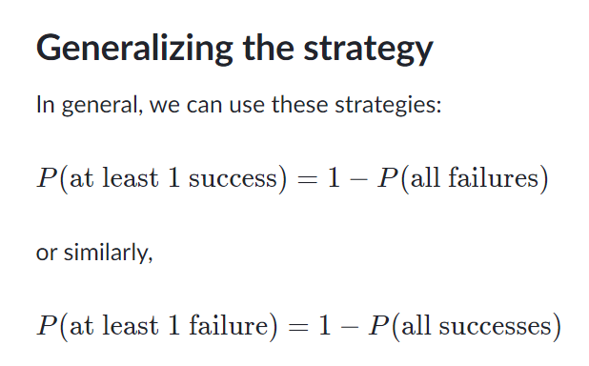

# Random Variables

Welcome to the first session on inferential statistics. This will be a very interactive session, with a lot of questions that will compel you to think about a concept, helping you explore it more actively.

So, let’s get started.

Recall the original question: In the long run (i.e., if it is played a lot of times), is this game profitable for the players or for the house? Or, will everybody break even in the long run?

Recall that we established a three-step process for answering this question:

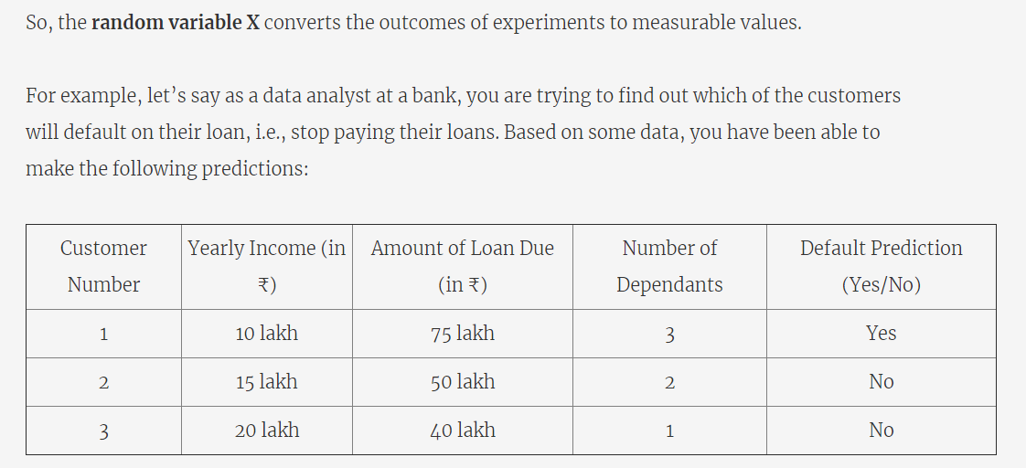

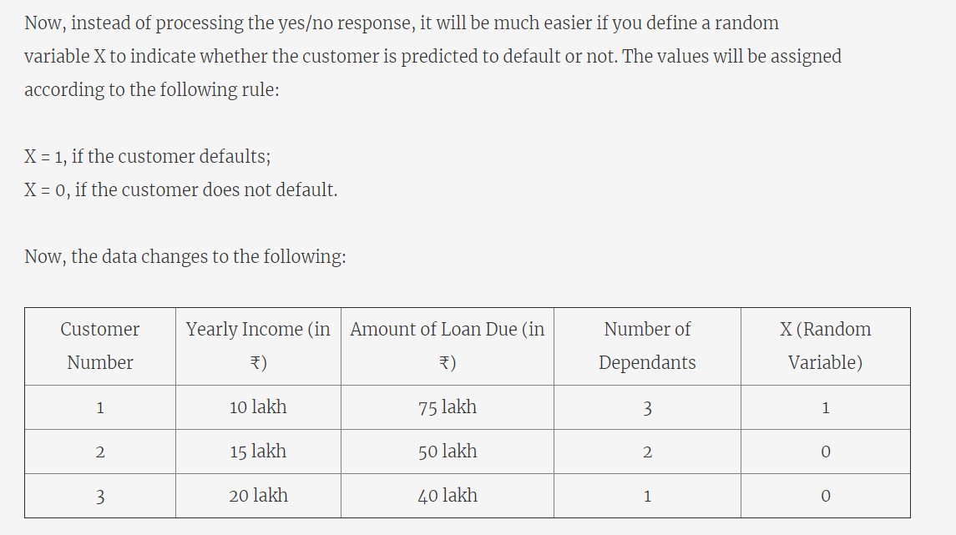

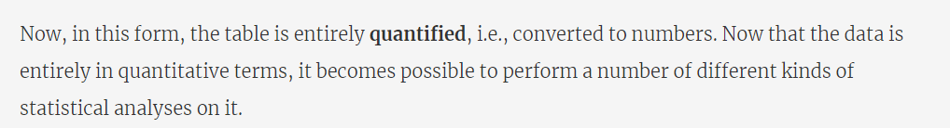



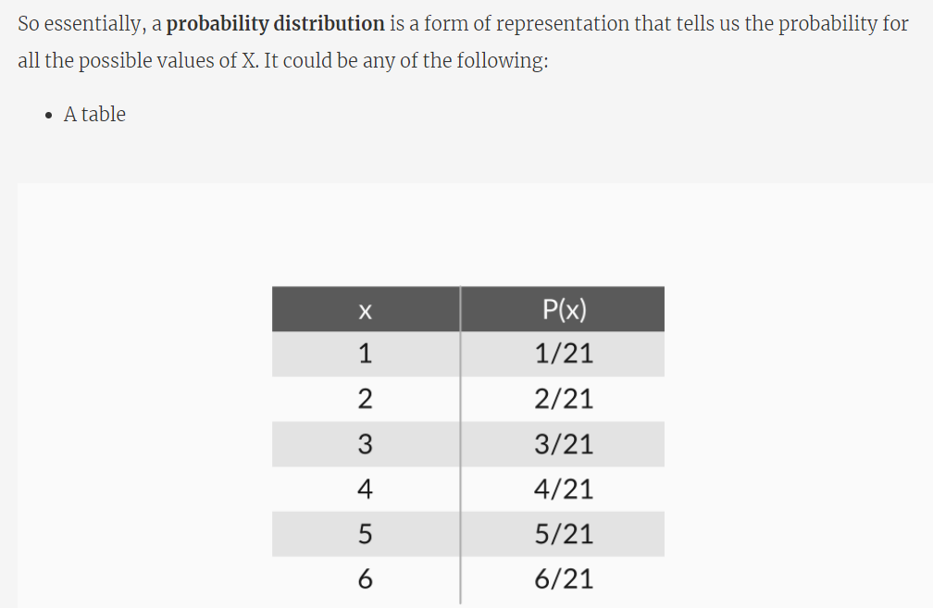

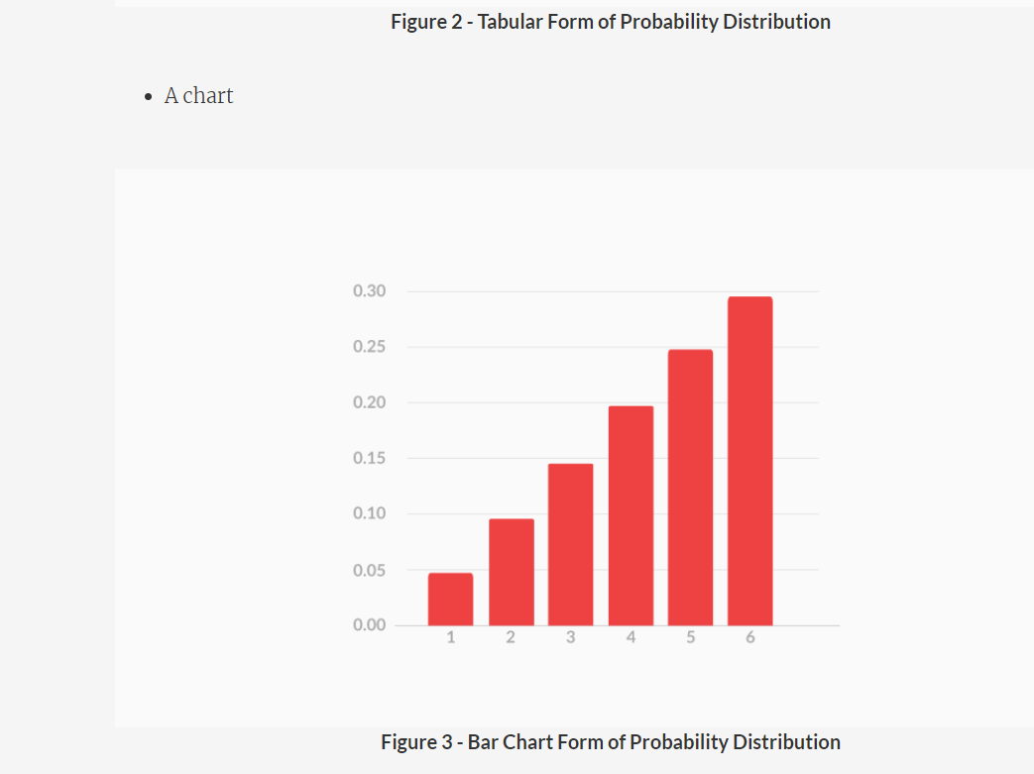

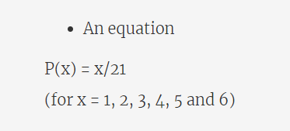

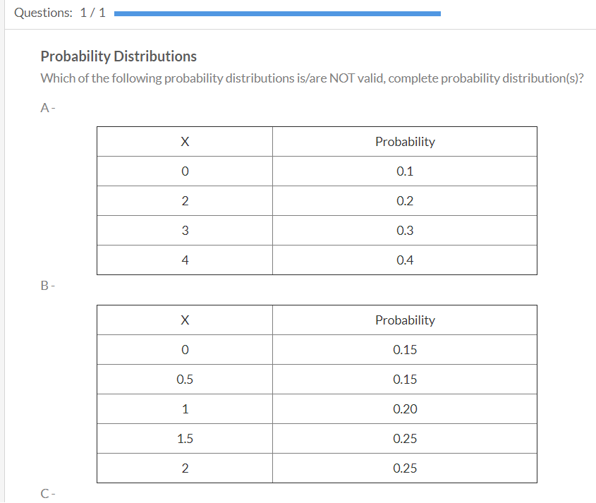

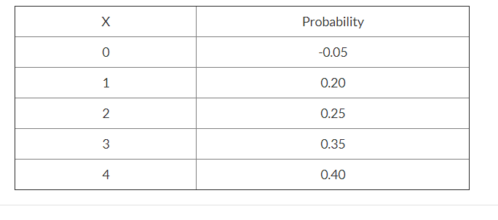

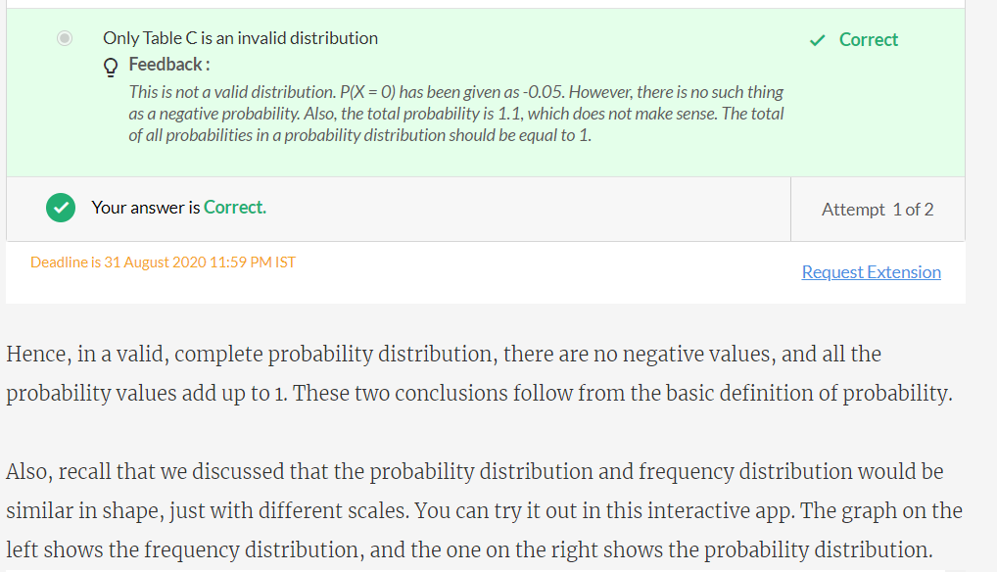

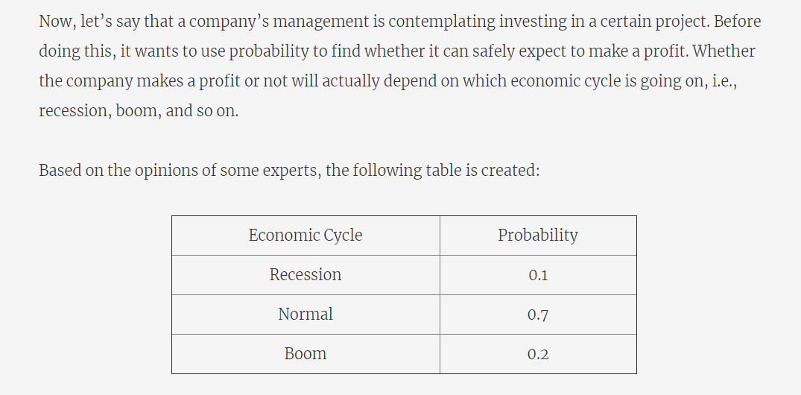

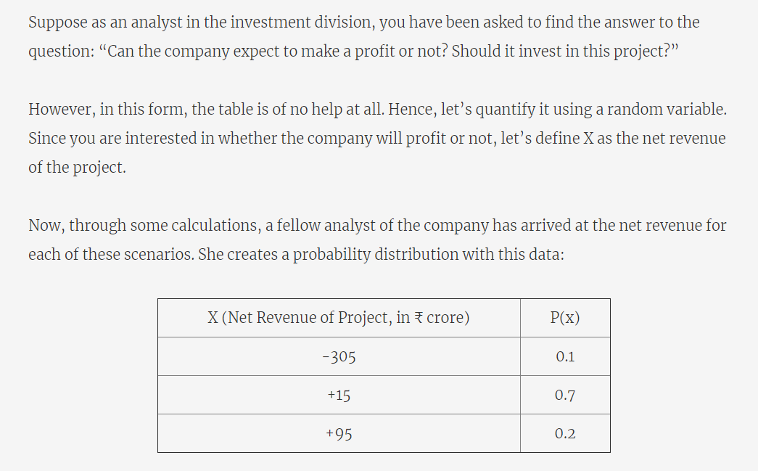

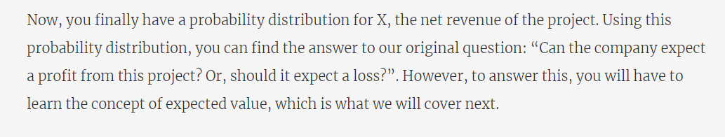

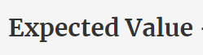

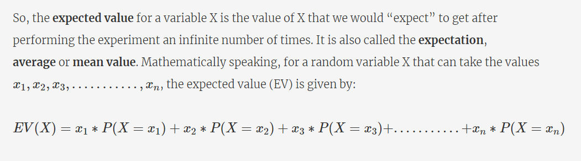

The problem you saw earlier, where we were asked by a company to suggest whether it should invest in a given project or not. We had made this probability distribution for X, the net revenue of the project:

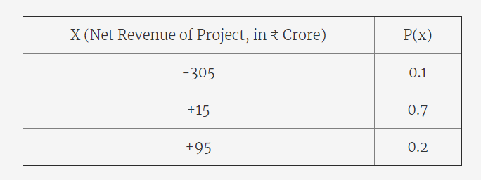



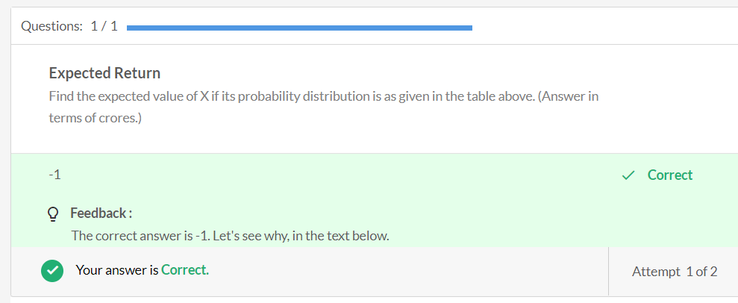

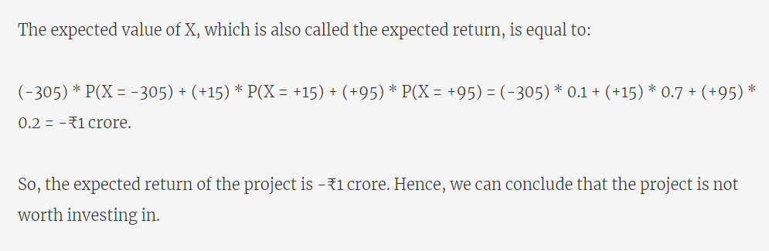

Refer - <https://www.investopedia.com/terms/e/expectedreturn.asp>

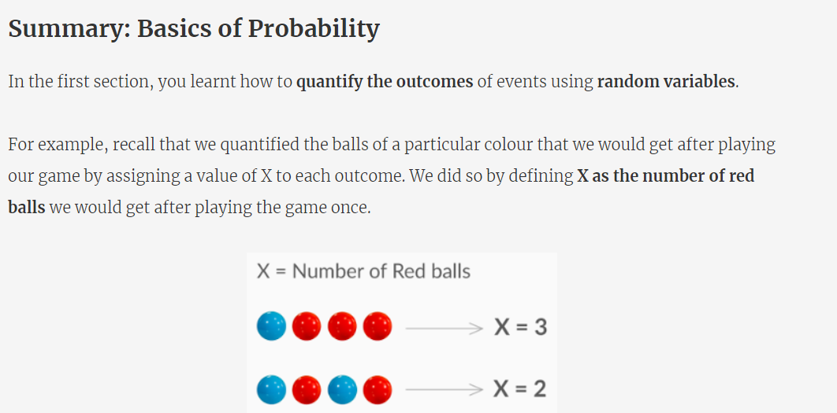

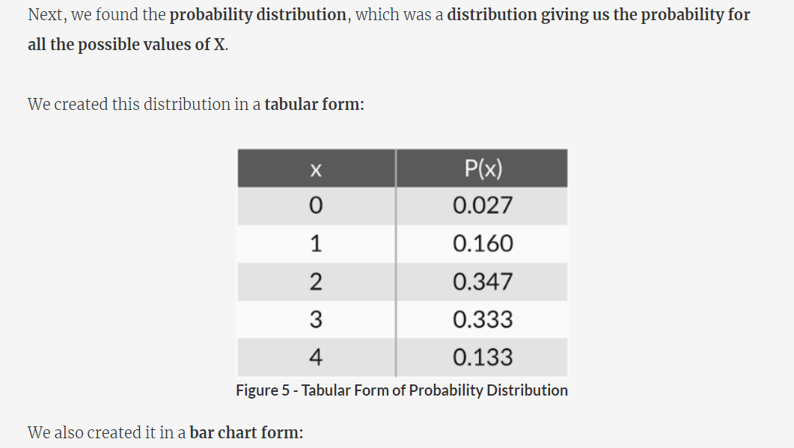

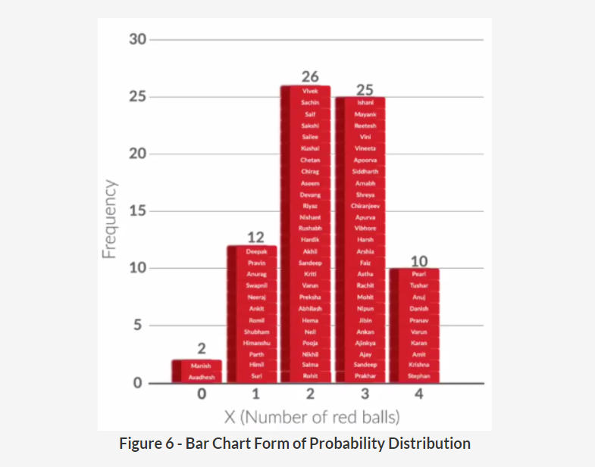

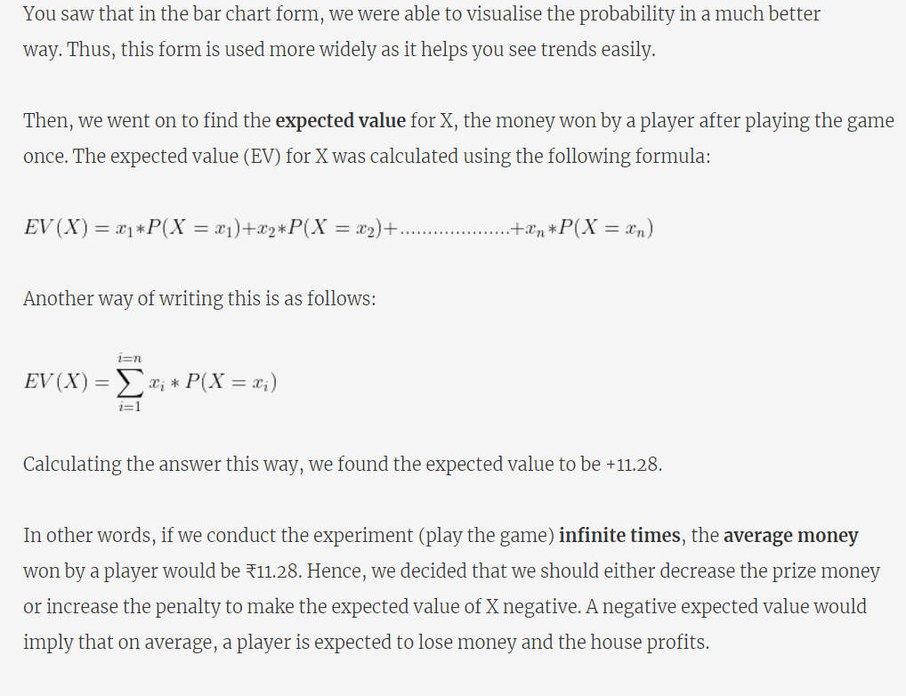



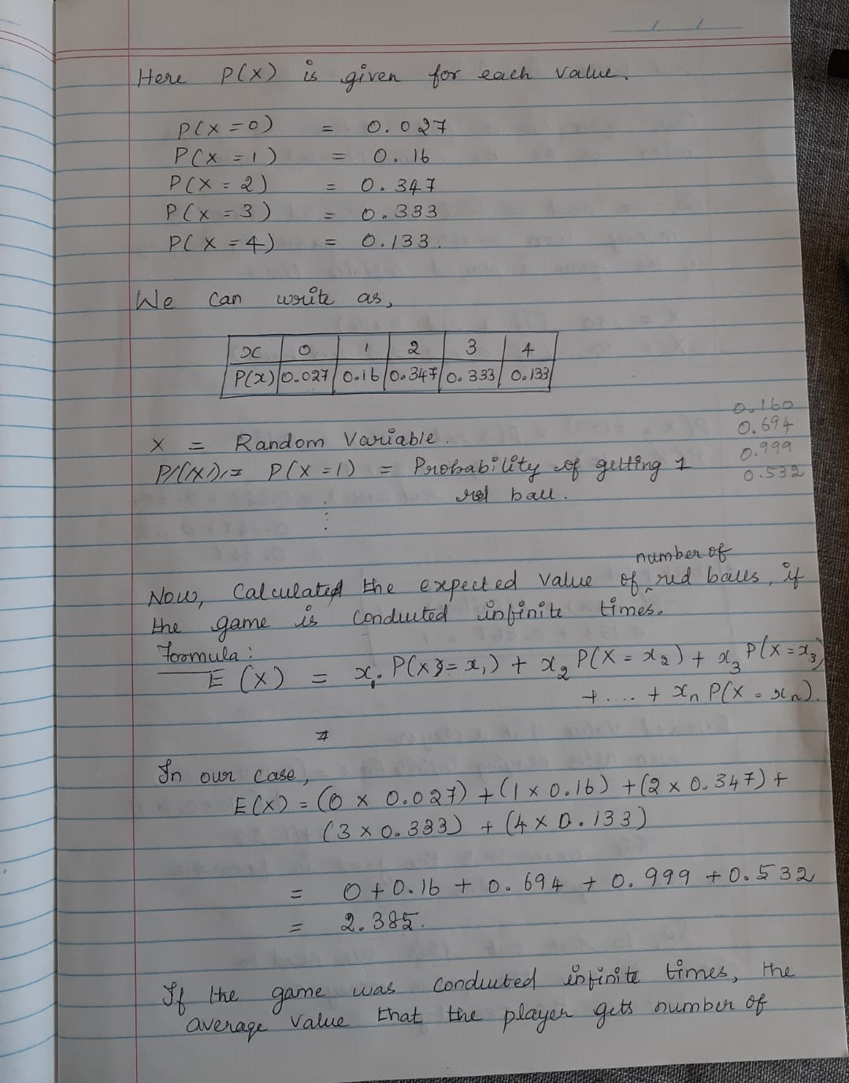

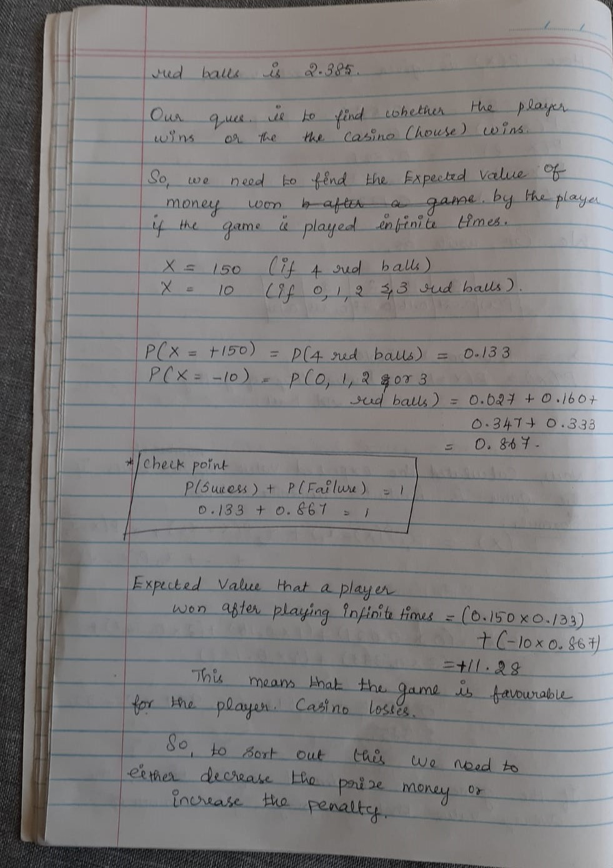

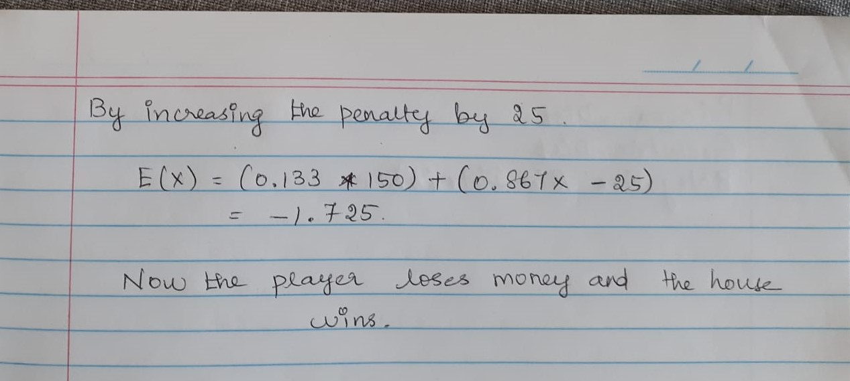

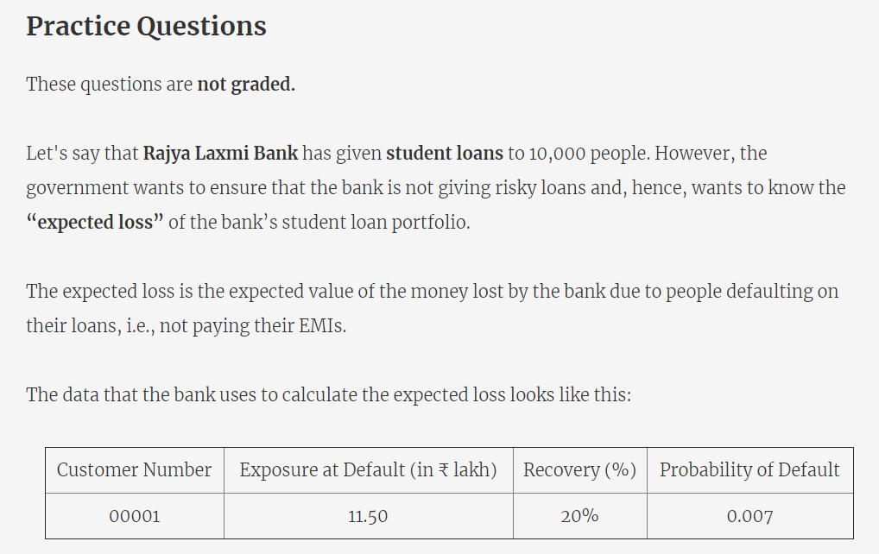

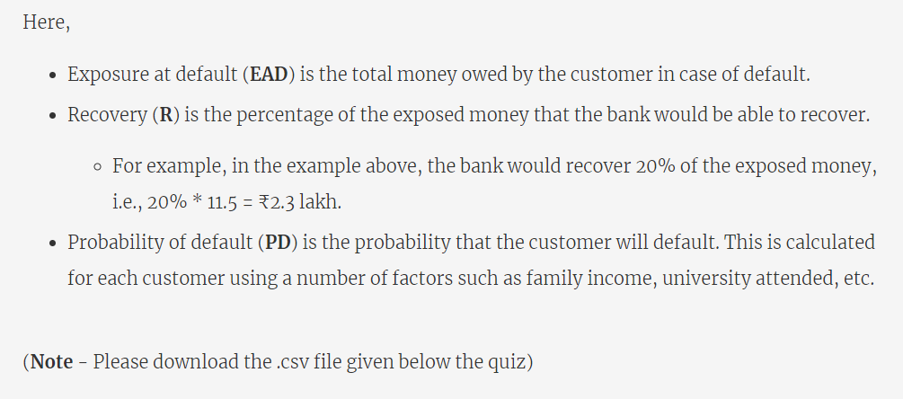

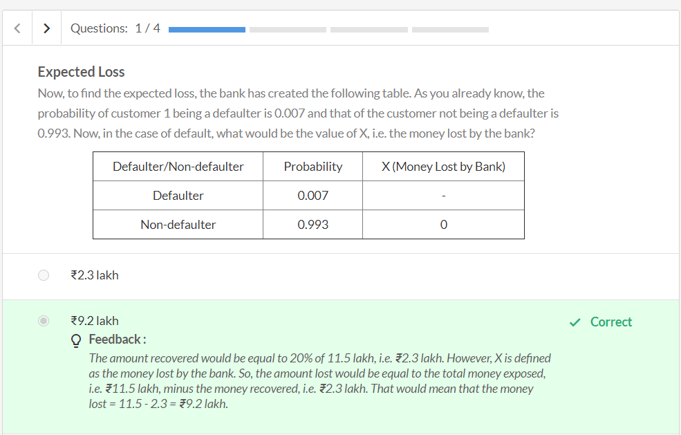

Expected Value Formula = sum(X.P(x)

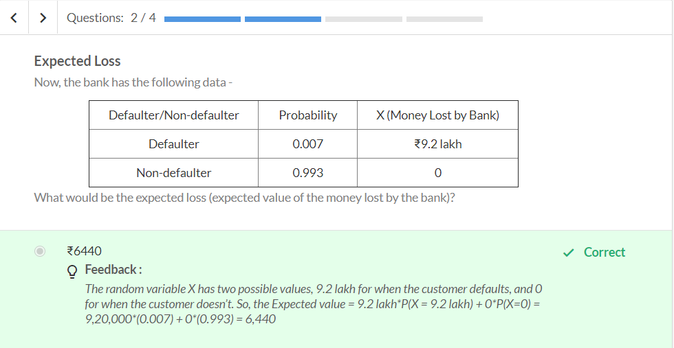

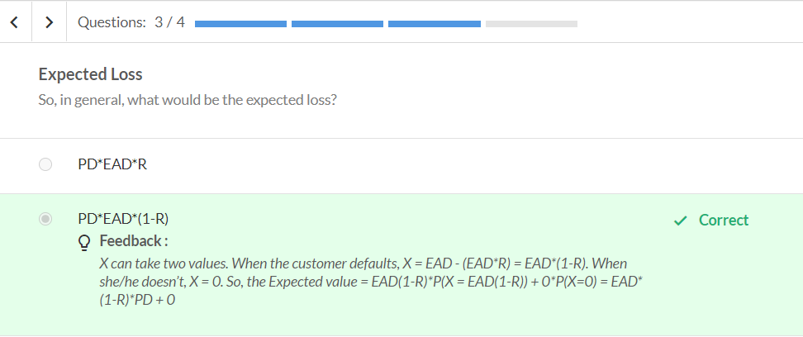

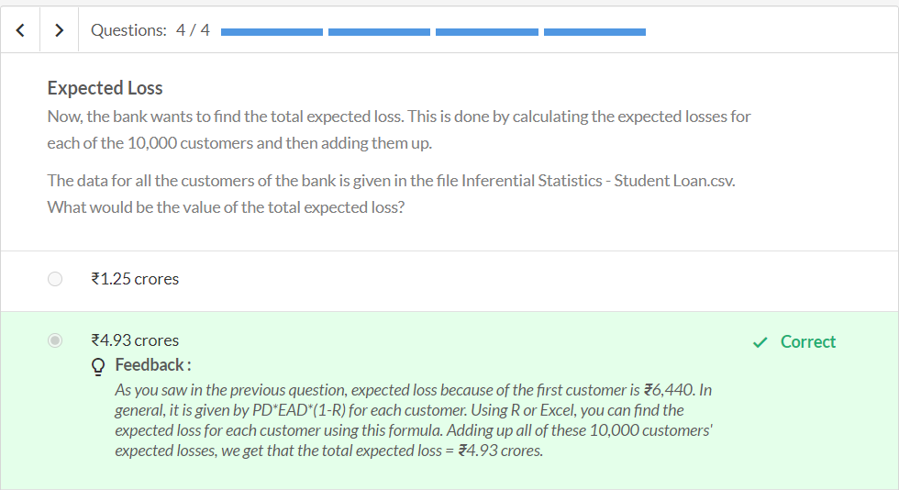

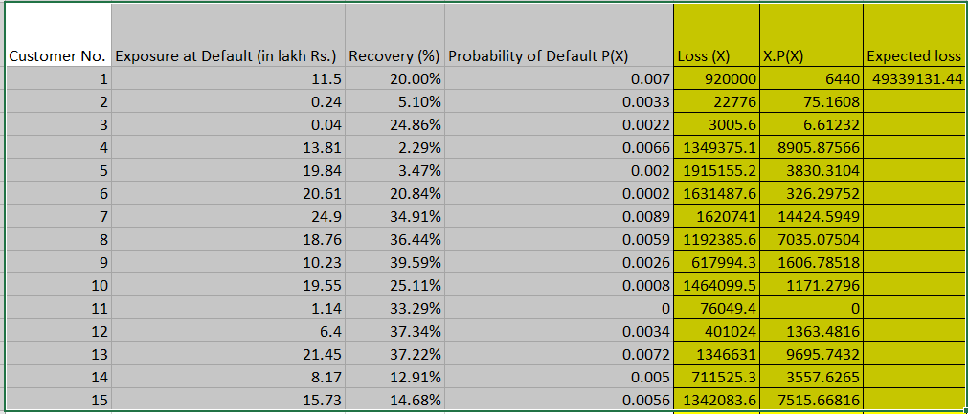

Graded Questions



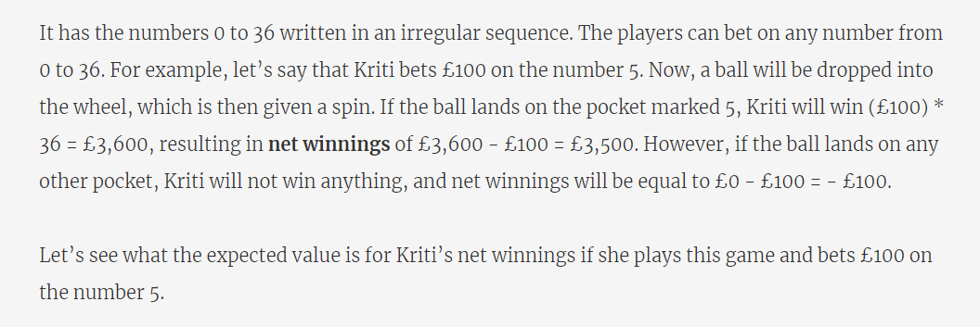

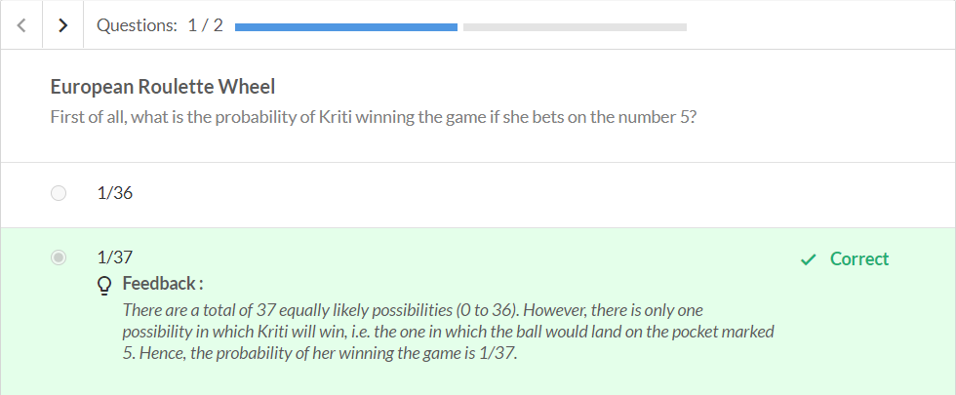

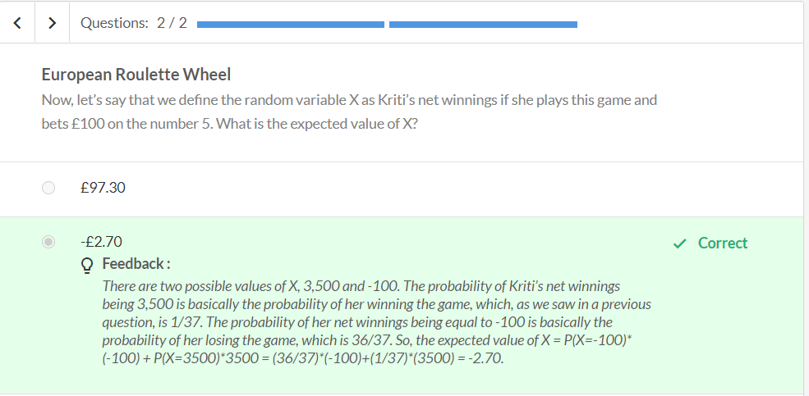



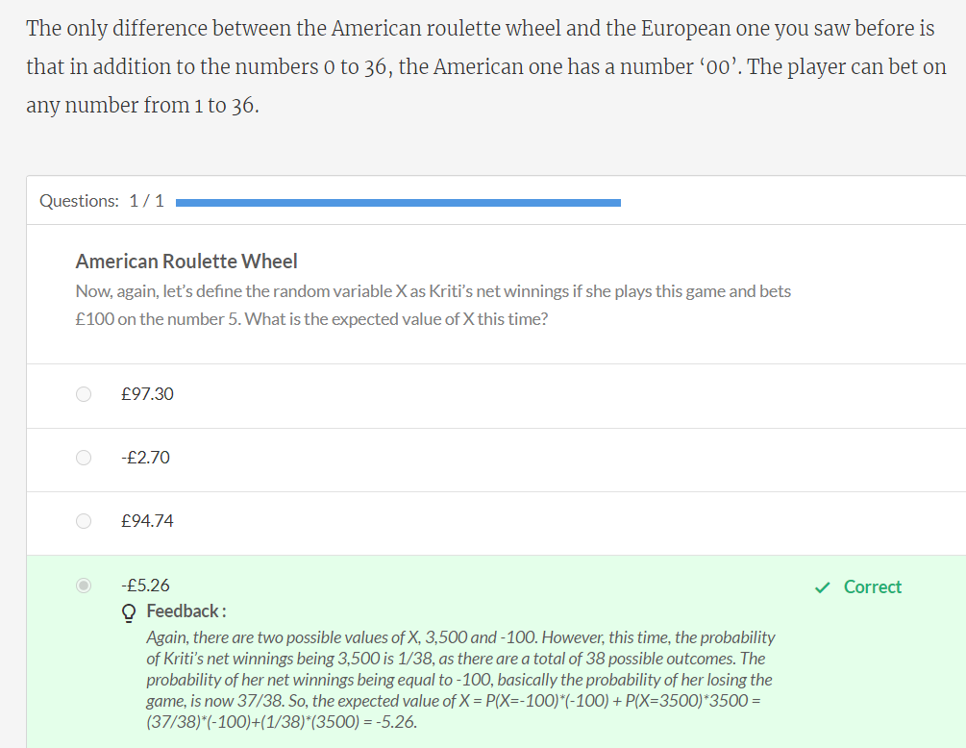

Discrete Probability Distributions

Consider a bag contains 3 red ball and 2 blue balls.

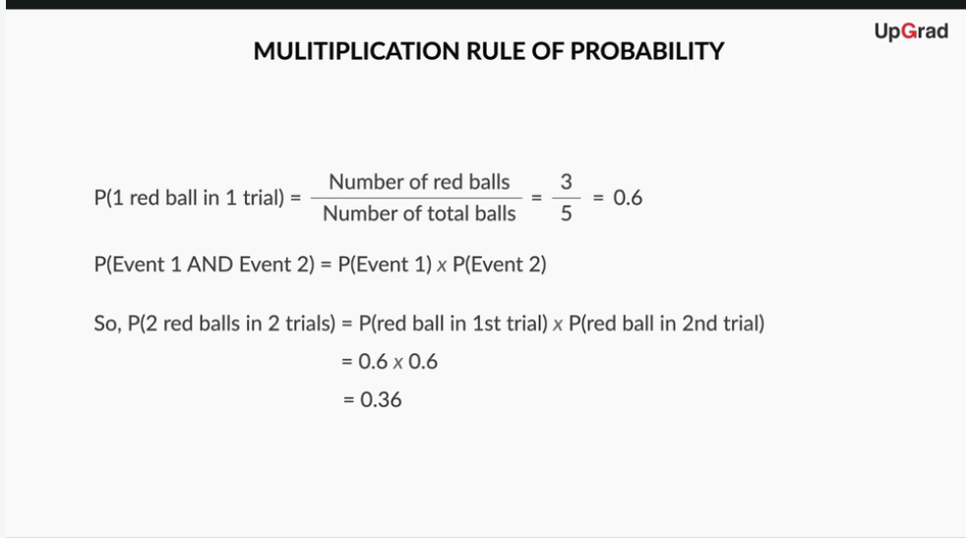

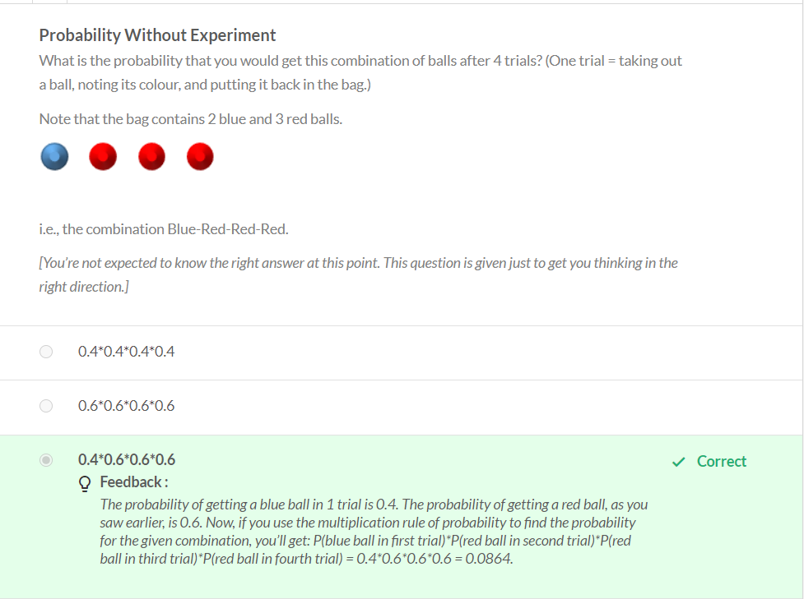

Various combinations allowed

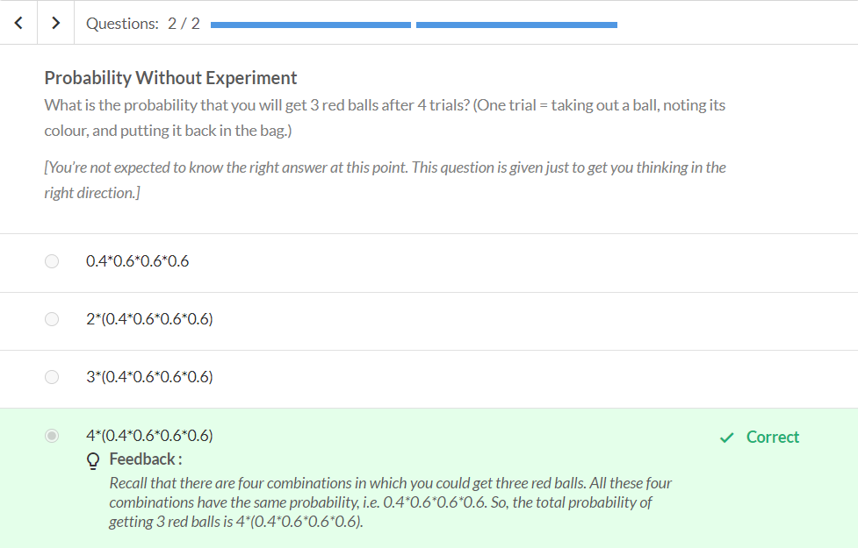



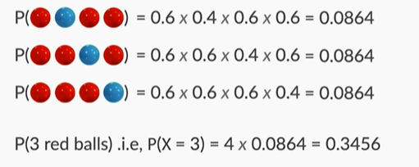

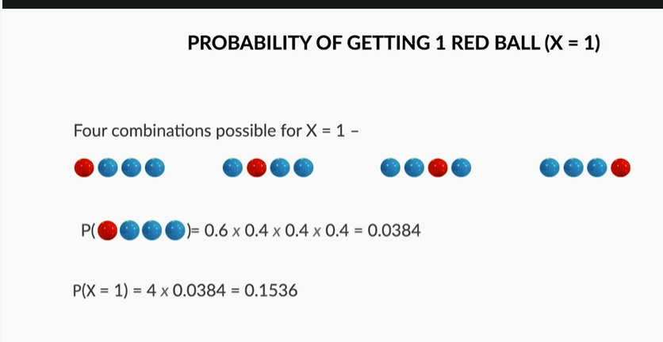

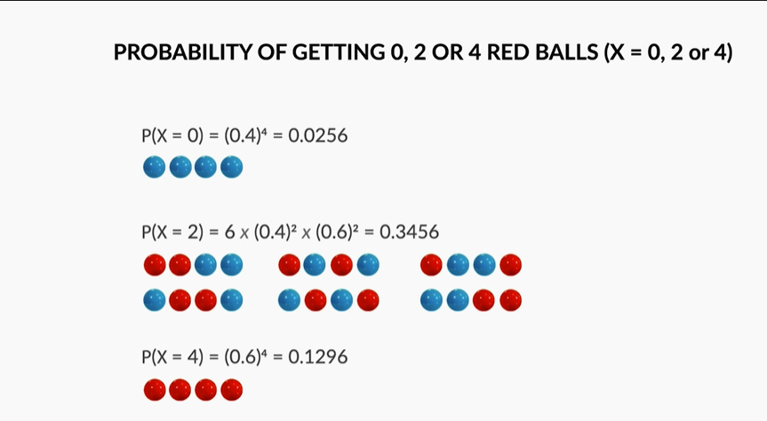

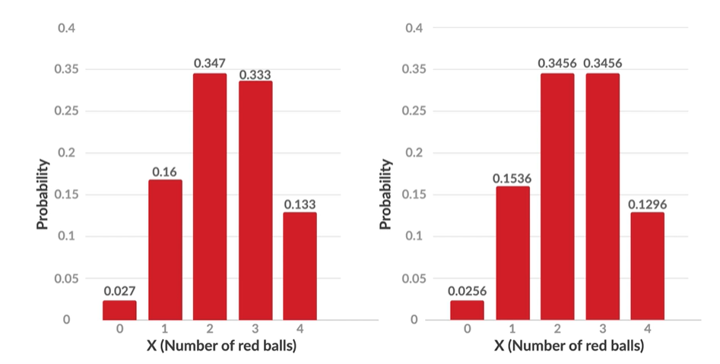

**Observed Probability (Experimented with 75 Upgrad people) Vs Theoretical Probability**

Thus, we have gone through the exercise of finding the **probability without conducting any experiment**. You saw that these theoretical (calculated) values of probability are actually quite close to the experimental values. The small differences exist because of the low number of experiments conducted.

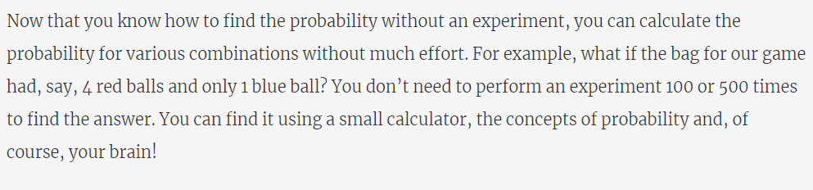

**Probability Without Experiment - II**

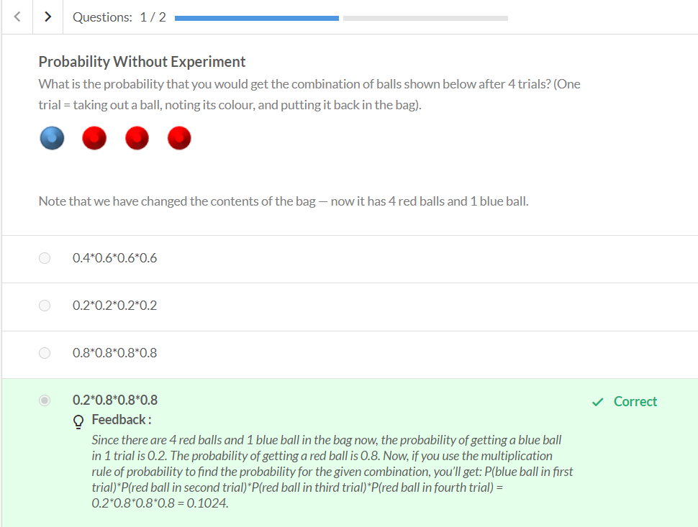

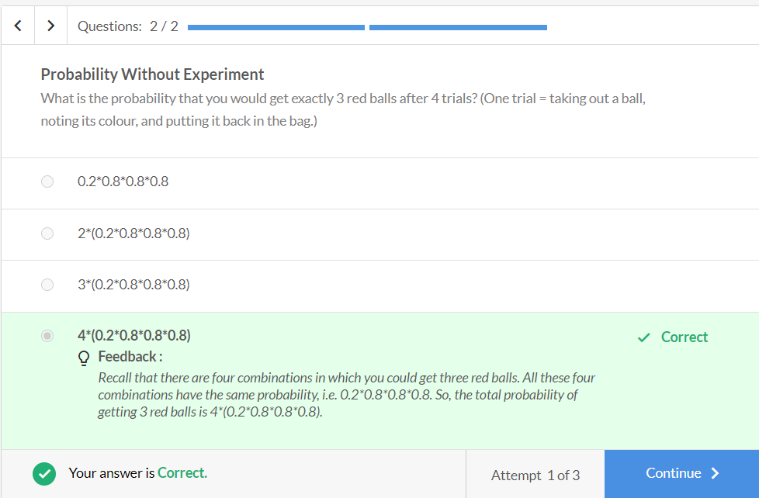

# Binomial Distribution

Earlier, we found the theoretical probability for our game and compared it with the experimental one. Finding the probability without conducting an experiment means that we can find the probability using just pen and paper and with minimal effort.

Now, let’s try to generalise it — let’s say that the probability of getting 1 red ball in one trial is equal to p. In that case, what would be the probability of all 4 balls being red? Let’s see in the following video.

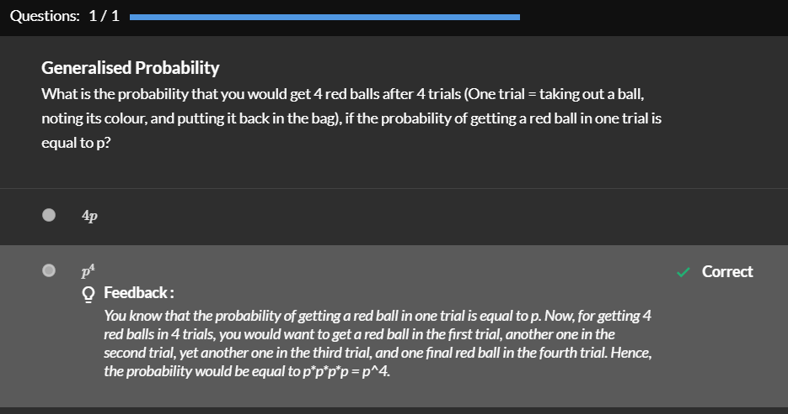

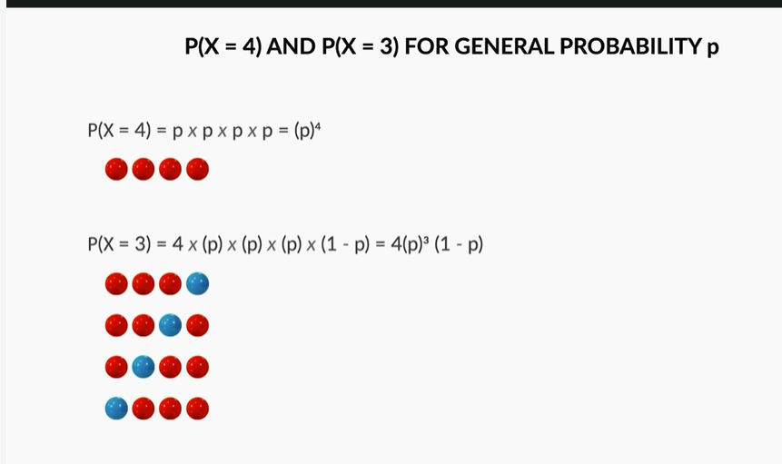

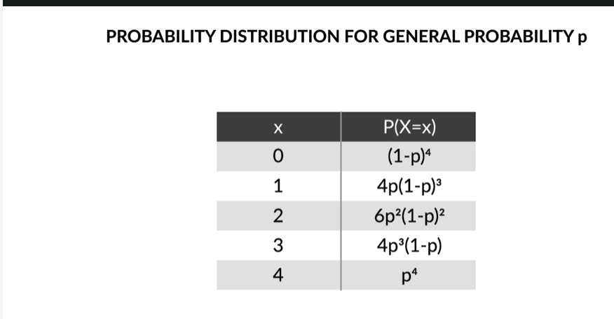

Lets generalise this. Instead of 4 times lets say n times, lets find the probability of getting ‘r’ red ball.

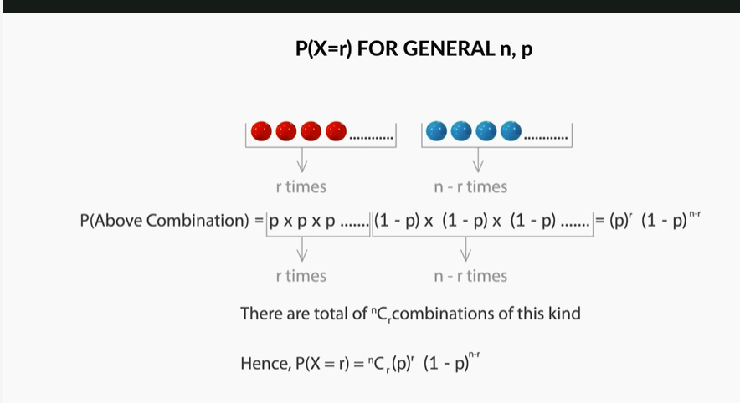

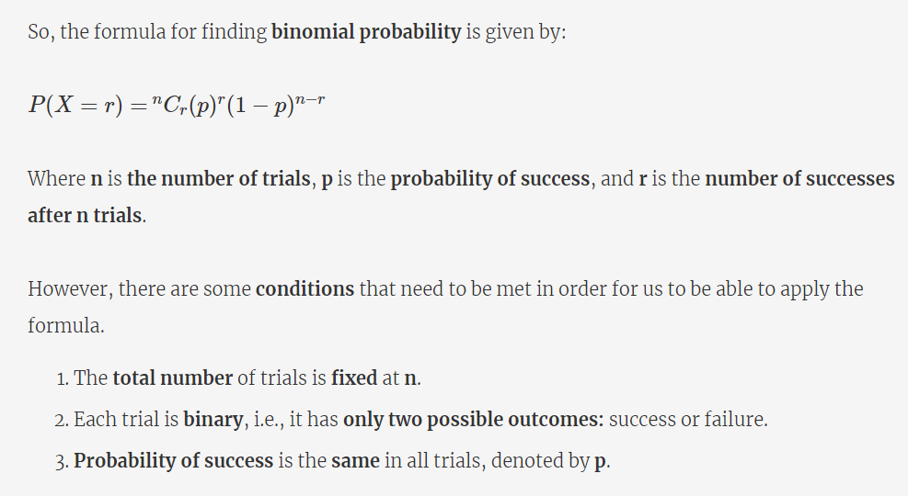

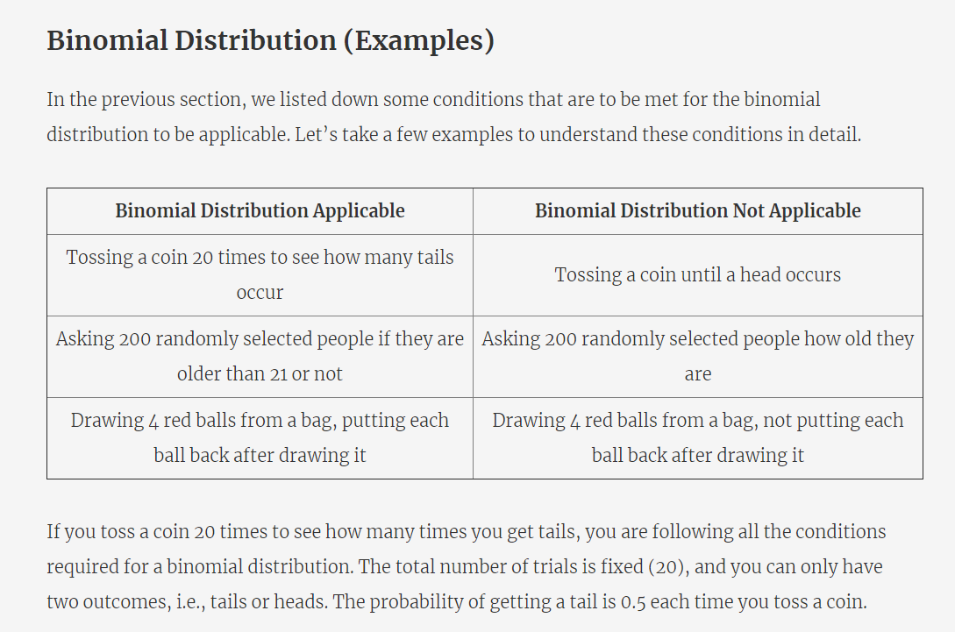

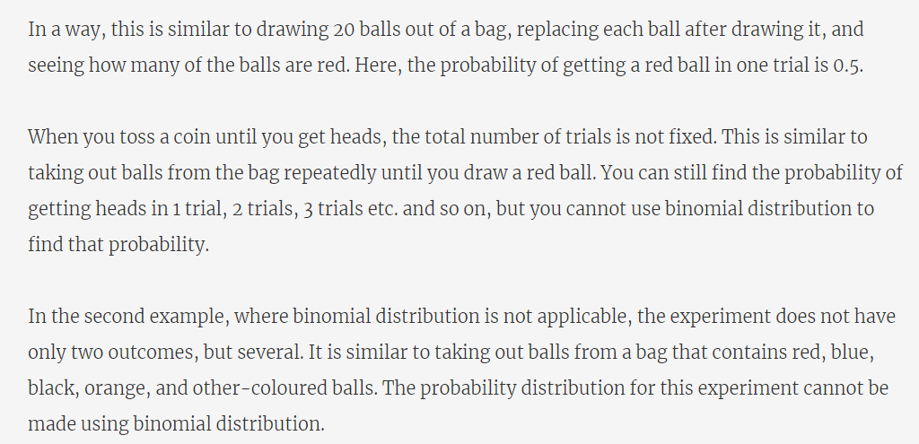

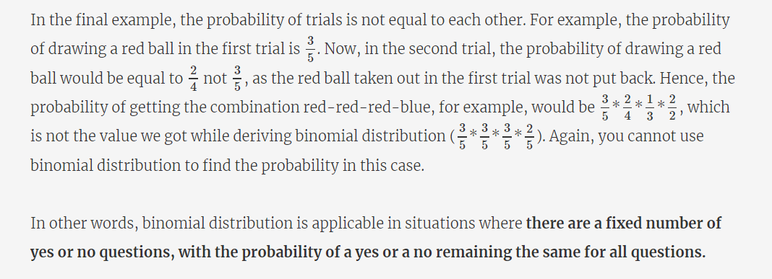

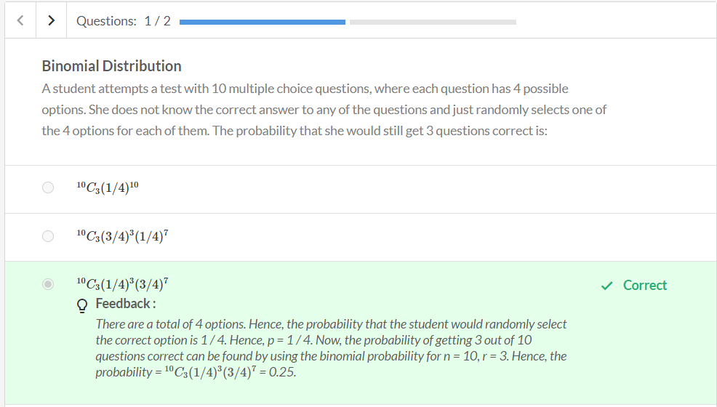

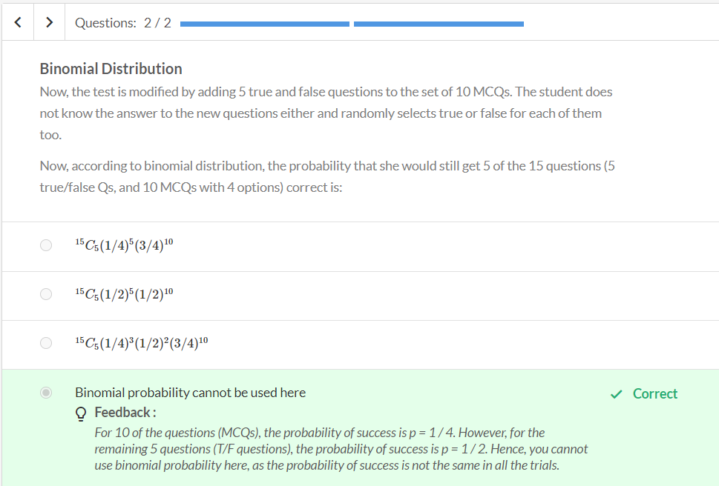

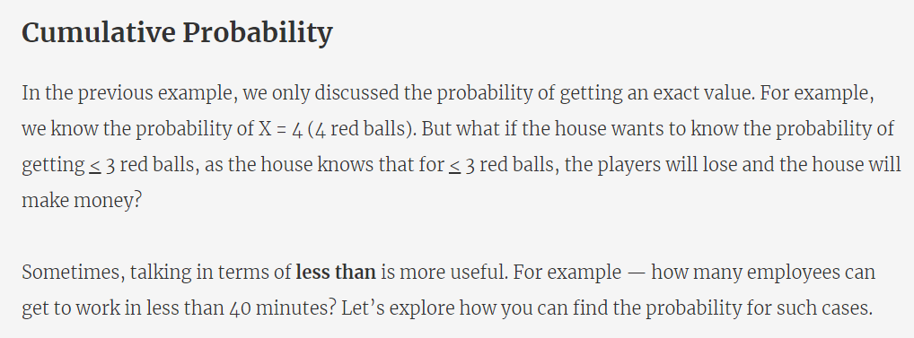

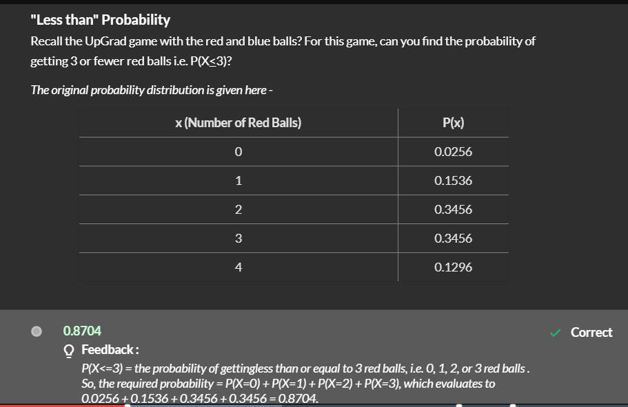

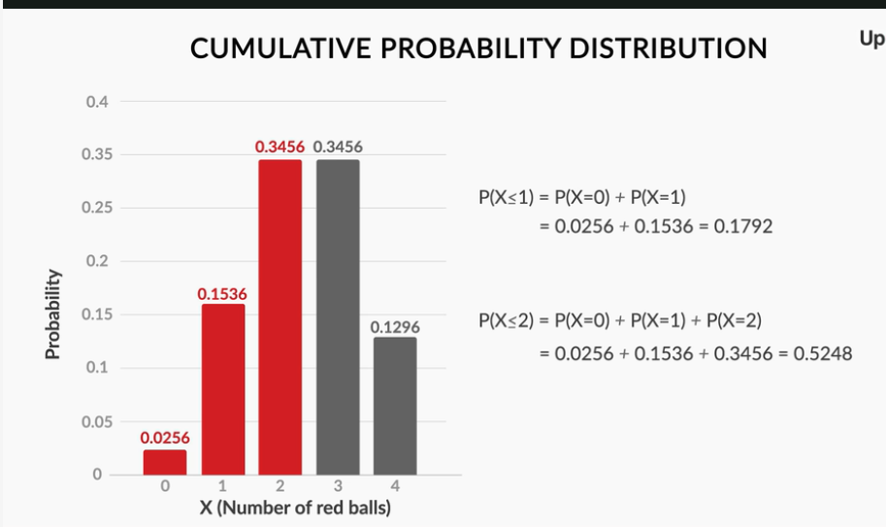

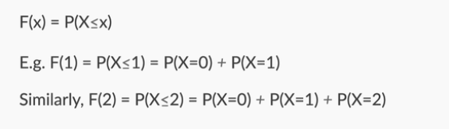

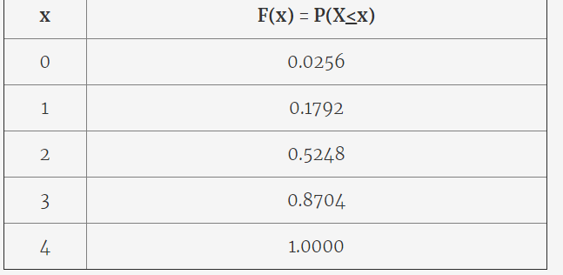

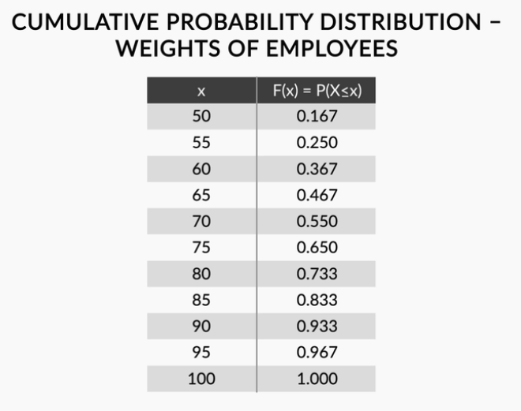

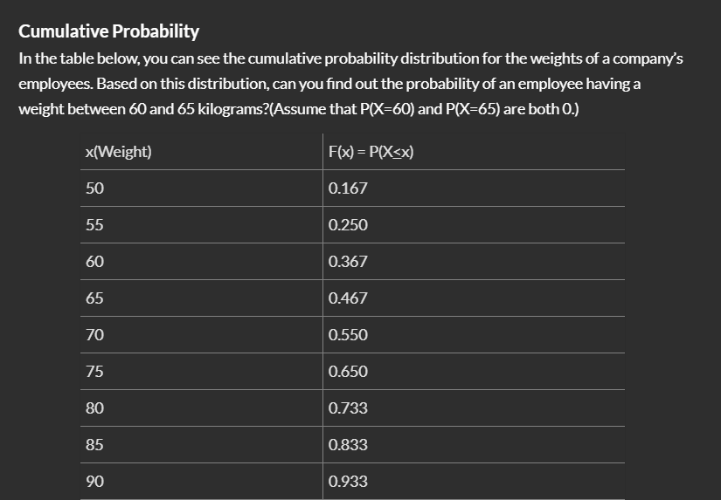





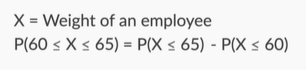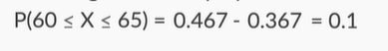

So, the **cumulative probability of X**, denoted by **F(x)**, is defined as **the probability of the variable being less than or equal to x**.

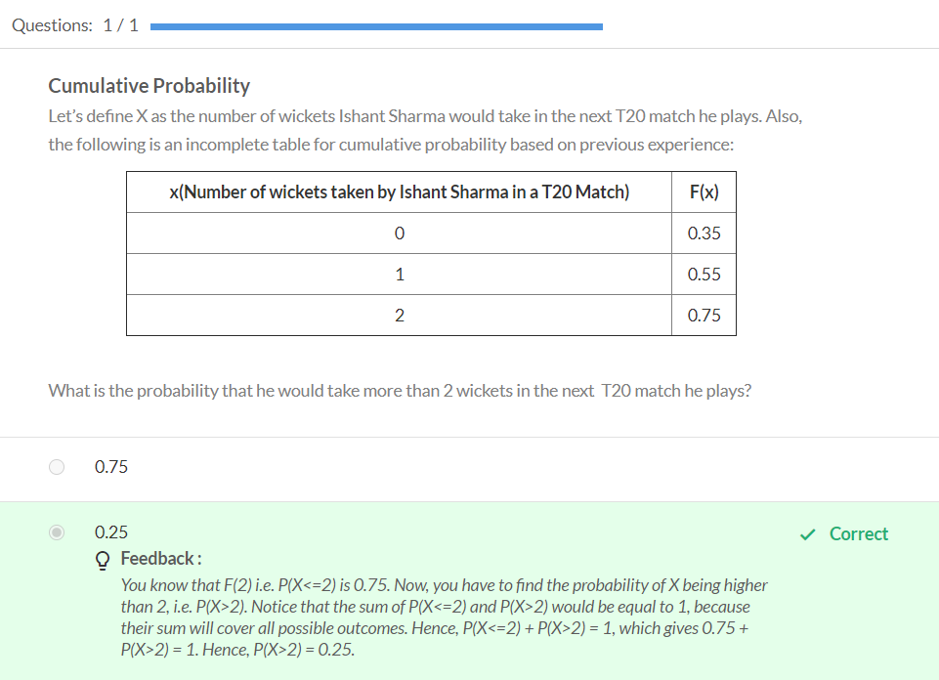

**Summary: Discrete Probability Distributions**

We started with learning how to find **probability without experiment**, using basic concepts such as the addition and the multiplication rule of probability.

As a demonstration, we calculated the probability of getting 0, 1, 2, 3 and 4 red balls for our upGrad red ball game. Then, we compared the values we got through theoretical calculations with the ones we got after the experiments in the first session. Recall that the values were quite similar.

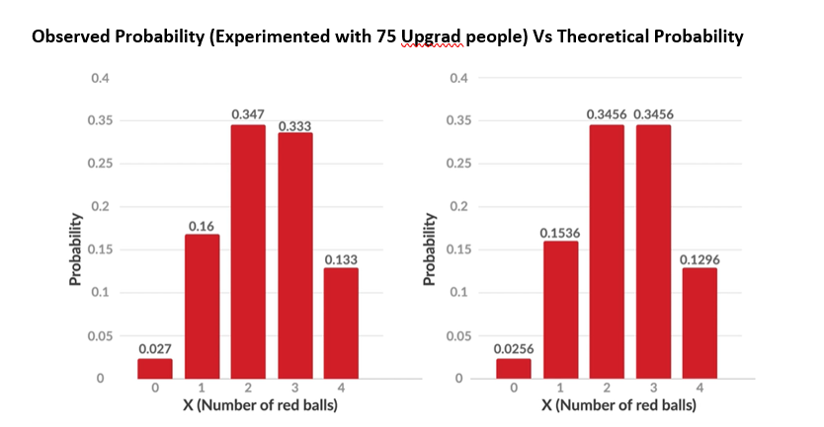

However, they were not exactly the same due to the low number of experiments conducted (75). If more experiments were performed, the values would have been exactly the same (the values are exactly the same if the number of experiments approaches infinity).

Next, we **generalised this probability**. Specifically, we talked about the probability of getting **r red balls** after drawing **n balls** from a bag. Here, the probability of drawing **a red ball in 1 trial** was equal to **p**.

The probability distribution for this case is given by the following table (X = number of red balls drawn after playing the game once).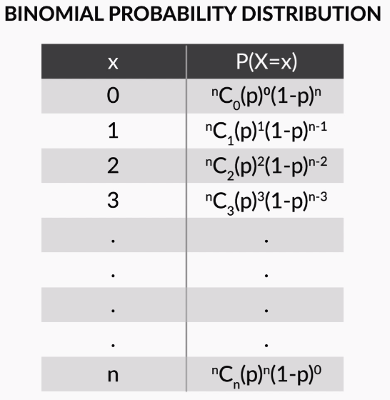

**Figure 3 - Binomial Distribution**

In general,

P(X=r)=  nCr(p)r(1−p)n−r

This distribution is called the **binomial distribution**. It can be used to find the probability of any kind of event, if that event is **a series of yes or no questions, with the probability of yes being the same for all questions**.

Phrasing the conditions more formally, the binomial distribution can be used if, for an experiment:

* The **total number** of trials is **fixed.**
* Each trial is **binary**, i.e., it has **only two possible outcomes:** success or failure.
* The **probability of success** is the **same** for all the trials.

Next, we discussed the **cumulative probability of x**, denoted by **F(x)**, which is the **probability that the random variable X takes a value less than or equal to x**.

For example, we found F(2), the probability of getting 2 or fewer red balls in our upGrad game. It was calculated as:

 F(2) = P(X < 2) = P(X = 0) + P(X = 1) + P(X = 2) = 0.0256 + 0.1536 + 0.3456 = 0.5248

The cumulative probability is a concept that we will use extensively in our next session on continuous random variables.



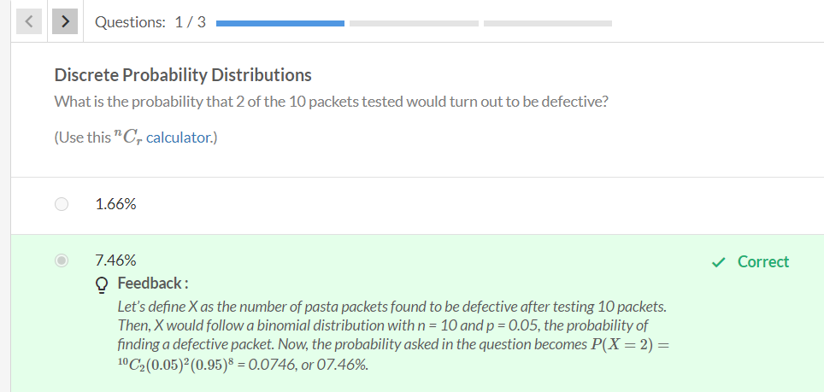

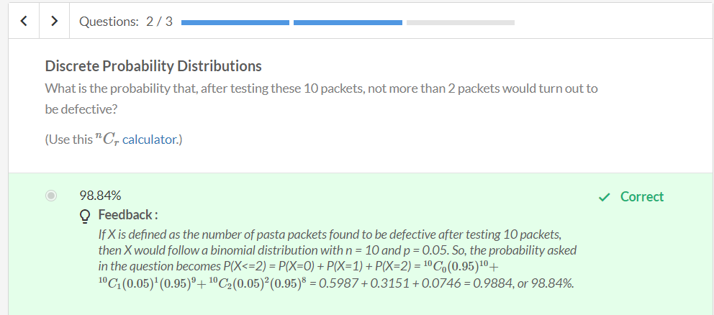

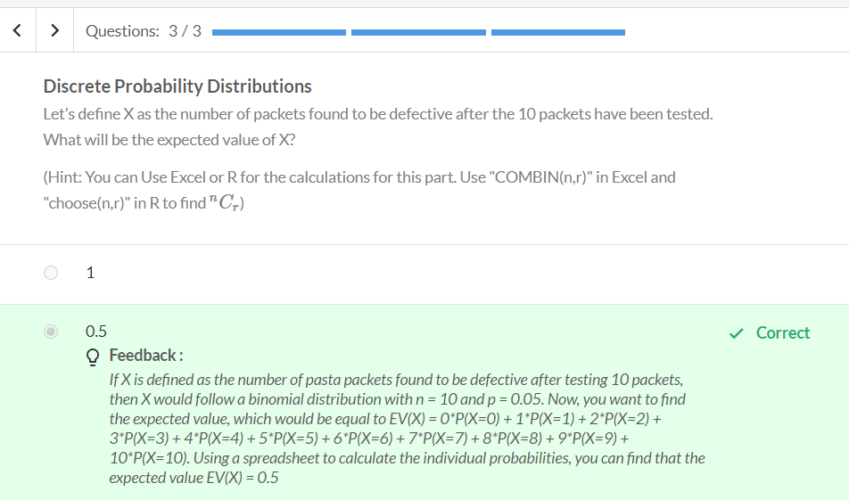

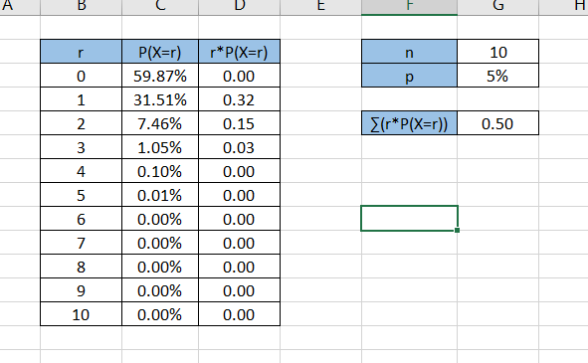

Refer - Expected Value for Binomial Distribution.xlsx



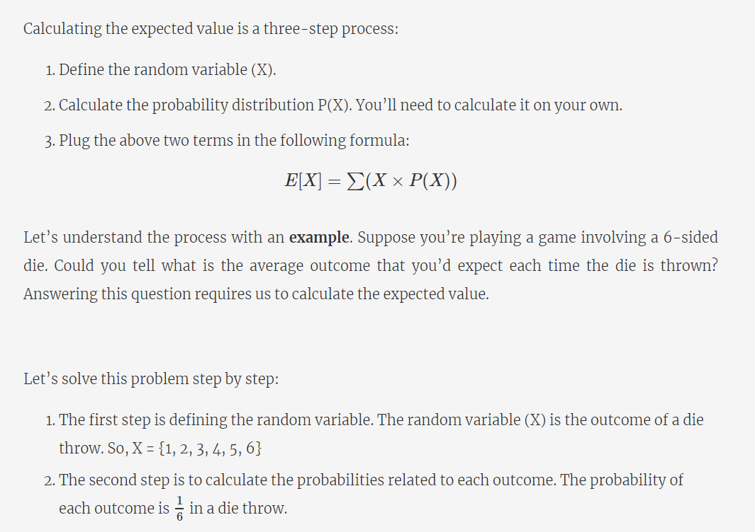

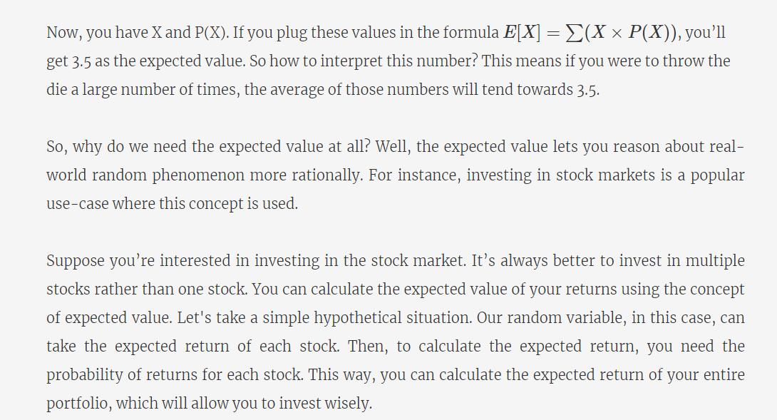



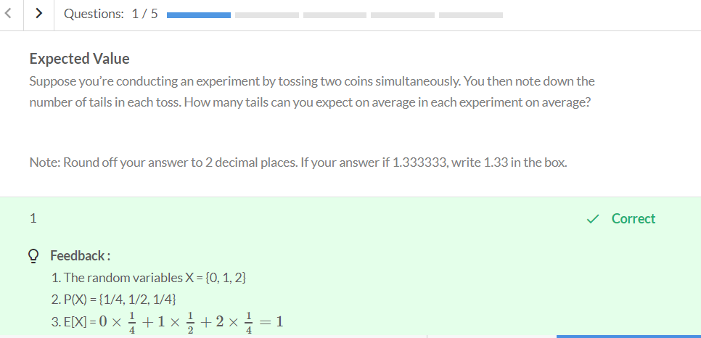

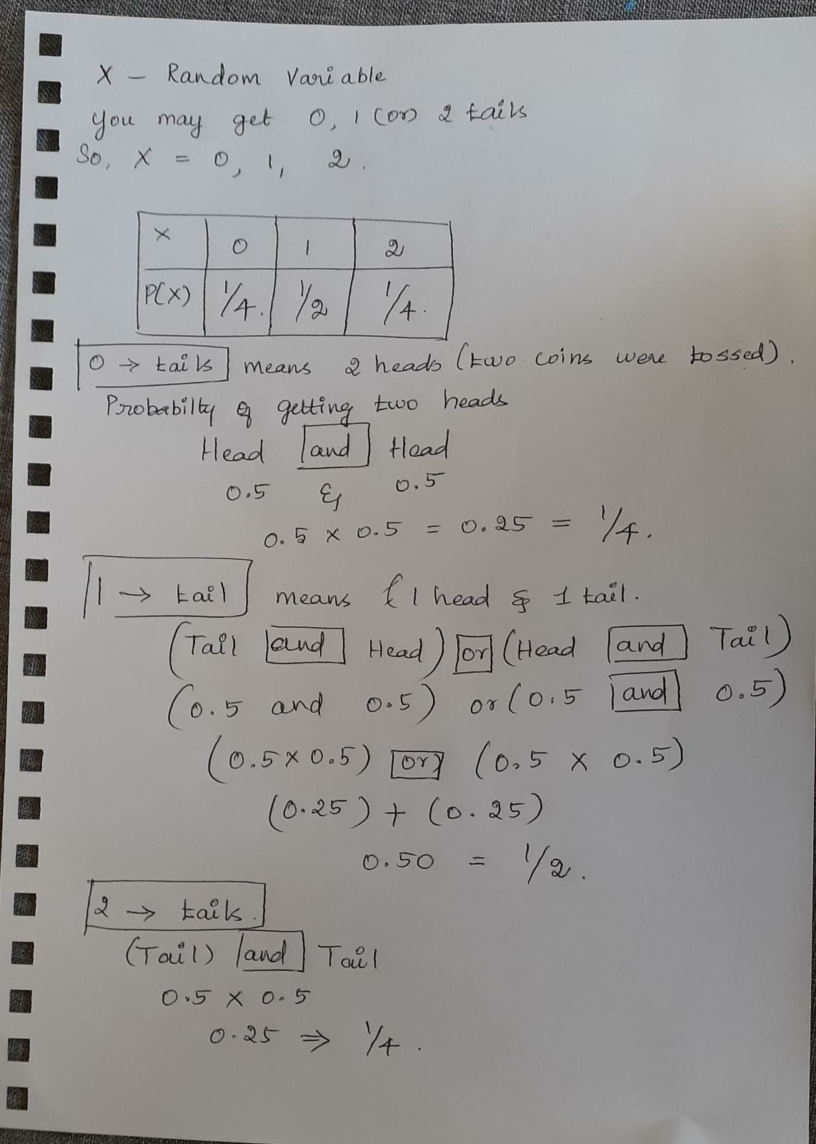

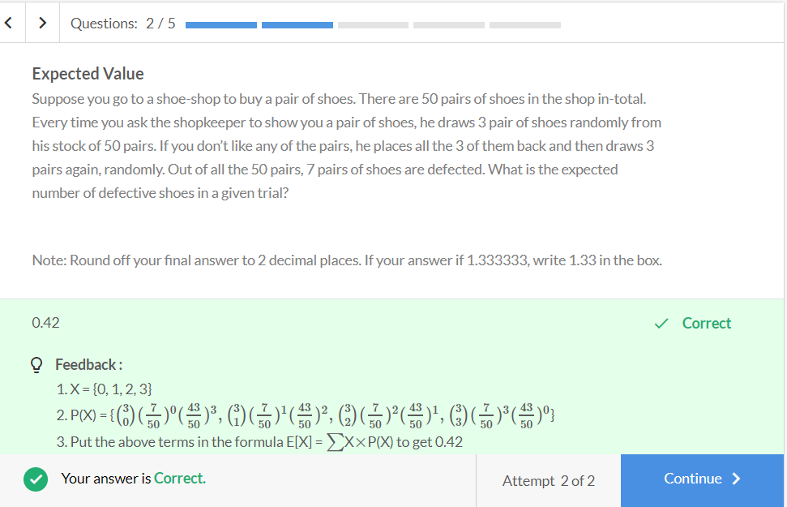

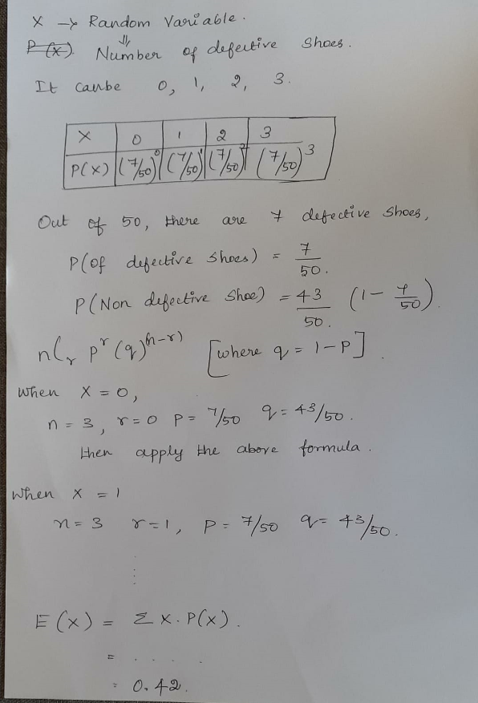

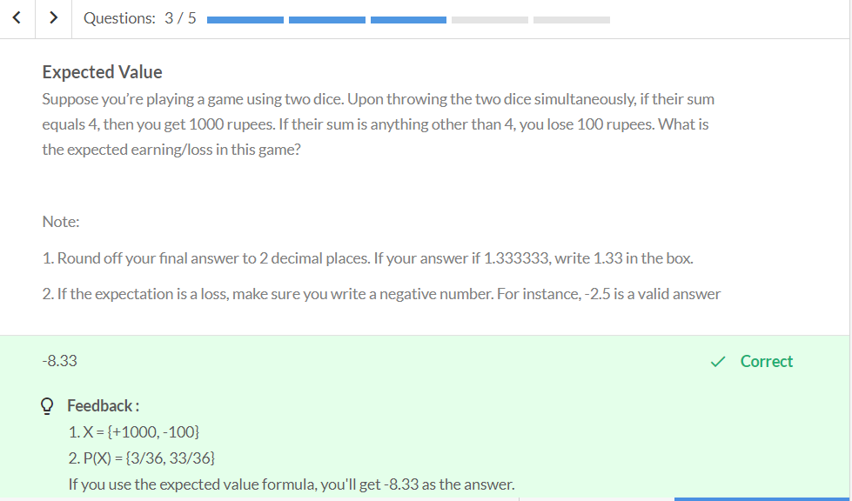

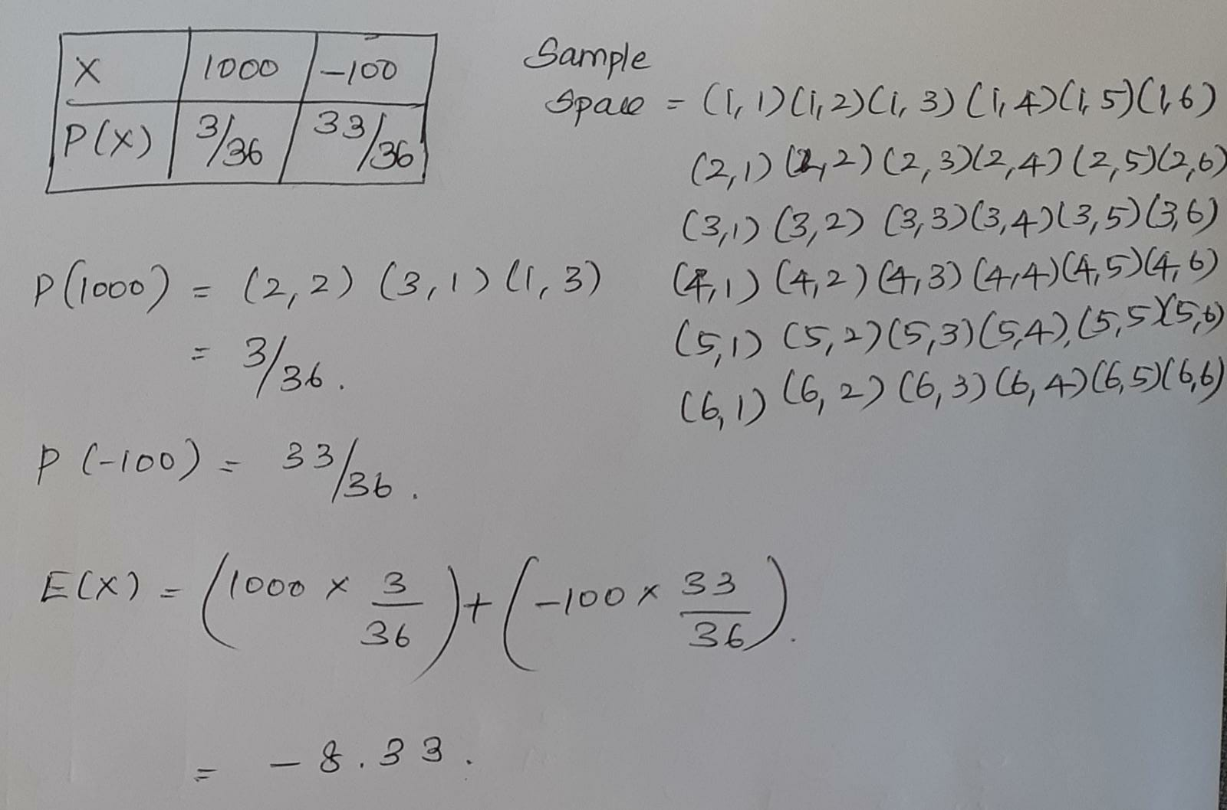

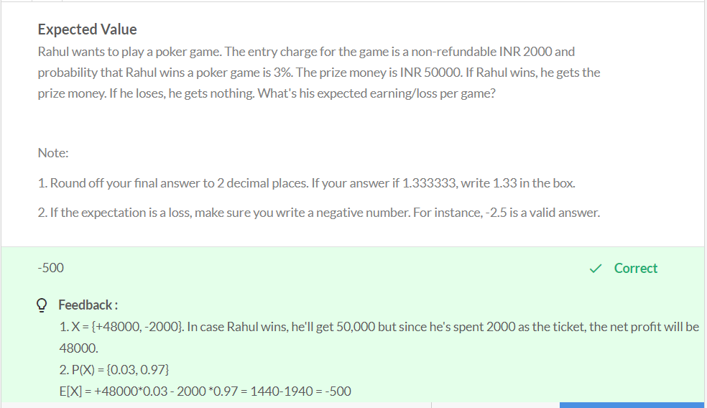

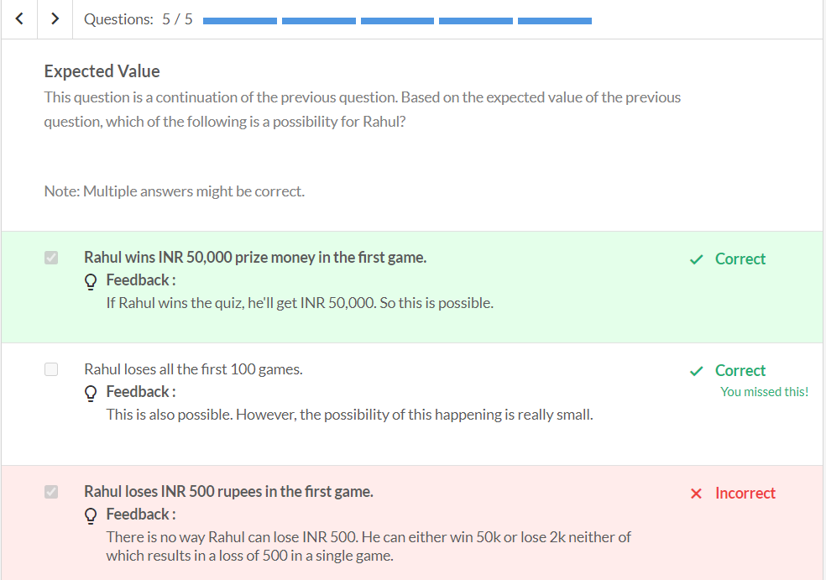



Atleast 2 – x>=2

Atmost 2 - x<=2

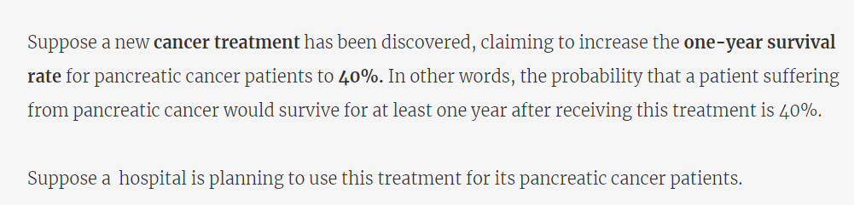

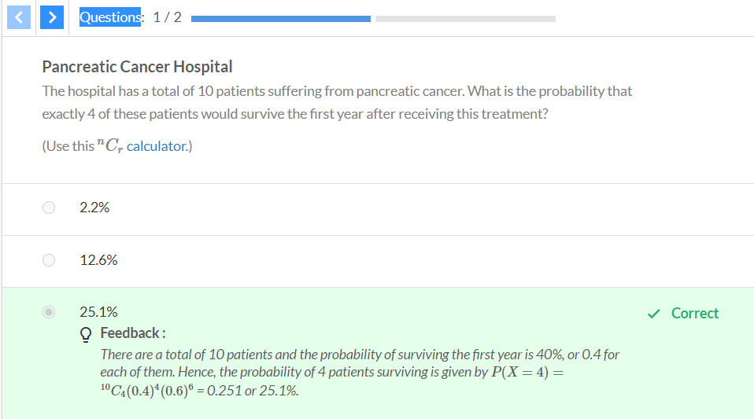

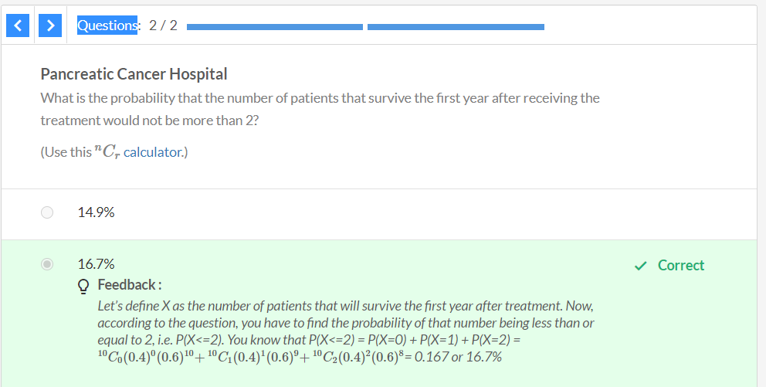

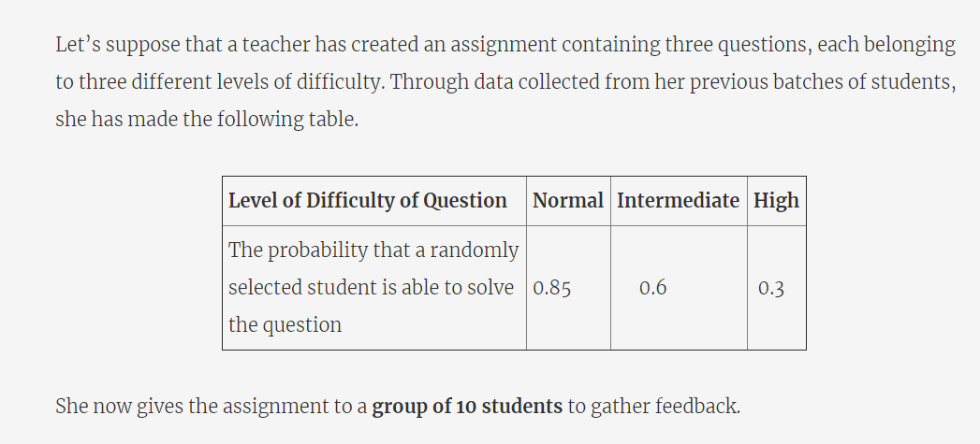

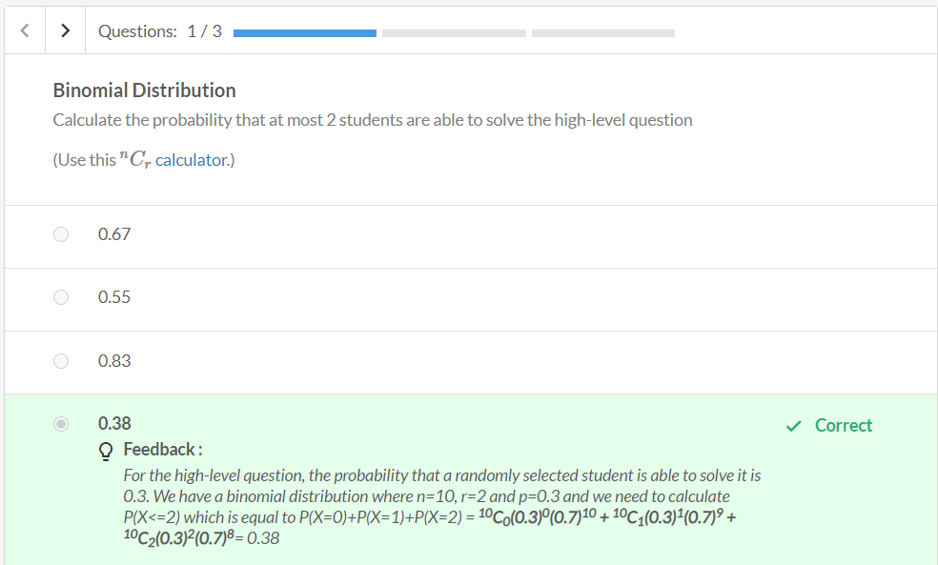

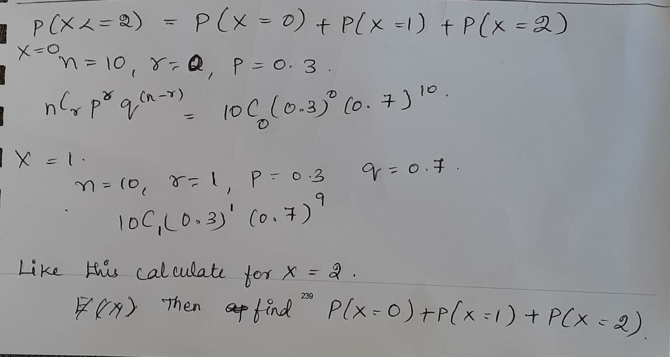

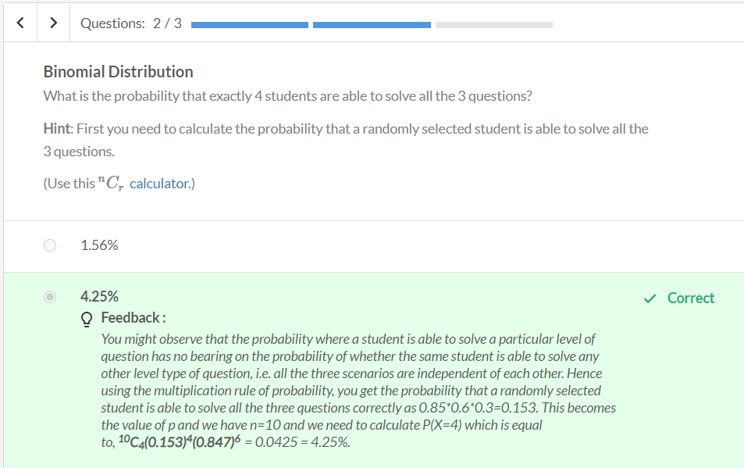

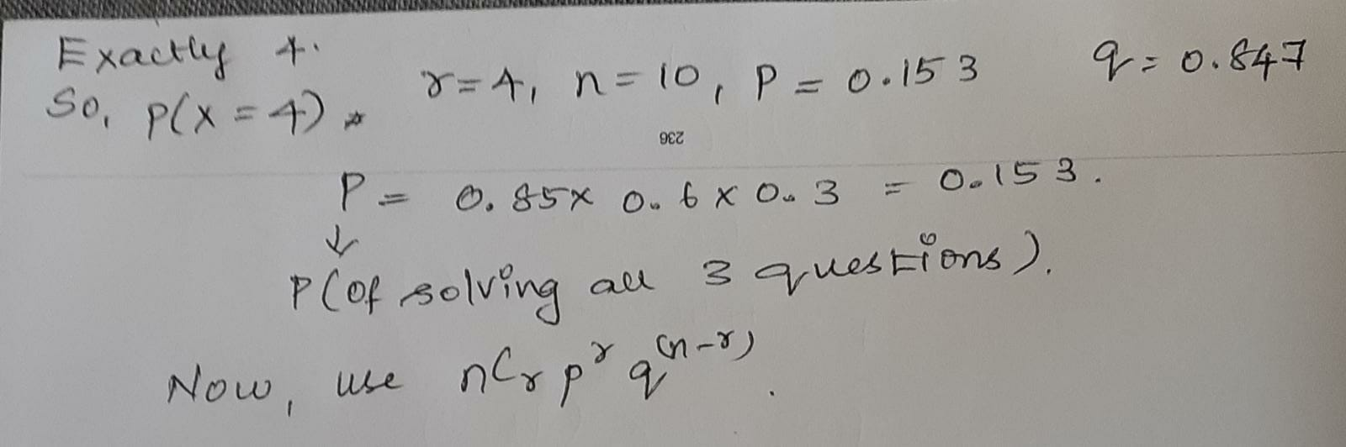

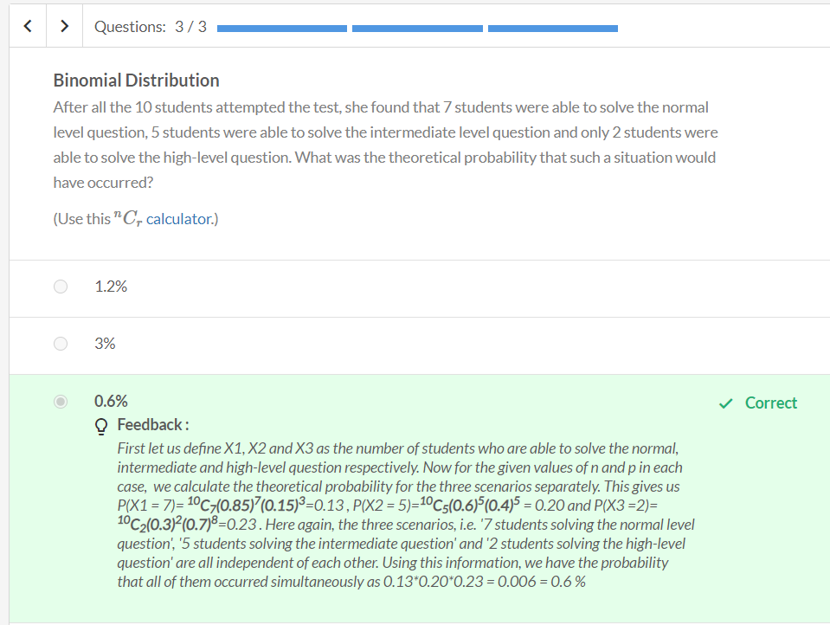

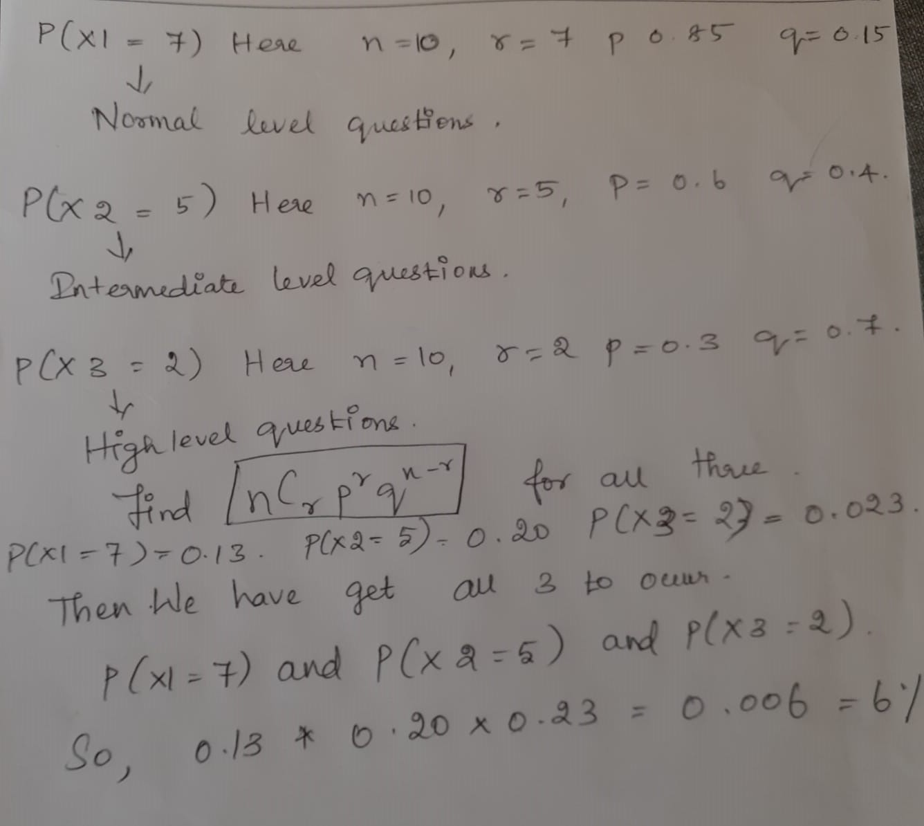

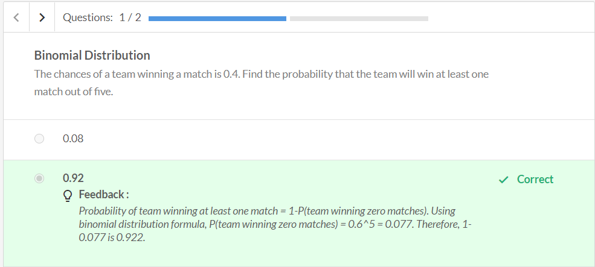

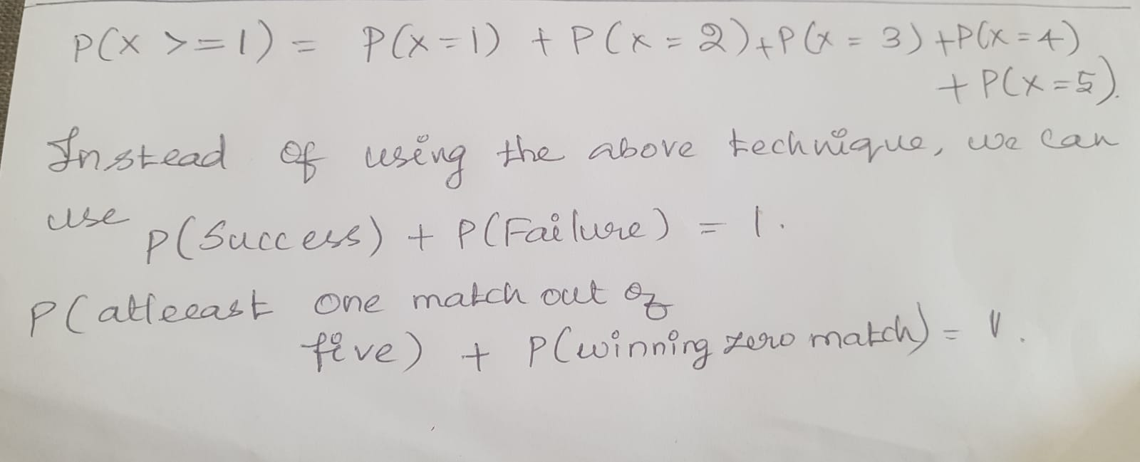

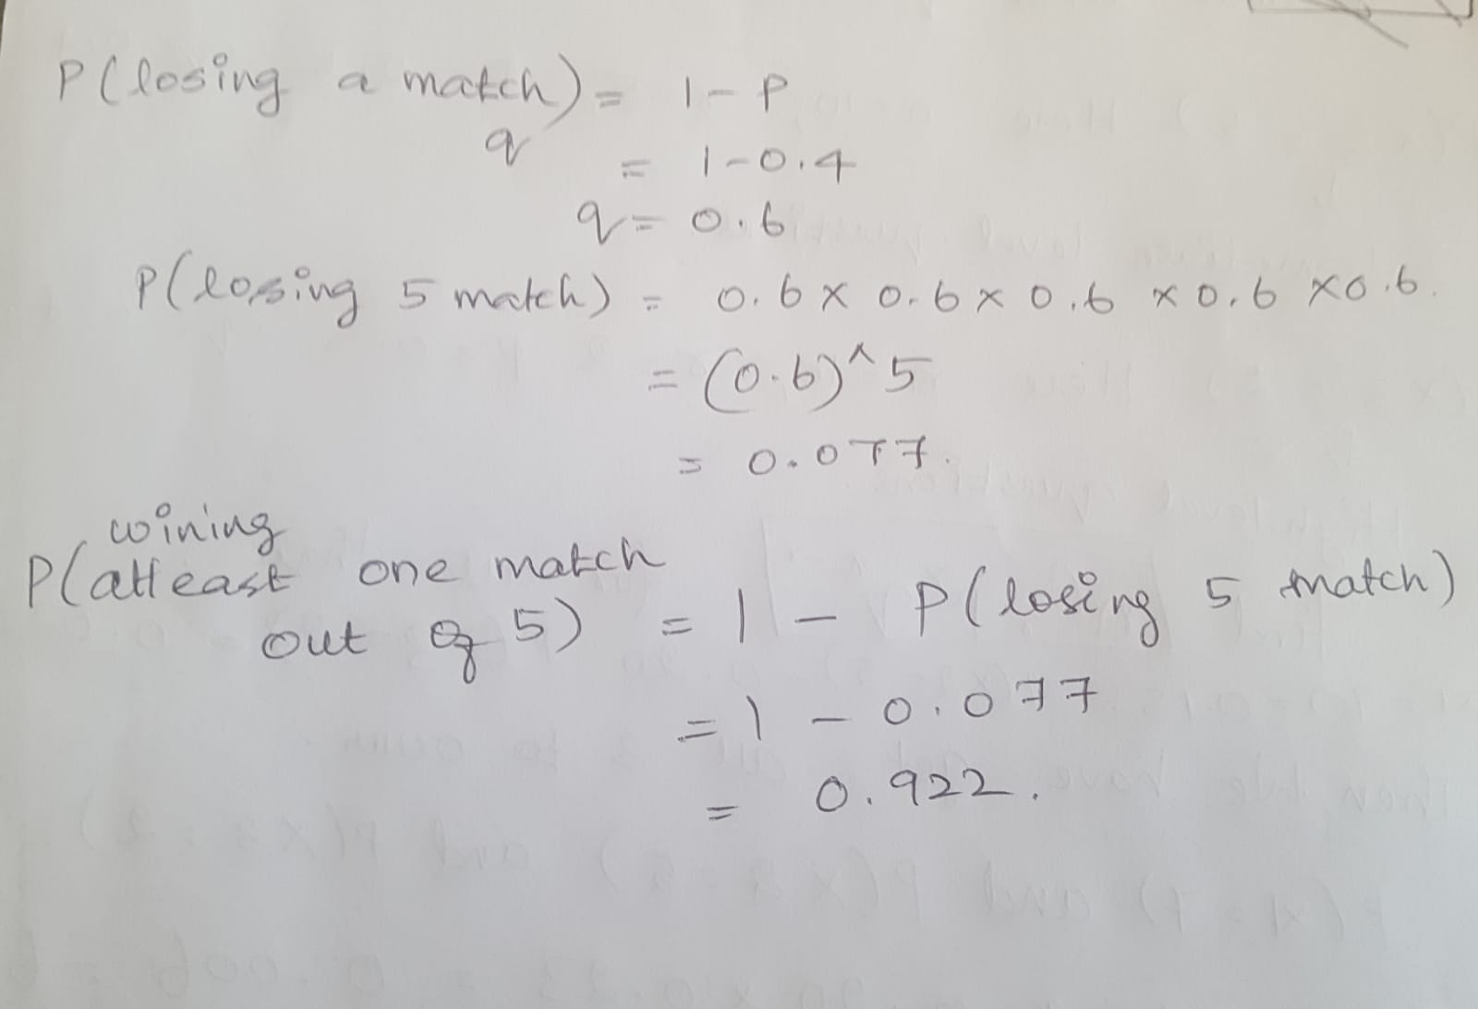

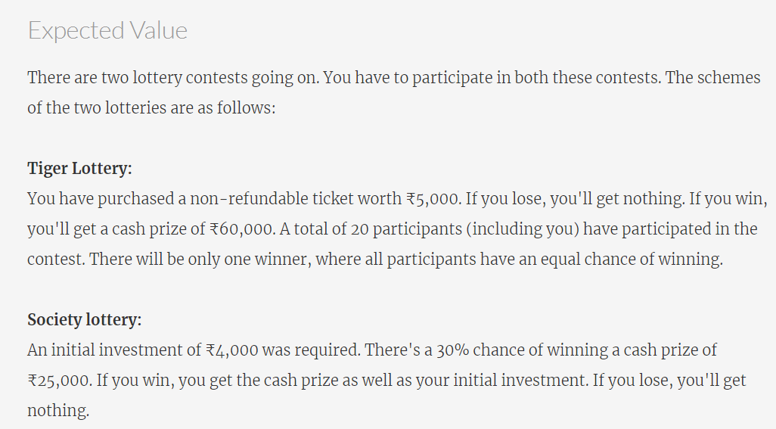

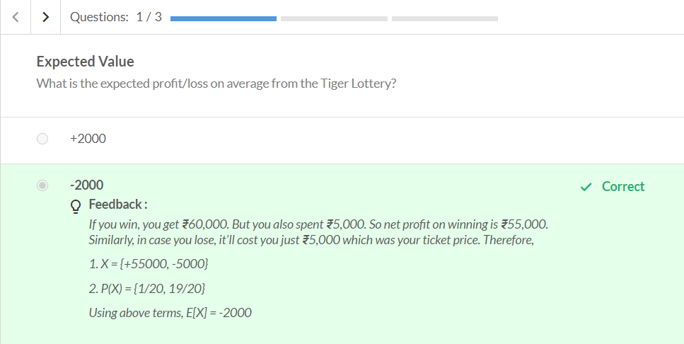

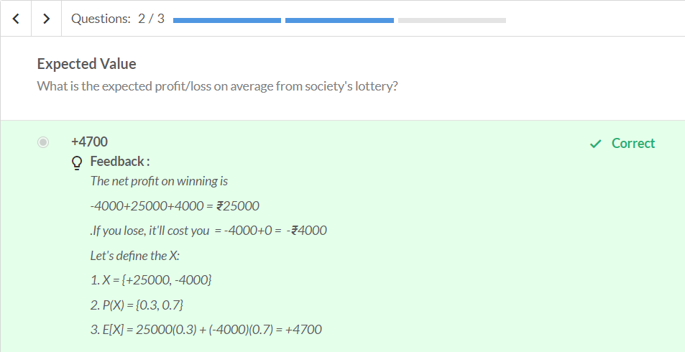

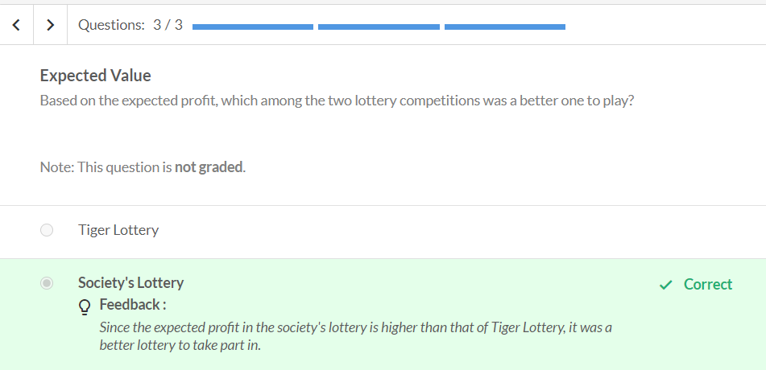

Continuous Probability Distribution

So far, we have only talked about discrete random variables, e.g., number of balls, number of patients, cars, wickets, pasta packets, etc. What happens when we talk about the **probability of continuous random variables**, such as time, weight etc.? Is there any difference? Let’s find out.

Consider a company has 3000 employees. We need to find the average commute time of an employee. If a employee takes 35 minutes to reach the office.





Here the commute time is a continuous random variable which takes 34.99,35, 35.01,35.02 and so on. Getting exactly 35 minutes will be very very minimal. So, the probability of getting exactly 35 minutes is 0.

So we need to calculate the probability of continuous random variable as ranges. Let’s see below.

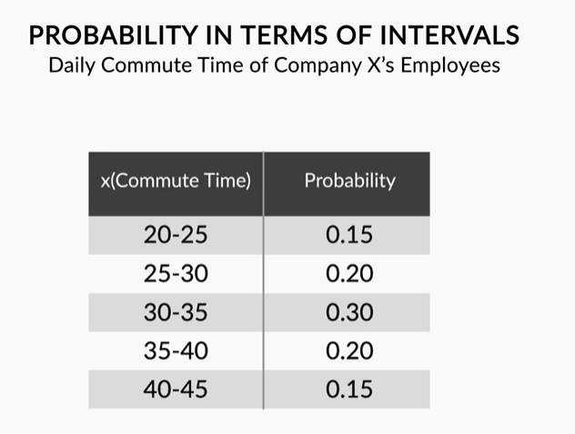

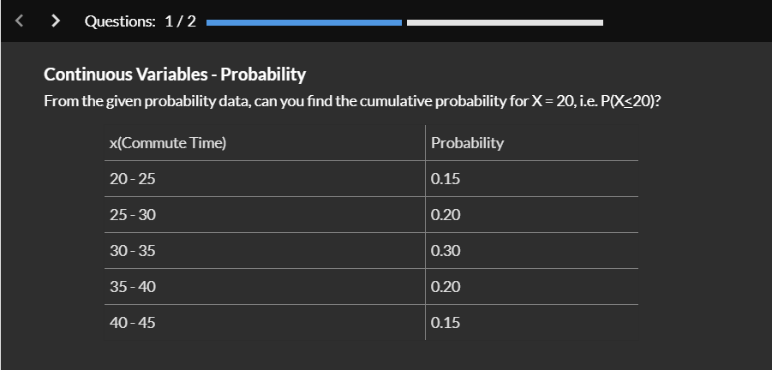

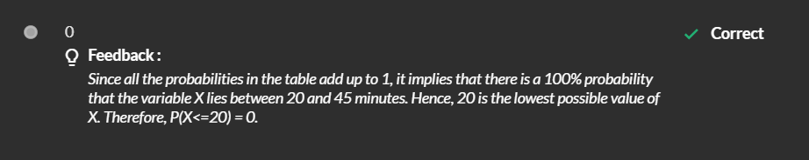

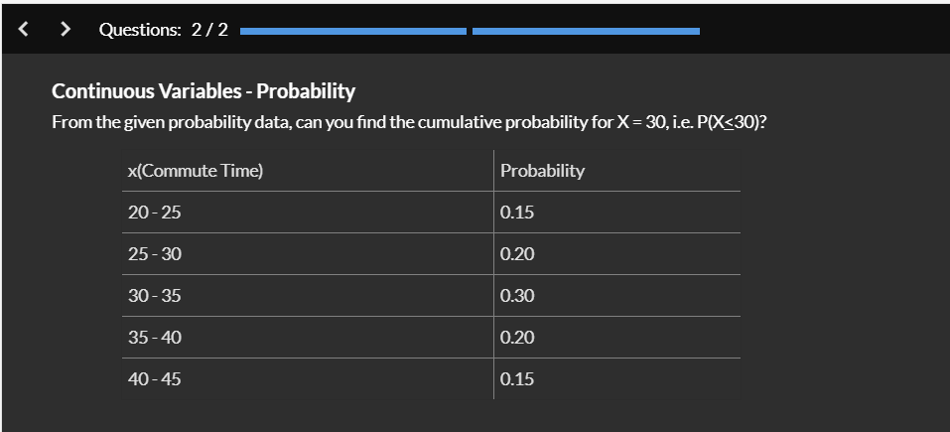



Now, we can find the cumulative Probability

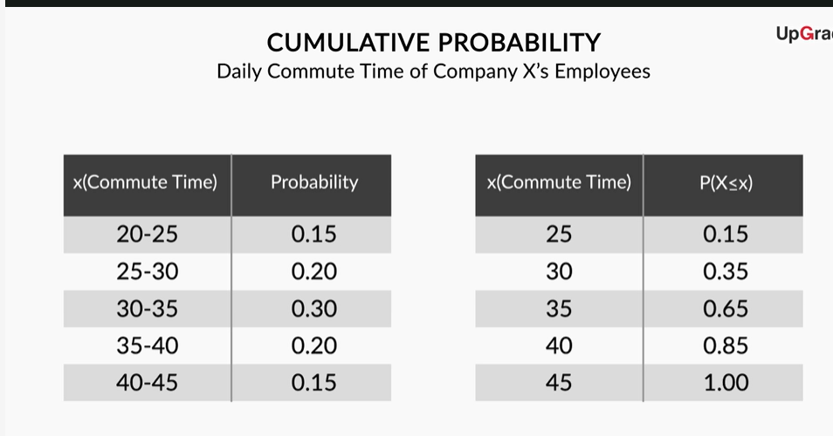

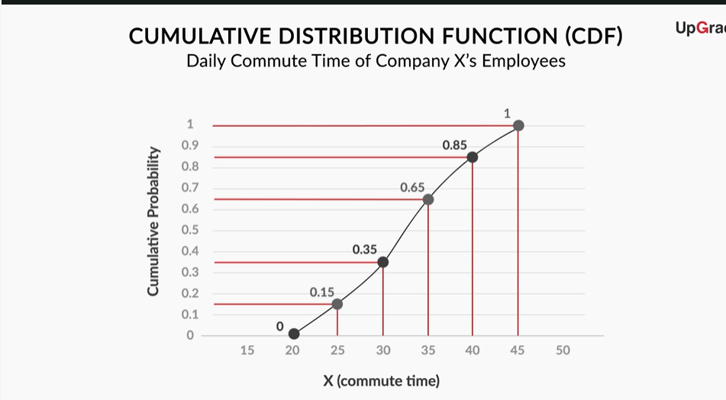

This means the commute time for 0-20 is 0 minutes, 0-25 is 0.15 minutes, 0-30 is 0.35 minutes,0-35 minutes is 0.65 and so on. Finally 0 – 45 is 1 minute.

From this distribution we can say that it si Monotonically non – decreasing function and it should have Asymptotically it should reach ‘1’.

**CDF**, or a **cumulative distribution function**, is a distribution that plots the cumulative probability of X against X.

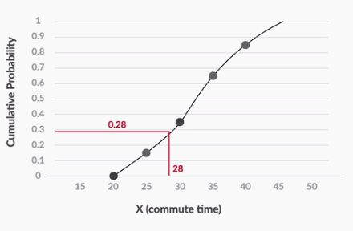

**Figure 1 - CDF (Cumulative Distribution Function)**

A **PDF**, or a **Probability Density Function**, however, is a function in which the area under the curve gives you the cumulative probability.

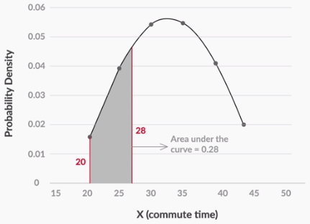

**Figure 2 - PDF (Probability Density Functions)**

For example, the area under the curve between 20, the smallest possible value of X, and 28 gives the cumulative probability for X, which is equal to 28.

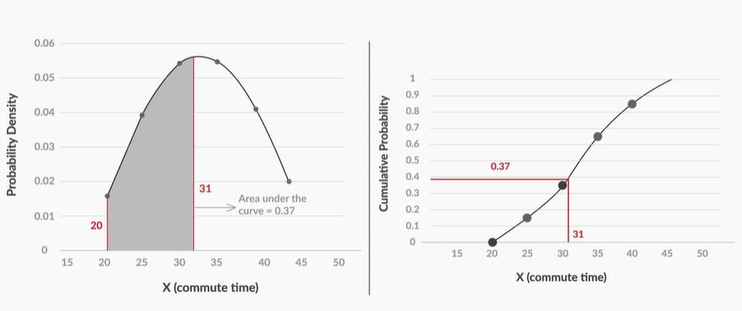

**PDF Vs CDF**

Similarly for the value of x = 30 the area under the PDF is 0.37 and in the CDF is also 0.37

**Cumulative Probability Distribution for Discrete Variables**

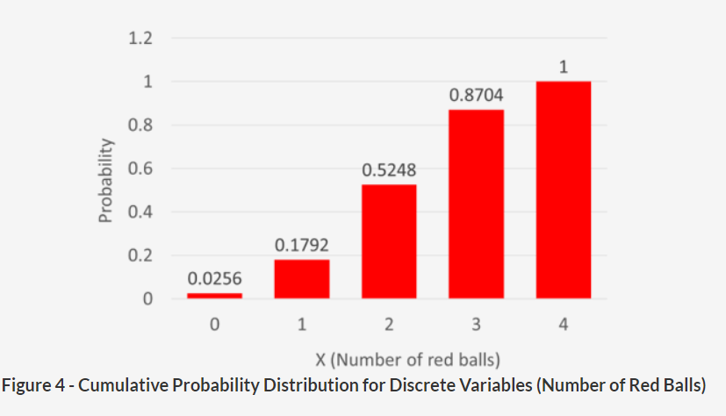

The reason for the difference is that for discrete variables, the cumulative probability does not change very frequently. In the discrete variable example, we only care about what the probability is for 0, 1, 2, 3 and 4. This is because the cumulative probability will not change between, say, 3 and 3.999999. For all values between these two, the cumulative probability is equal to 0.8704.

However, for the continuous variable, i.e., the daily commute time, you have a different cumulative probability value for every value of X. For example, the value of cumulative probability at 21 will be different from its value at 21.1, which will again be different from the one at 21.2, and so on. Hence, you would show its cumulative probability as a continuous curve, not a bar chart.

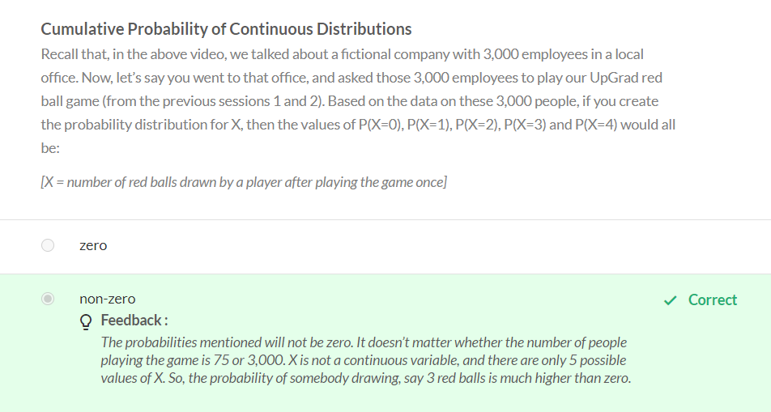

In the above case, X – is a discrete variable

**Probability Denstiy Function – II**

In statistics, uniform distribution is a term used to describe a form of **probability** distribution where every possible outcome has an equal likelihood of happening.

Eg : A coin also has a **uniform distribution** because the probability of getting either heads or tails in a coin toss is the same.

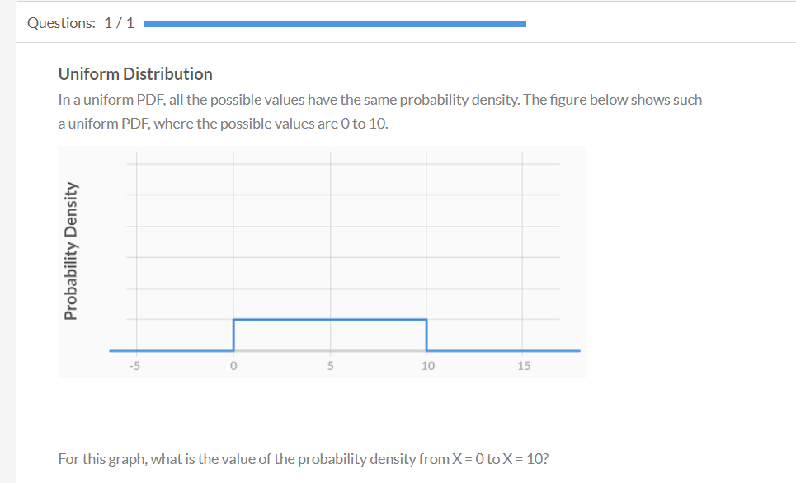

Since all possible values are between 0 and 10, the area under the curve between 0 and 10 is equal to 1.

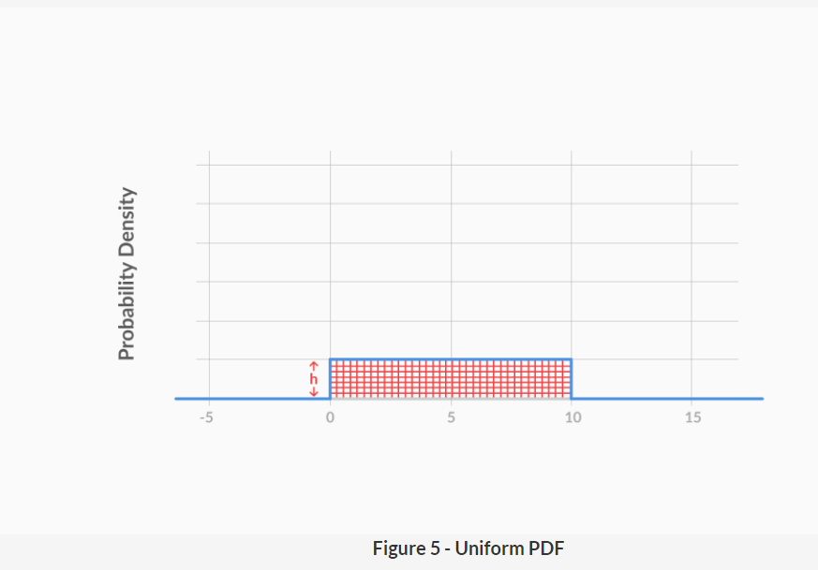

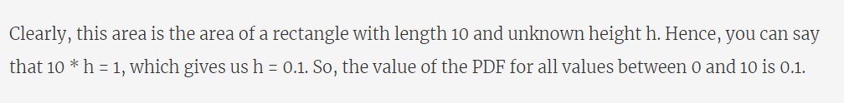

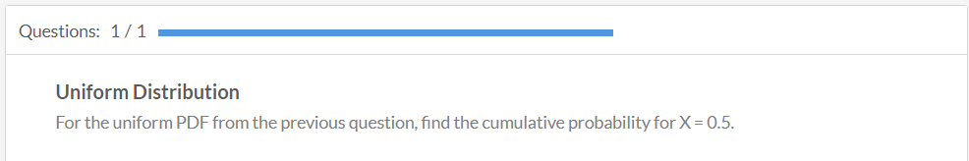

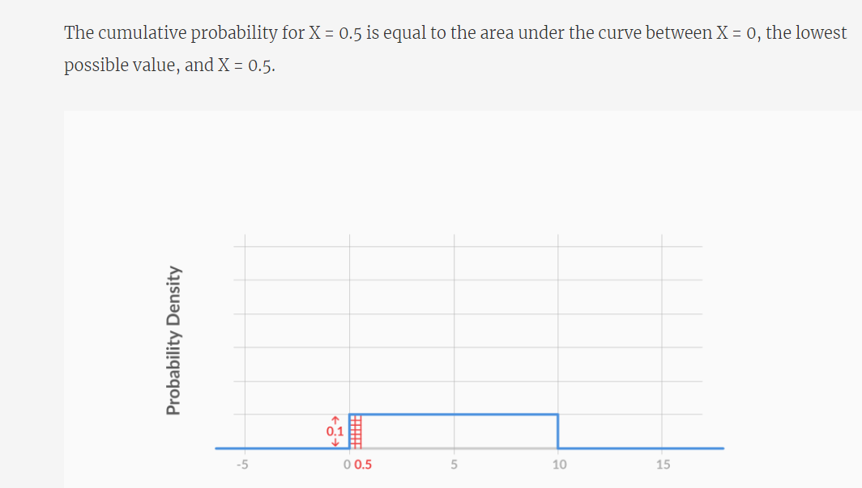

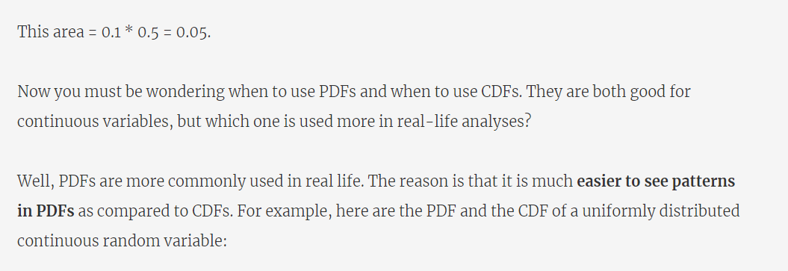

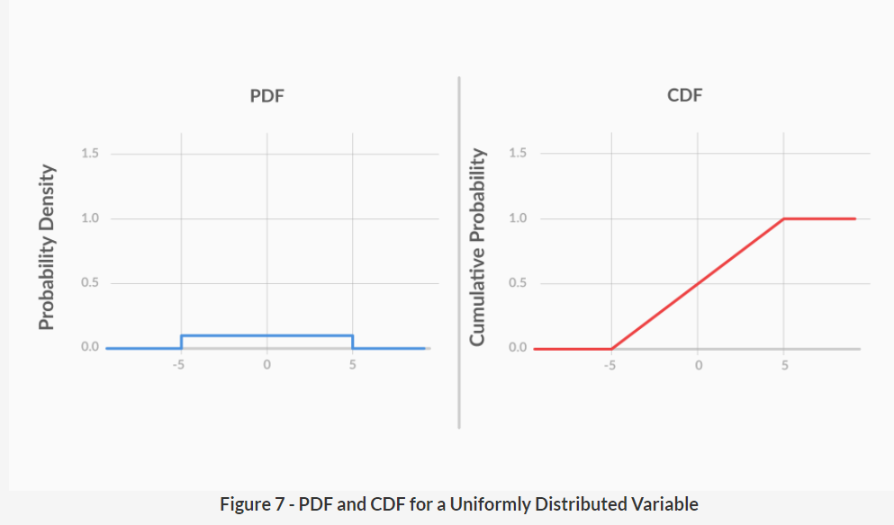

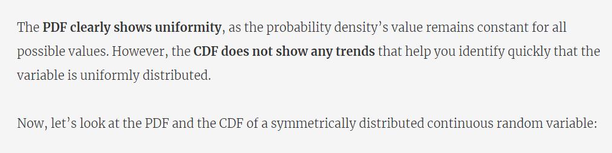

A **distribution is symmetrical if** a vertical line can be drawn at some point in the histogram such that the shape to the left and the right of the vertical line are mirror images of each other.

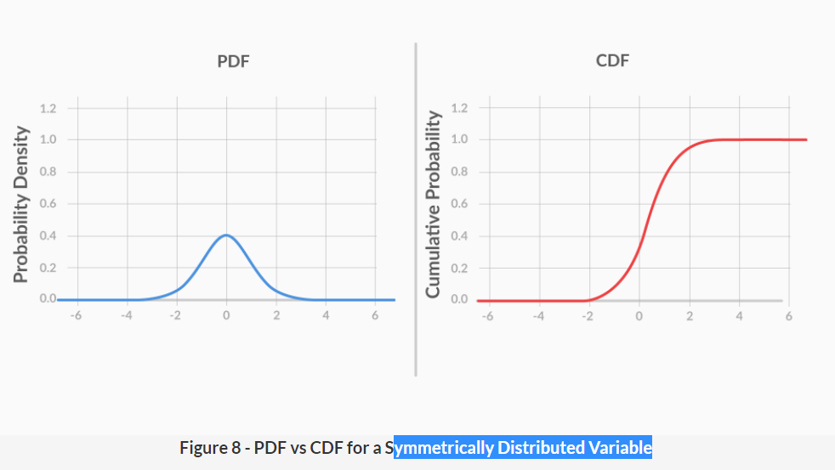

Again, it is clear that the symmetrical nature of the variable is much more apparent in the PDF than in the CDF.  
Hence, generally, PDFs are used more commonly that CDFs.

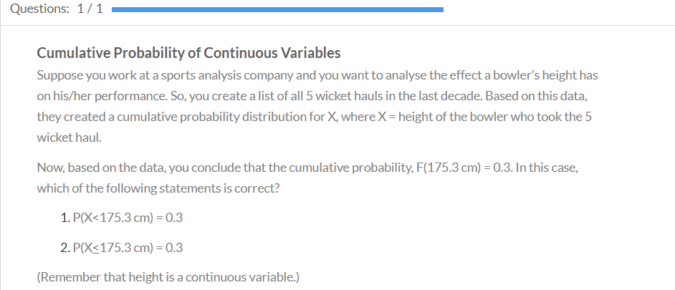

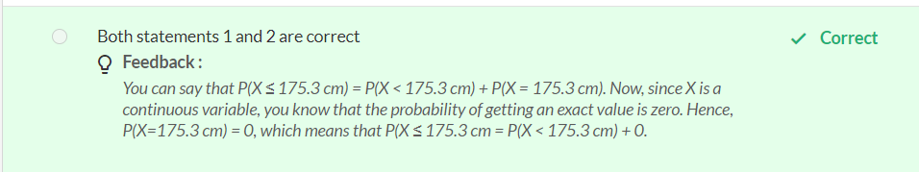

# Normal Distribution

You saw how the probability distributions of continuous random variables differ from those of discrete random variables.  
But can you think of some examples of continuous distributions? Which is the most commonly used continuous probability distribution? Which distribution occurs most commonly in nature?

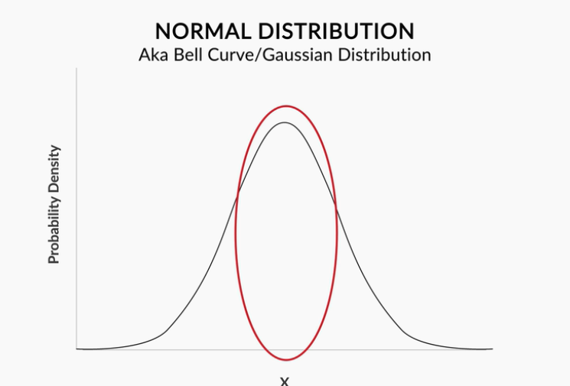

1. Most of the values lie around the middle.

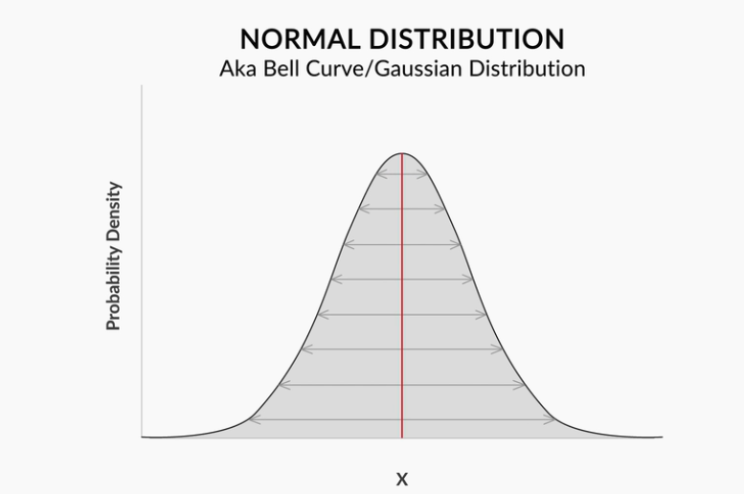

Above diagram shows Normal distribution is Symmetric distribution on both the sides.

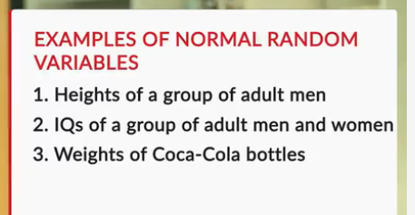

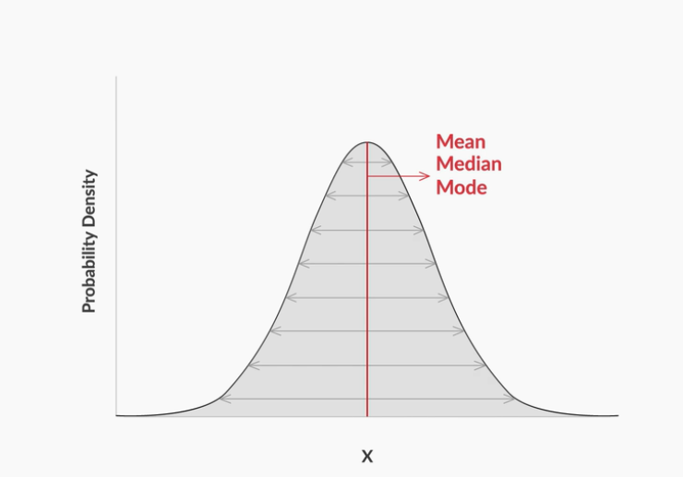

Here mean, median and mode all lie in the same line.

Normally distributed data follows the **1-2-3 rule**. This rule states that there is a:

1. **68%** probability of the variable lying **within 1 standard deviation(refer the below diagram)** of the mean,
2. **95%** probability of the variable lying **within 2 standard deviations(refer the below diagram)** of the mean, and
3. **99.7%** probability of the variable lying **within 3 standard deviations(refer the below diagram)** of the mean.

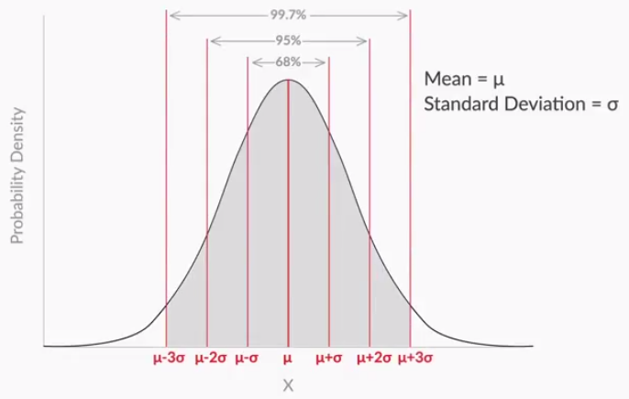

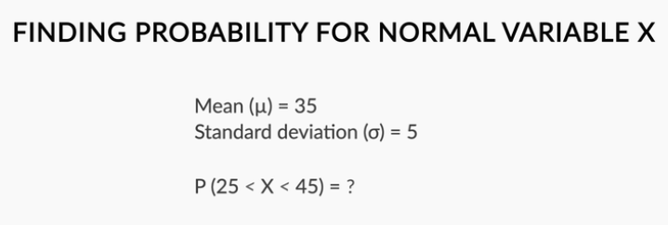

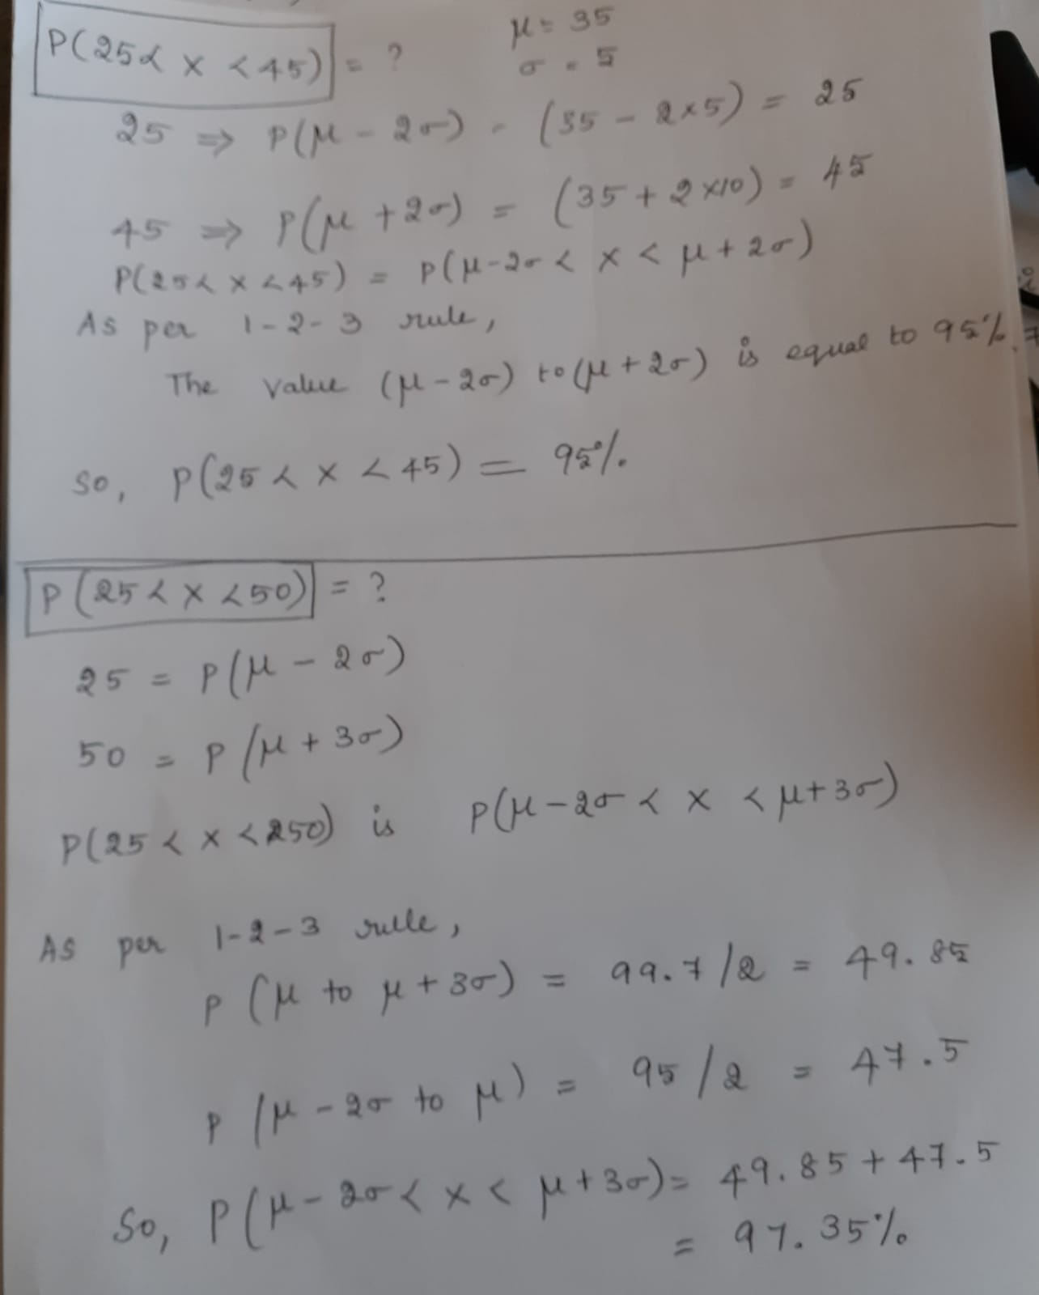

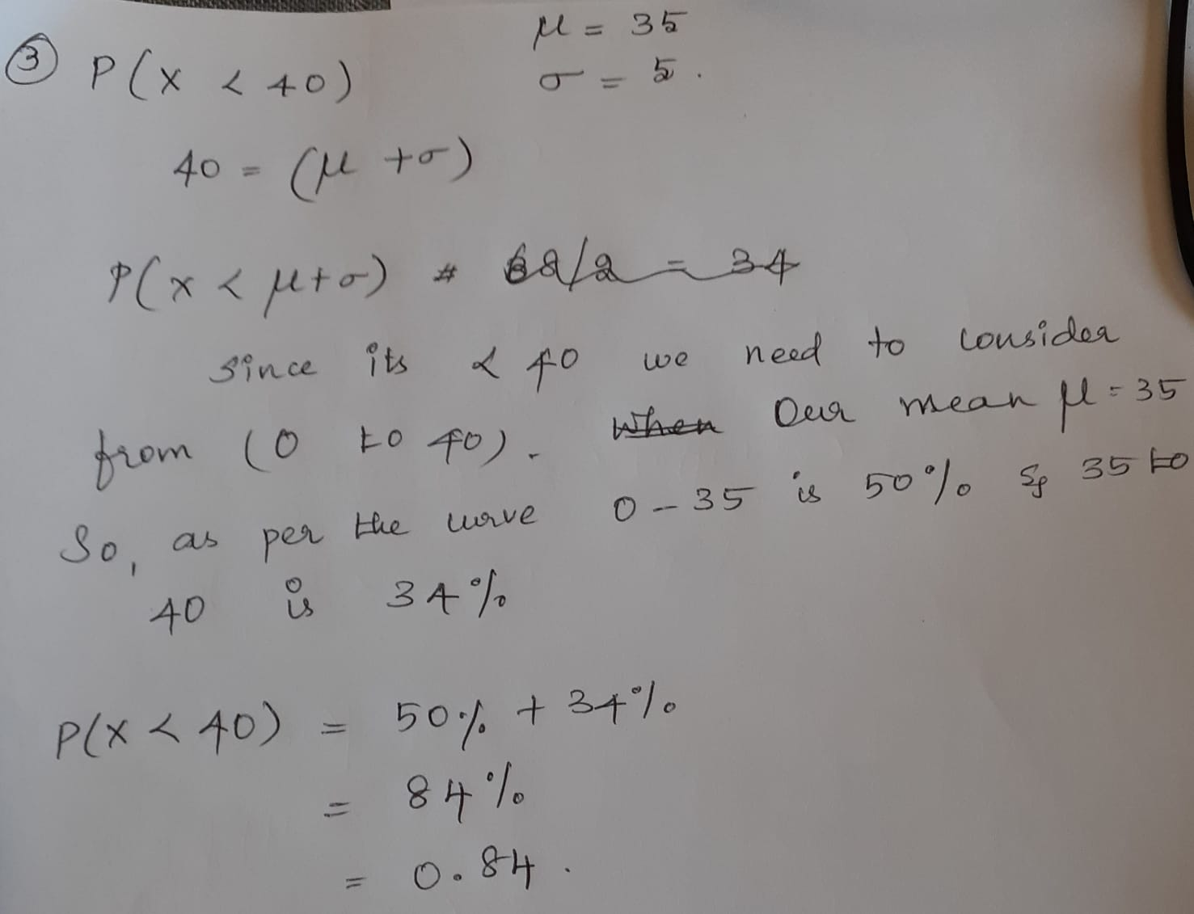

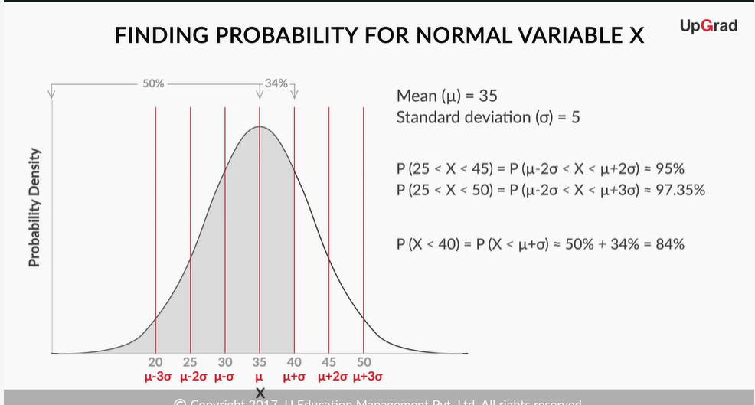

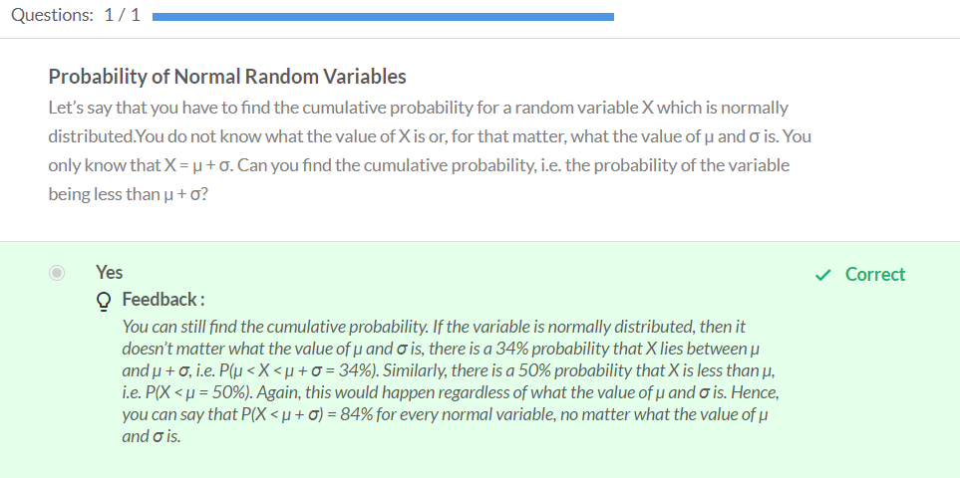

# Standard Normal Distribution

As you learnt in the previous question, it doesn’t matter what the values of µ and σ are. If you want to find the probability, all you need to know is how far the value of X is from µ, and specifically, what **multiple of σ** is the **difference between X and µ**.

Consider mean = 35 and Standard deviation is 5. Our Random variable x = 43.5.

We have to find how far the 43.25 from 35. It is 8.25 or we can say as 1.65 standard deviation.

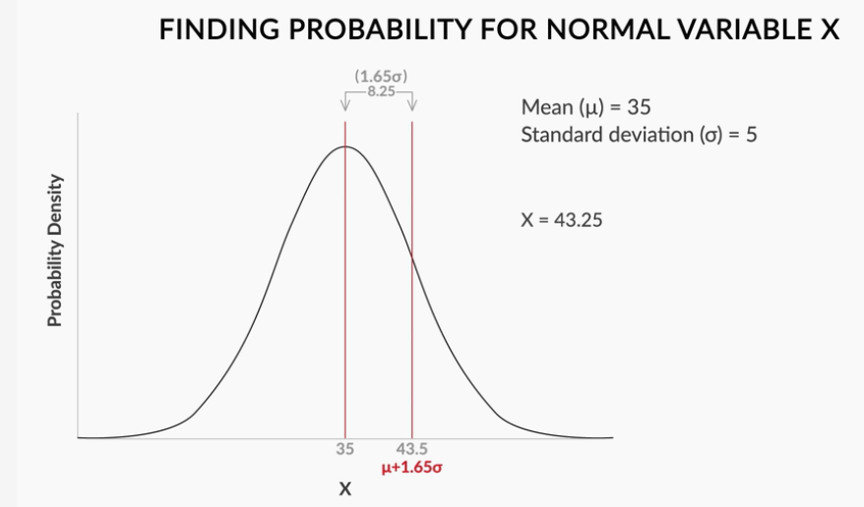

This value 1.65 SD is the Z score of the random variable.

the **standardised random variable** is an important parameter. It is given by:

Z=X−μ/σ

**Find P(-2<Z<2)**

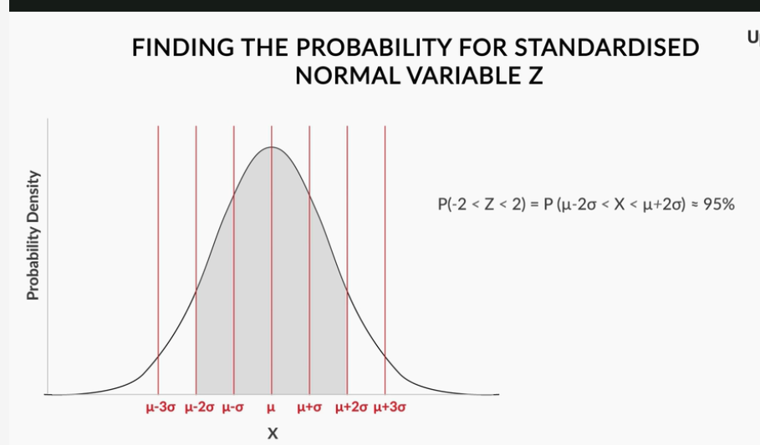

Calculate same as before - Finding the Probability of a Random Variable X.

**Find P(-2<Z<3)**

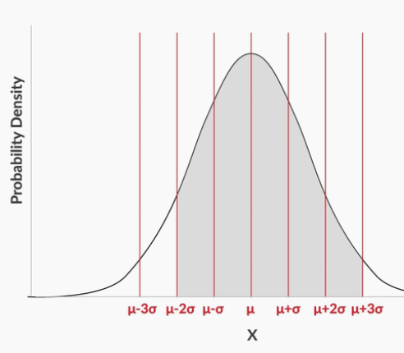

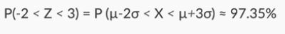

**Find P(Z<1)**

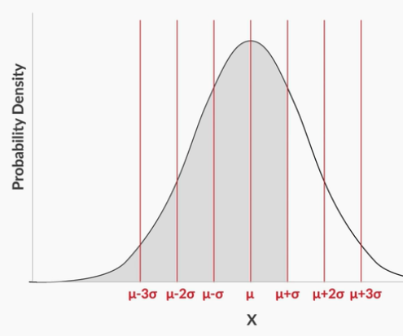

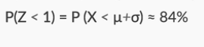

**X Vs Z**

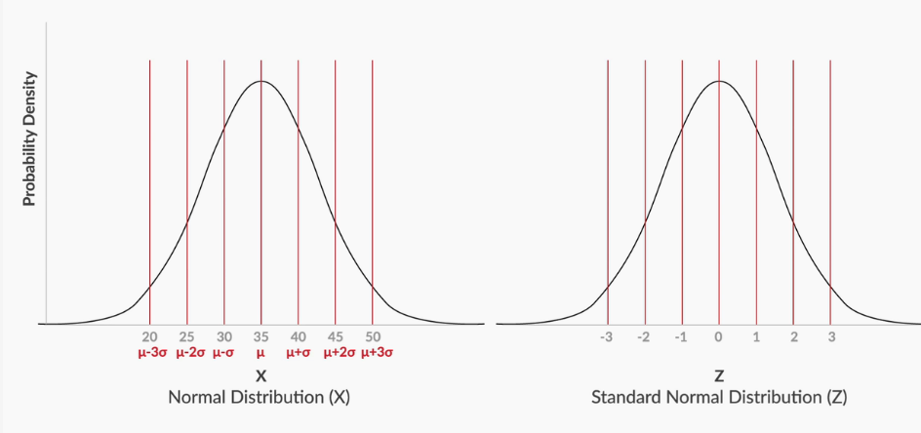

Here, we are able to find the value of Z = -3 to +3. If we want to find the the cumulative probability for Z = 0.68.In these cases, we need to use Z – Table.

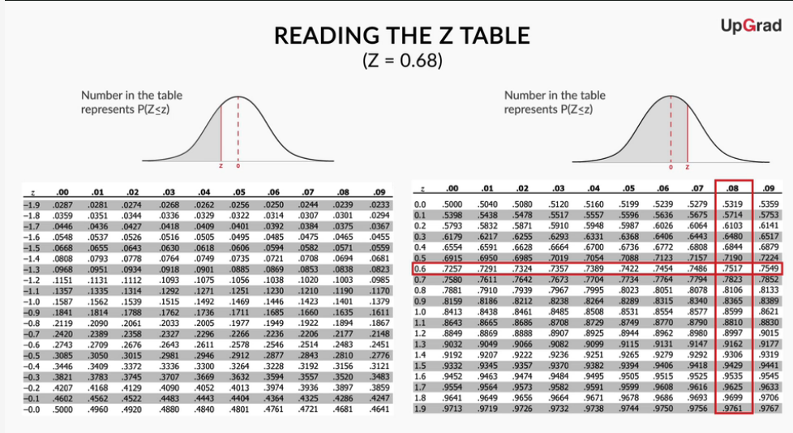

The Cumulative probability for Z = 0.68 is 0.7517



Now, lets find the probability of Employee commute time < 43.25 using Z table.

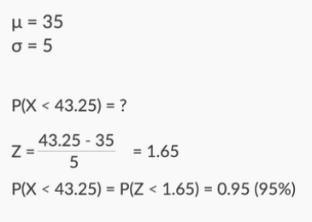

First find the Z value using the formula Z=X−μ/σ. We will get Z = 1.65.

Now use the Z- table and find the value for 1.65

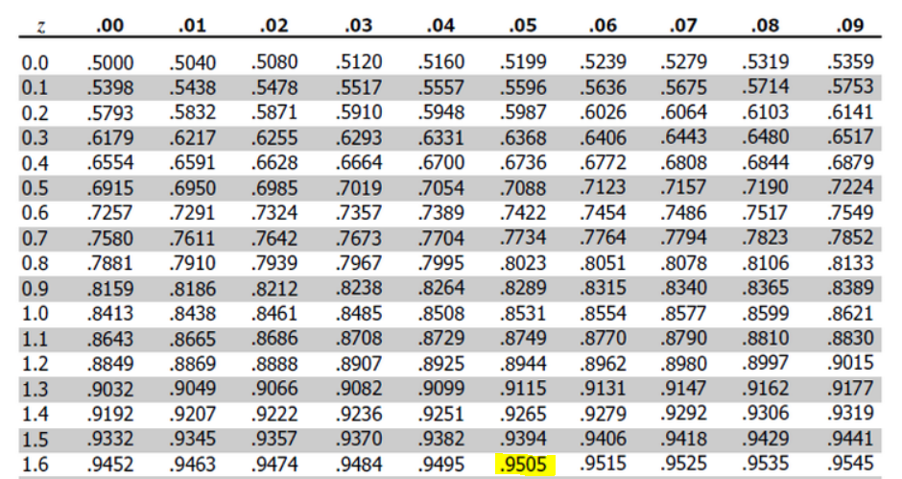

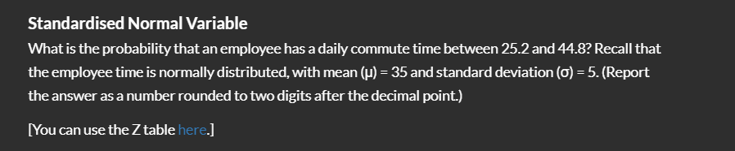

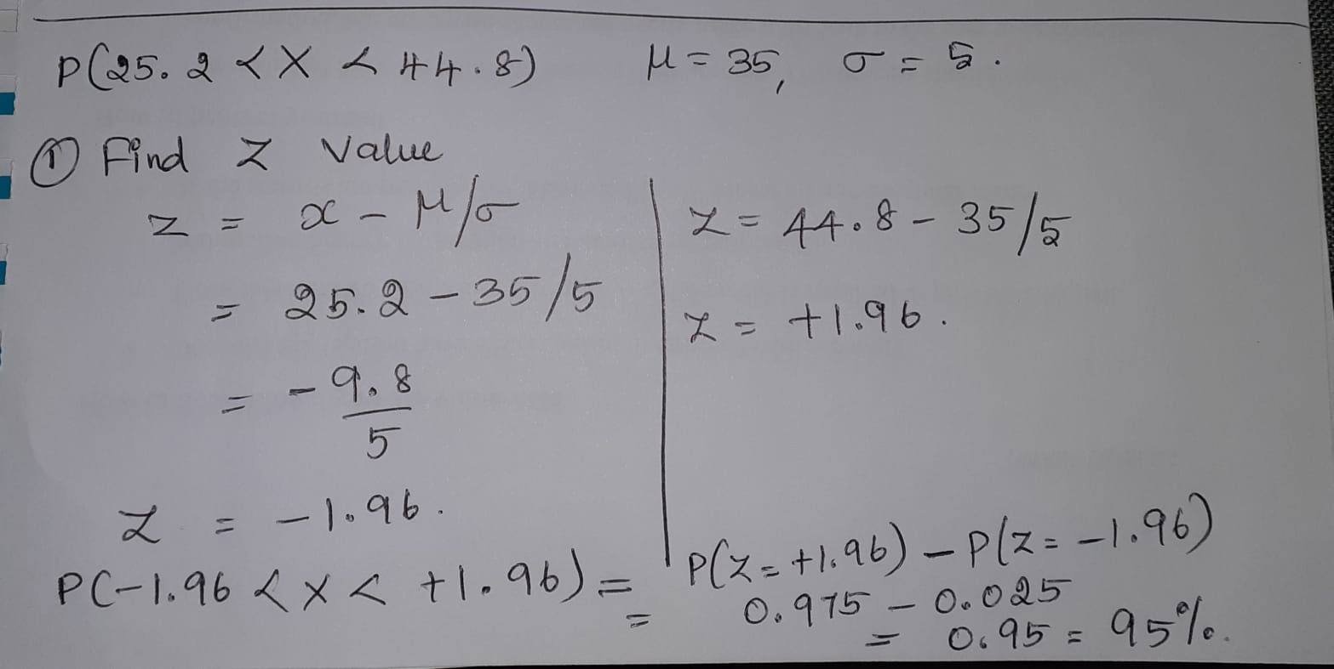

Use Z table for finding the value for +1.96 and -1.96

As you just learnt, the **standardised random variable** is an important parameter. It is given by: Z=X−μ/σ

Basically, it tells you **how many standard deviations away from the mean** your random variable is. As you just saw, you can find the cumulative probability corresponding to a given value of Z, using the **Z table**:

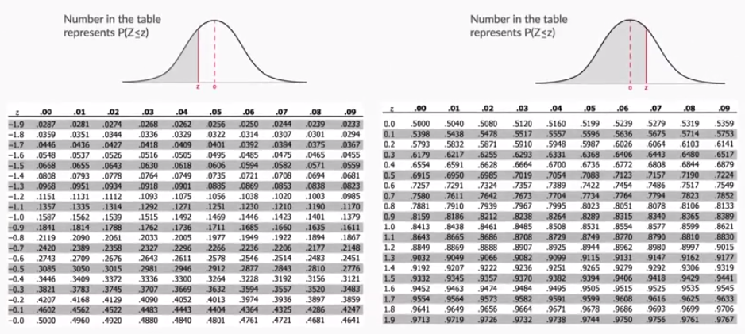

**Figure 11 - Z Table**

You can also use **Excel** to find the cumulative probability for Z. For example, let’s say you want to find the cumulative probability for Z = 1.5. In the Excel sheet, you will type:

= NORM.S.DIST(1.5, TRUE)

Basically, the syntax is:

= NORM.S.DIST(z, TRUE)

 Here, z is the value of the Z score for which you want to find the cumulative probability. TRUE = find cumulative probability, FALSE = find probability density.

Also, you can find the probability without standardising. Let’s say that X is normally distributed, with mean (μ) = 35 and standard deviation (σ) = 5. Now, if you want to find the cumulative probability for X = 30, you would type: = NORM.DIST(30, 35, 5, TRUE)

Basically, the syntax is: = NORM.DIST(x, mean, standard_dev, TRUE)

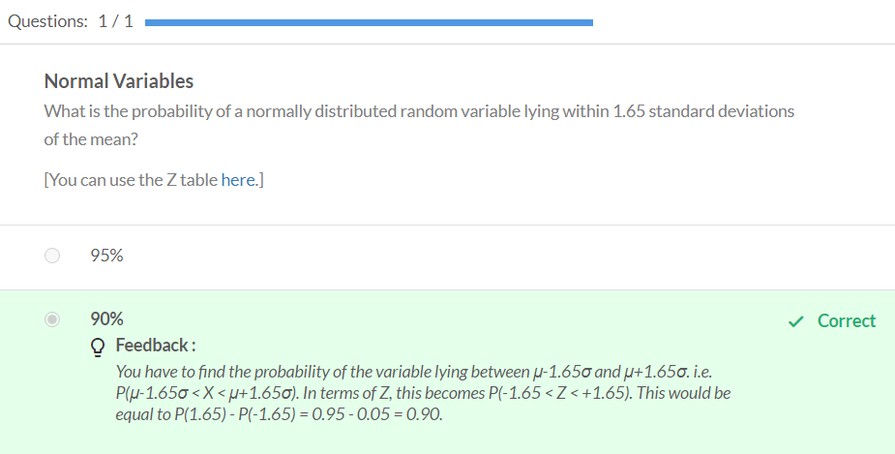

The **value of σ**affects the **shape** of the normal distribution. This will be true of any graph, not just a normal distribution. A **low**value of σ means that the graph is **narrow**, while a **high** value implies that the graph is **wider**. This is because a wider graph has more values away from the mean, resulting in a high standard deviation.

**Summary: Continuous Probability Distributions**

You started this session by learning that for a **continuous random variable**, the **probability of getting an exact value is** very low, almost **zero**. Hence, when talking about the probability of continuous random variables, you can only talk **in terms of intervals**. For example, for a particular company, the probability of an employee’s commute time being exactly equal to 35 minutes was zero, but the probability of an employee having a commute time between 35 and 40 minutes was 0.2.

Hence, for continuous random variables, **probability density functions** (**PDFs**) and **cumulative distribution functions** (**CDFs**) are used instead of the bar chart type of distribution used for the probability of discrete random variables. These functions are preferred because they talk about probability in terms of intervals.

Then, you understood that the major difference between a PDF and a CDF is that in a CDF, you can find the cumulative probability directly by checking the value at x. However, for a PDF, you need to find the area under the curve between the lowest value and x to find the cumulative probability.

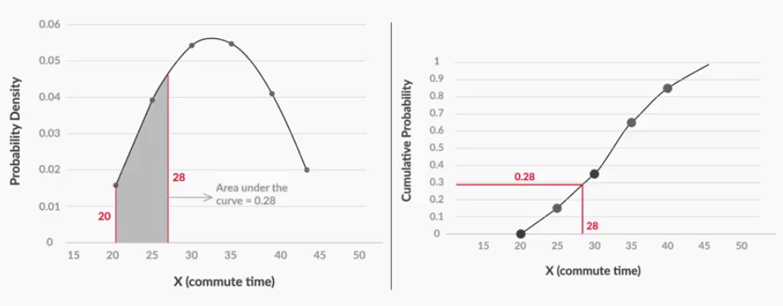

**Figure 12 - PDFs vs CDFs**

You also learnt that **PDFs are still more commonly used**, mainly because it is very **easy to see patterns** in them. For example, for a uniformly distributed variable, the PDF and CDF look like this:

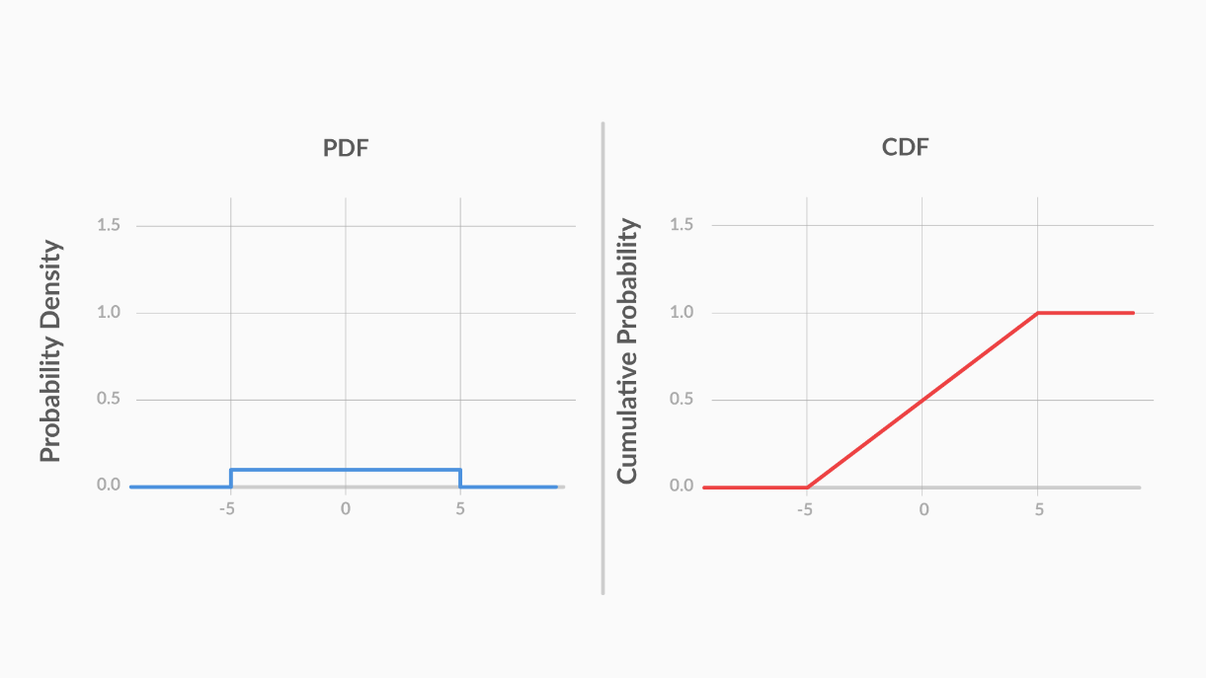

**Figure 13 - PDF and CDF for a Uniformly Distributed Variable**

While the PDF clearly shows that the variable is uniformly distributed, the CDF does not offer any such quick insights.

Next, you learnt about a very famous probability density function: the **normal distribution**. You saw that it is **symmetric**, and its **mean, median and mode** lie at the **centre**.

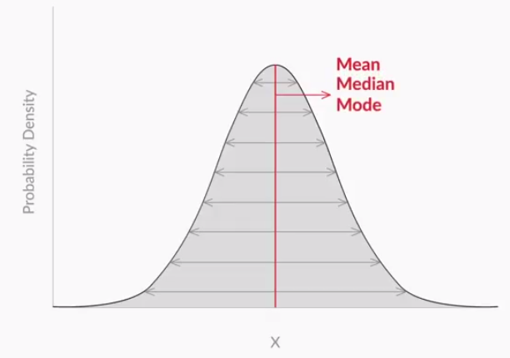

**Figure 14 - Normal Distribution**

You also learnt the **1-2-3 rule**, which states that there is a:

1. **68%** probability of the variable lying **within 1 standard deviation** of the mean,
2. **95%** probability of the variable lying **within 2 standard deviations** of the mean, and
3. **99.7%** probability of the variable lying **within 3 standard deviations** of the mean.



**Figure 15 - 1-2-3 Rule for the Normal Distribution**

Then, you learnt that to find the probability, you do not need to know the value of the mean or the standard deviation; just knowing **the number of standard deviations away from the mean** your random variable is suffices. That is given by:

Z=(X−μ/σ)

This is called the **Z score**, or the **standard normal variable**.

Finally, you learnt how to find the cumulative probability for various values of Z using the **Z table**. For example, you found the cumulative probability for Z = 0.68 using the Z table.

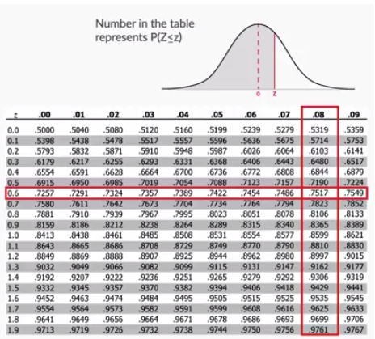

**Figure 16 - Z Table**

The intersection of row '0.6' and column '0.08', i.e., 0.7517, is your answer.

Also, you learnt how to use Excel to find this probability. For example, the cumulative probability for Z =1.5 can be found using Excel by typing:

= NORM.S.DIST(1.5, TRUE)

Also, you can find the probability without standardising. The syntax for that is:

= NORM.DIST(x, mean, standard_dev, TRUE)

A normal distribution finds use in many statistical analyses. In the next session, you will learn about its use in the central limit theorem, which is, in turn, useful for understanding the next module on hypothesis testing.

# Practice Questions

Let’s say you **work as an analyst** at a **pharma company**, which manufactures an antipyretic drug (tablet form) with **paracetamol** as the active ingredient. The amount of paracetamol specified by the drug regulatory authorities is **500 mg** with a **permissible error** of **10%**. Anything below 450 mg would be a quality issue for your company, as the drug will be ineffective, while any amount above 550 mg would lead to a serious regulatory issue.

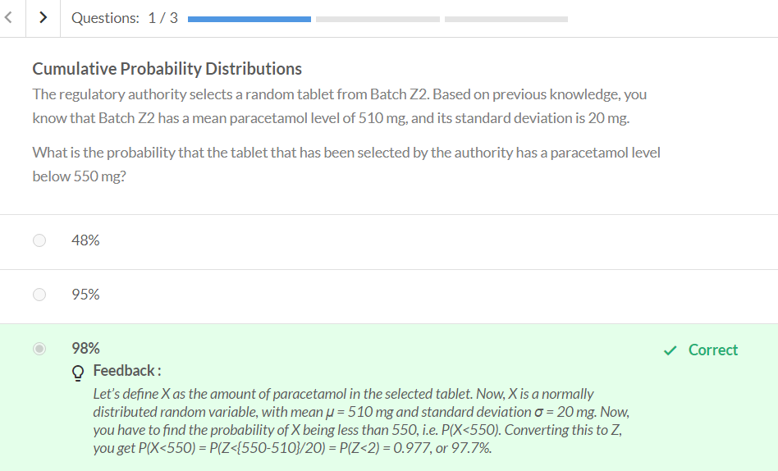

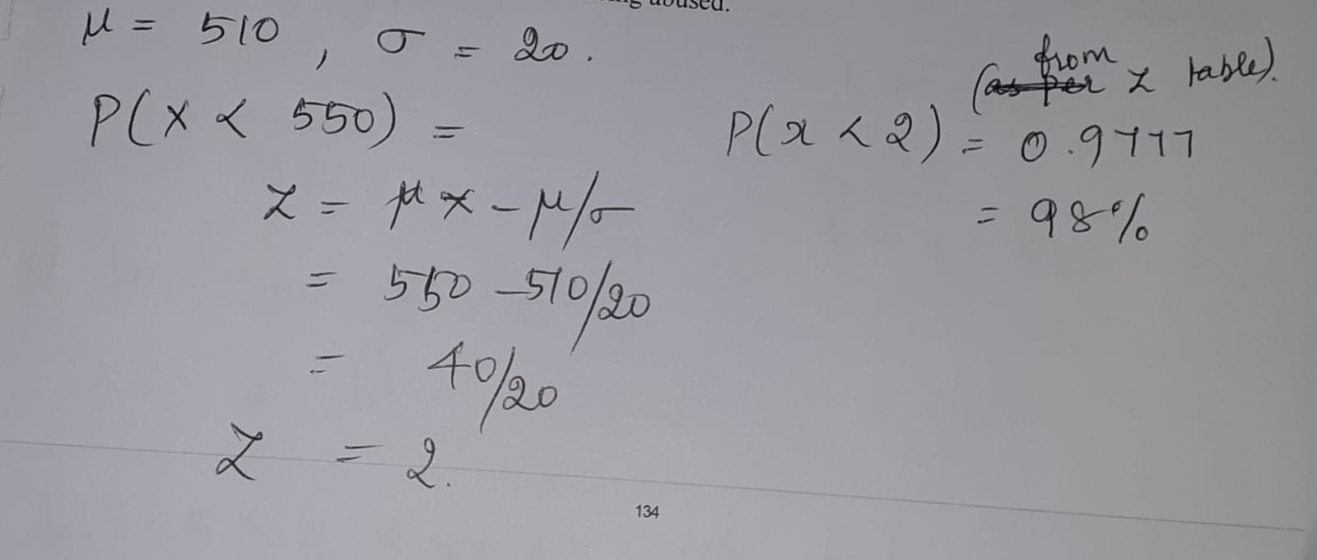

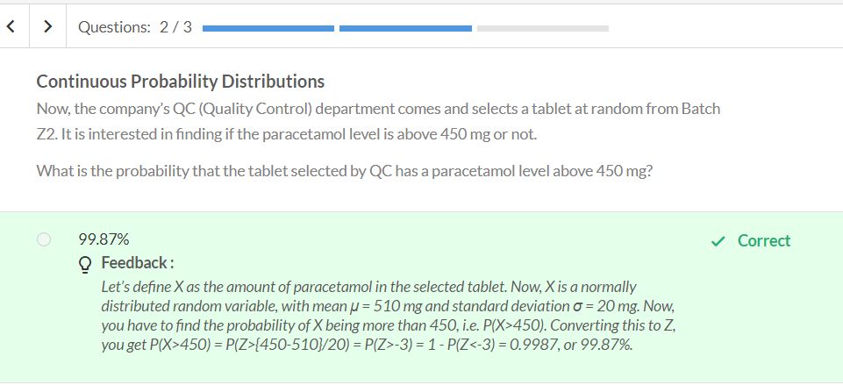

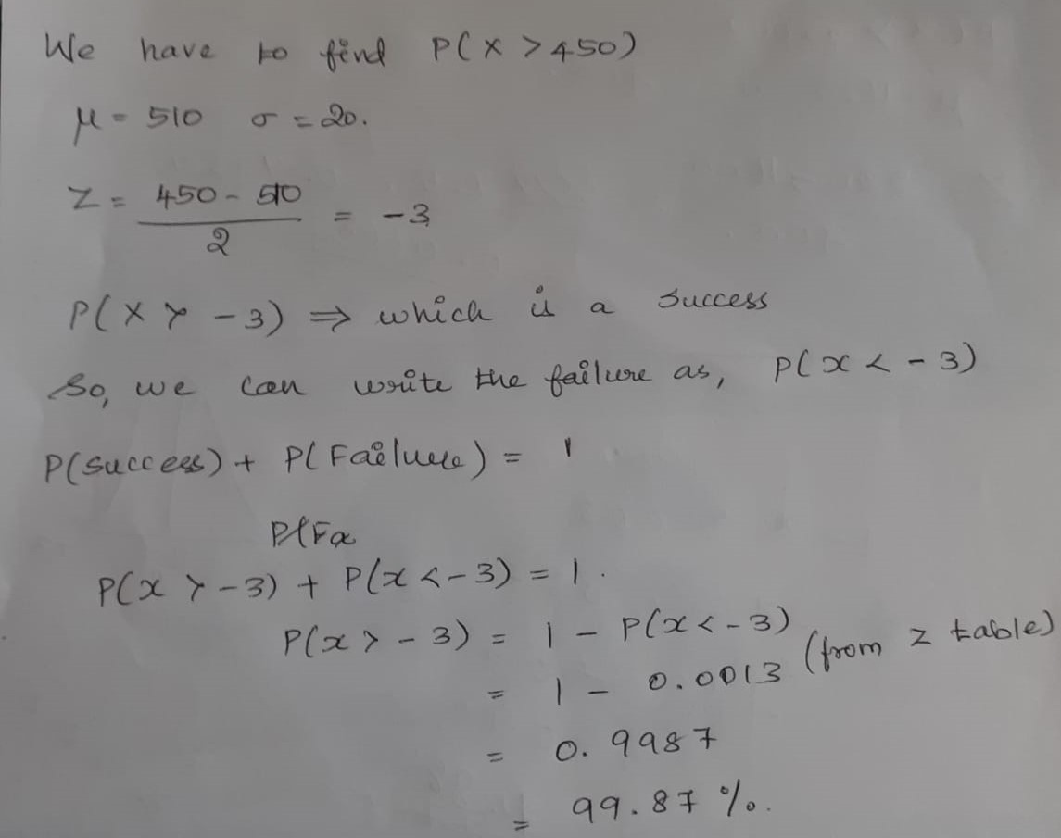

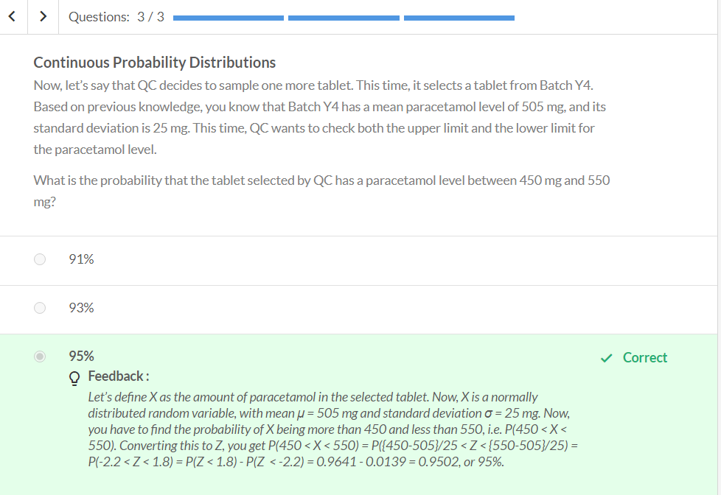

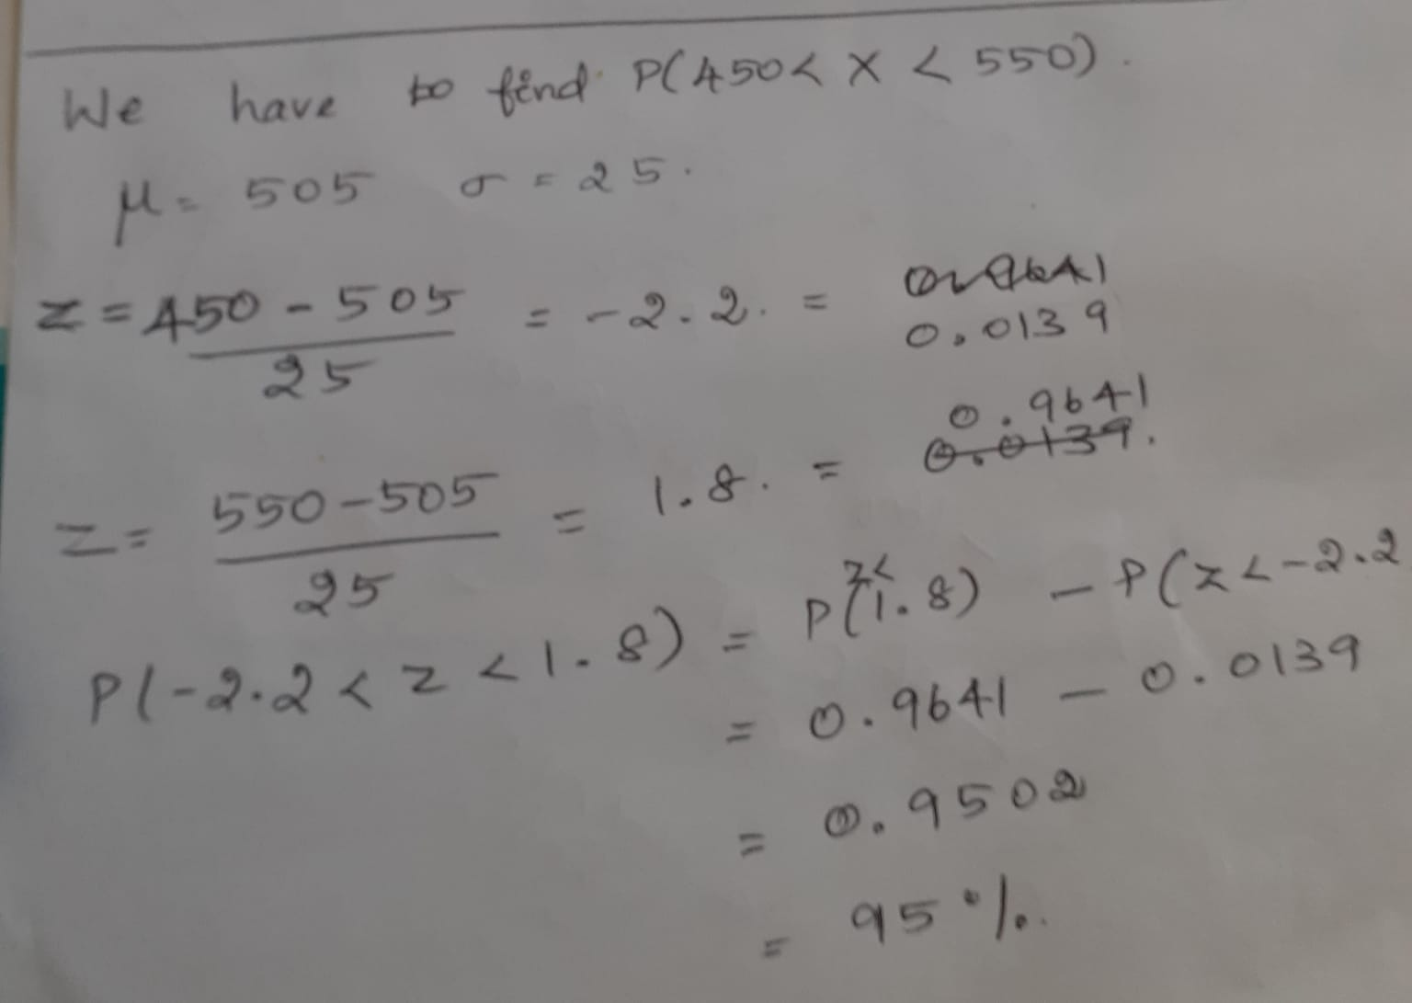

# Graded Questions

**Figure 17 - Uniformly Distributed Variable (p = 0.1)**

The graph above represents the PDF of a uniformly distributed random variable X. As you can see, the probability density is equal for all the possible values of X (-5 to +5).

**Uniform Distribution**

What is the probability of the random variable X lying between -1.5 and +2.5, i.e. P(-1.5<X<2.5)?

**0.4**

**Feedback :**

*The probability of the variable lying between -1.5 and 2.5 would be equal to the area under the PDF, between X = -1.5 and X = 2.5. This would be equal to the area of a rectangle, with breadth 0.1 and length 2.5 - (-1.5) = 4. Multiplying the two, you get the area of the rectangle, which is equal to 0.1*4 = 0.4.*

The **normal distribution**, aka the **Gaussian distribution**, was discovered by **Carl Friedrich Gauss** in 1809. Gauss was trying to create a probability distribution for **astronomical errors**. Astronomical errors are the errors that were made by astronomers while observing phenomena such as distances in space.

For example, Gauss found that an astronomer trying to estimate the distance between Earth and Uranus always makes an error. This **error** is **normally distributed**, with **µ = 0 km** and **σ = 1,000 km**.

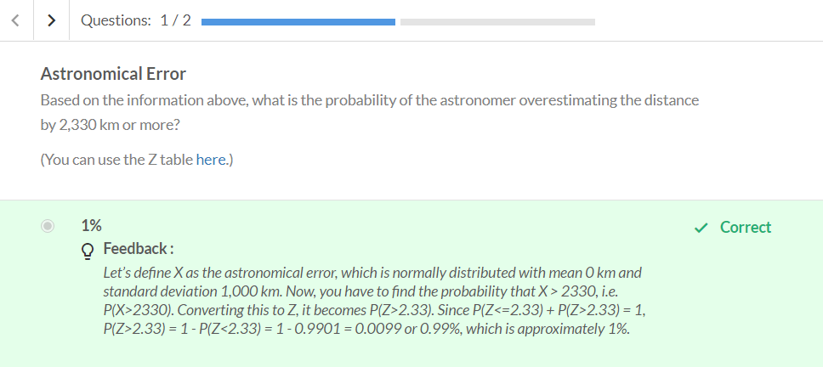

Refer – Practice question 2 (same approach) (Paracetamol level above 450mg)

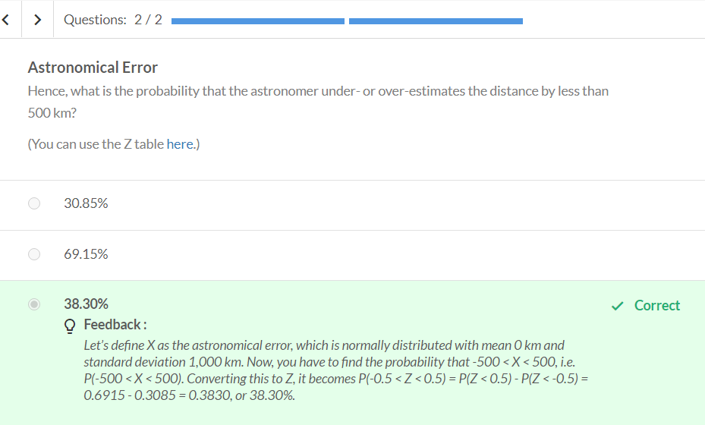

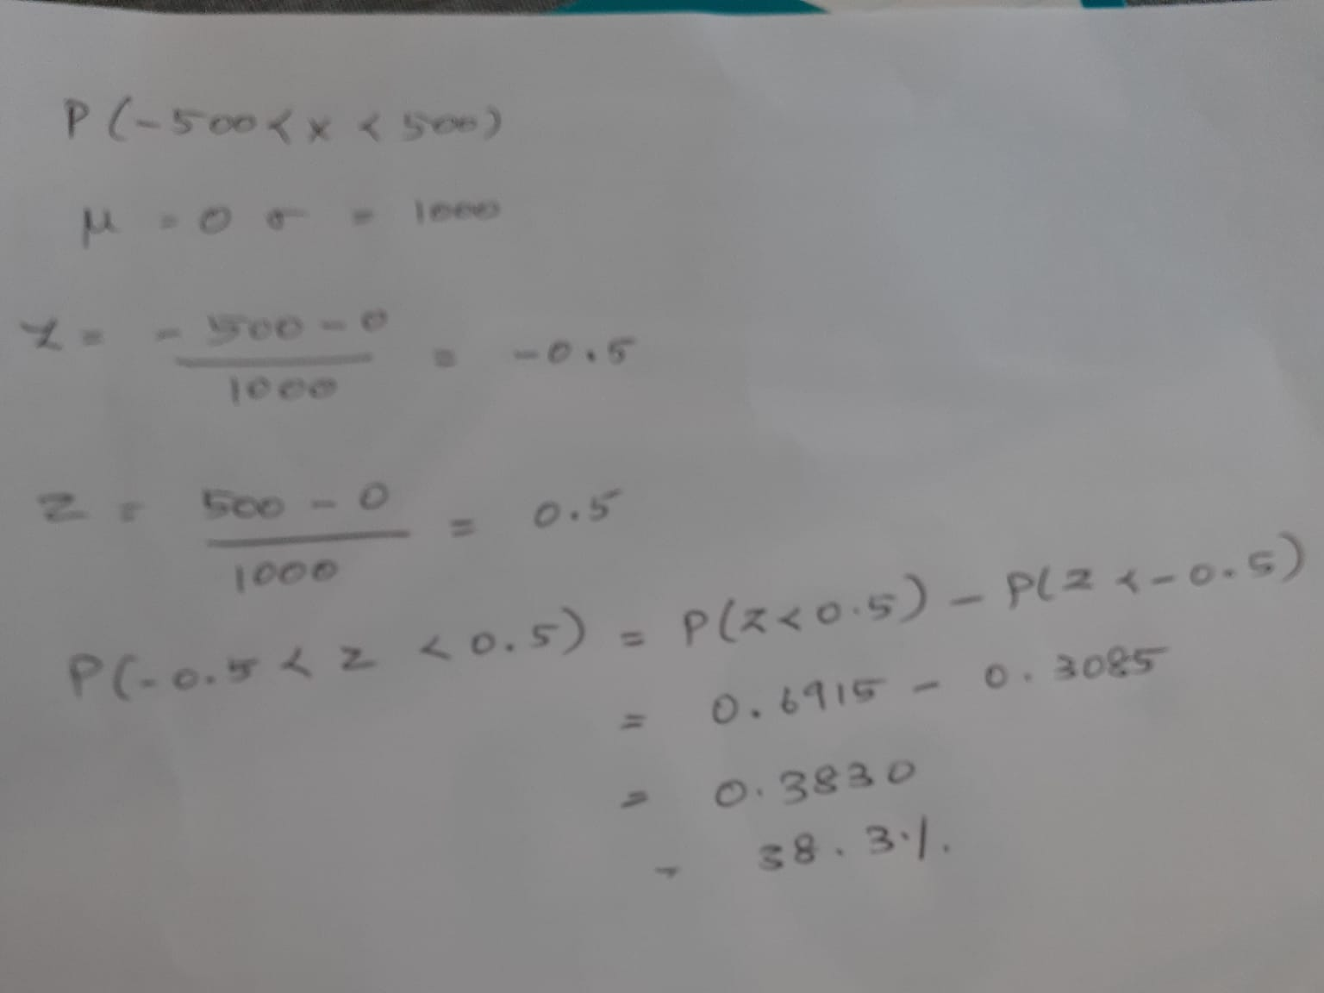

In the light of the heavy rains and the consequent floods in Kerala, the state government decided to find out how probable these types of rainfalls are during the month of August so that they can redesign the current state infrastructure and prepare themselves for such future events.

From historical data, it was found that the average rainfall received by Kerala in the month of August was  **1600 mm**with a standard deviation of **400 mm.** Assuming that the rainfall data follows a **normal distribution**,answer the following questions**.**

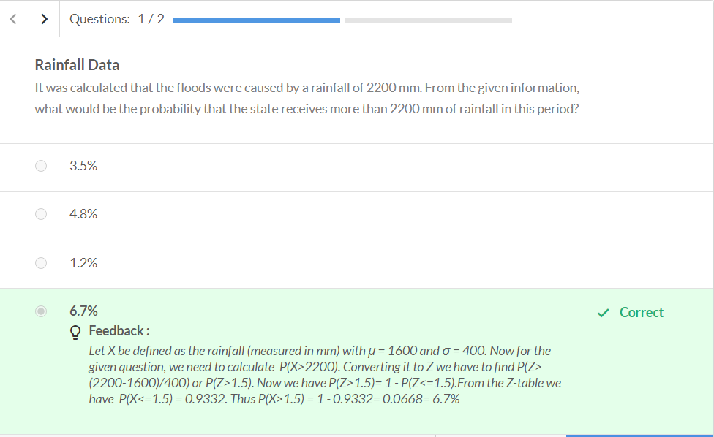

Refer – Practice question 2 (same approach) (Paracetamol level above 450mg)

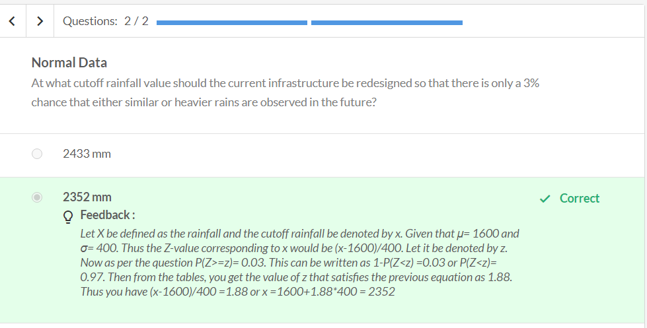

# Introduction: Central Limit Theorem

# Samples

So far, you have conducted analyses for data on 75 people, 3,000 people, and so on. But what if you need to analyse a very large amount of data, e.g., data on 3,00,000 people? Or, what if you need to do this for, say, the entire Indian population?  
Suppose for a business application, you want to find out the average number of times people in urban India visited malls last year. That’s 400 million (40 crore) people! You cannot possibly go and ask every single person how many times they visited the mall. That’s a costly and time-consuming process. How can you reduce the time and money spent on finding this number?

Terminology used:

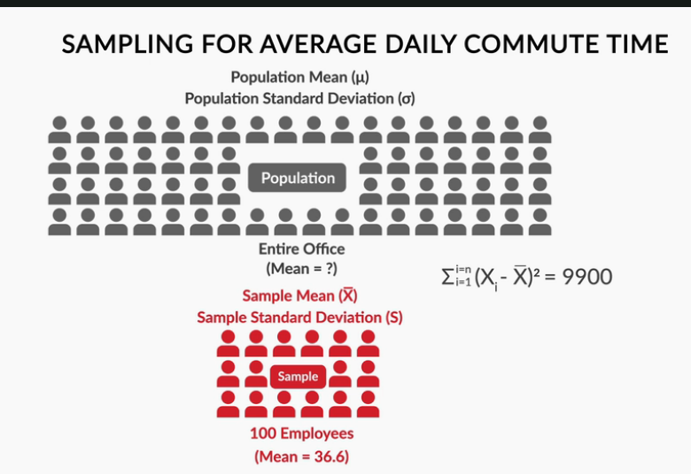

1.Sample

2.Population

3.Sample Mean

4.Population Mean

5. Sample Standard Deviation

6.Population Standard Deviation

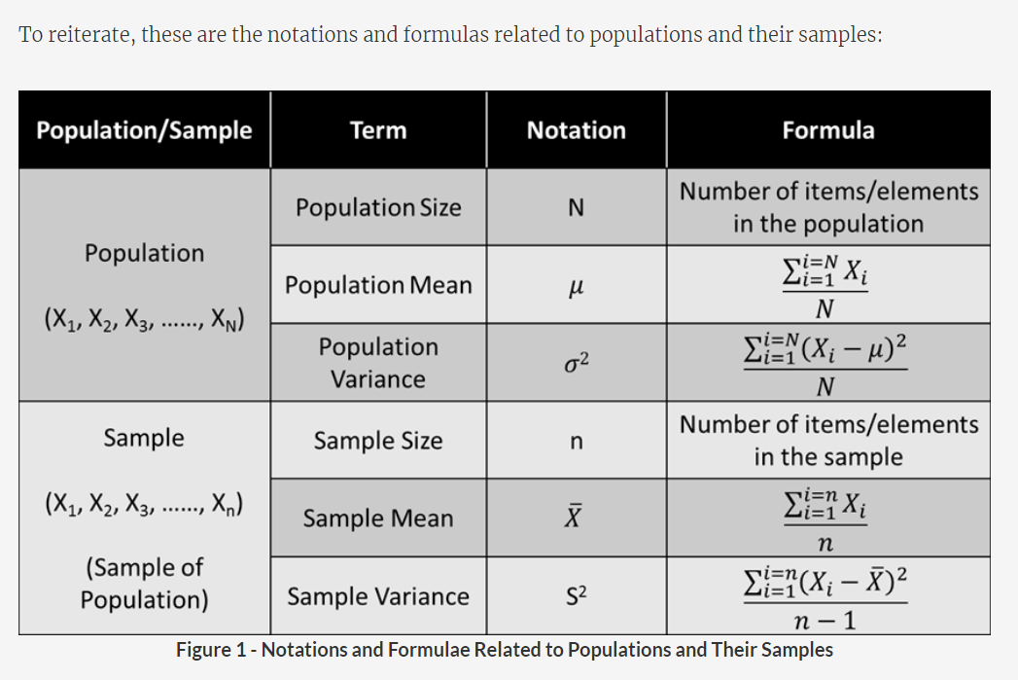

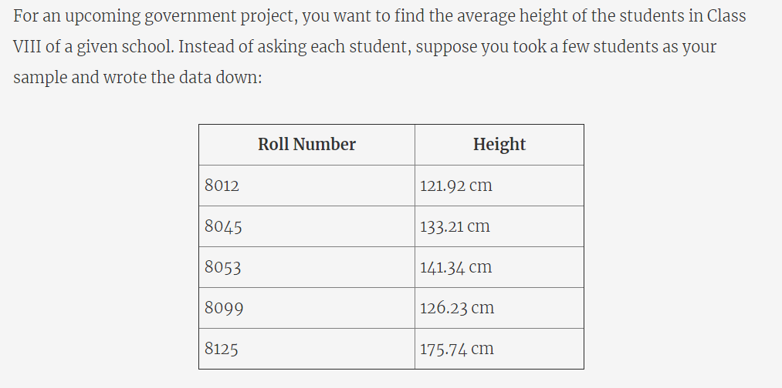

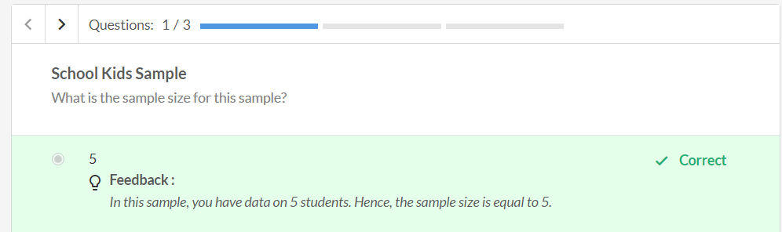

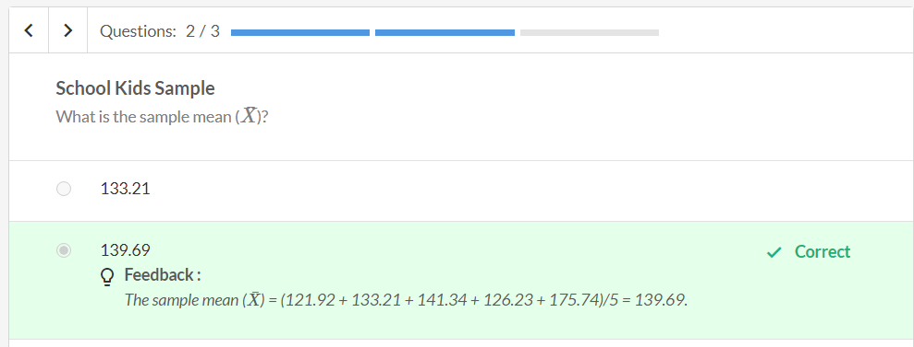

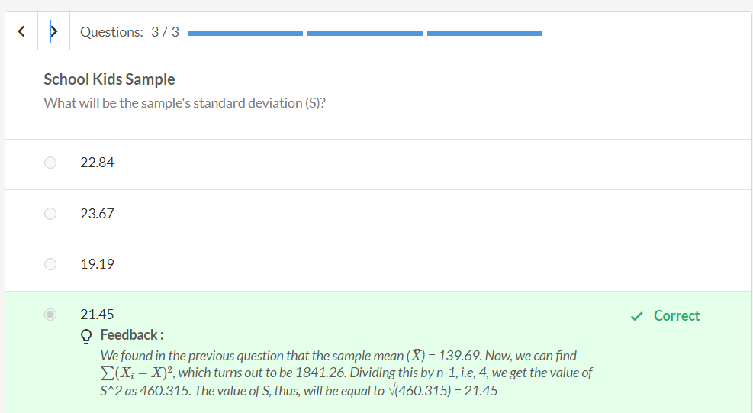



In case you want to read more about this feature, please refer to this [link](http://fortune.com/2017/03/22/facebook-fact-checking-tool/).

<https://fortune.com/2017/03/22/facebook-fact-checking-tool/>

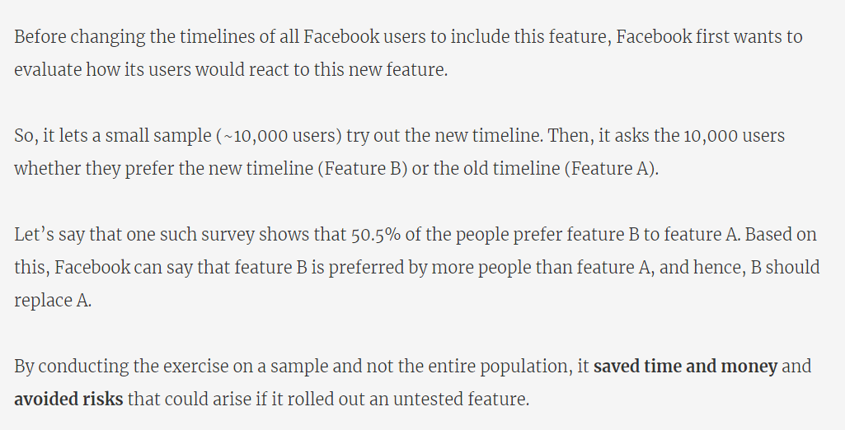

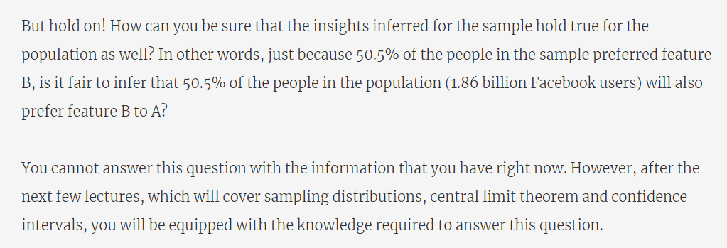

# Sampling Distributions

Now, let's move on to sampling distributions, whose properties, as we said earlier, will help you estimate the population mean from the sample mean.

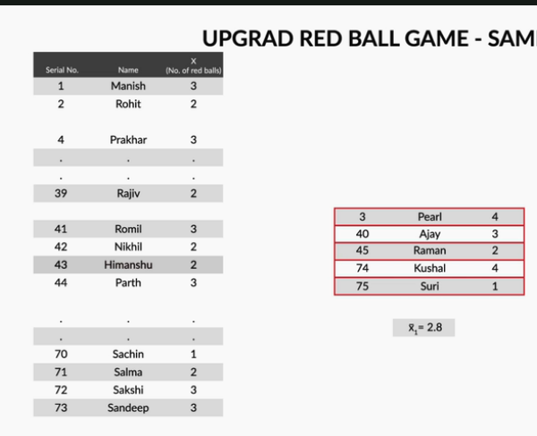

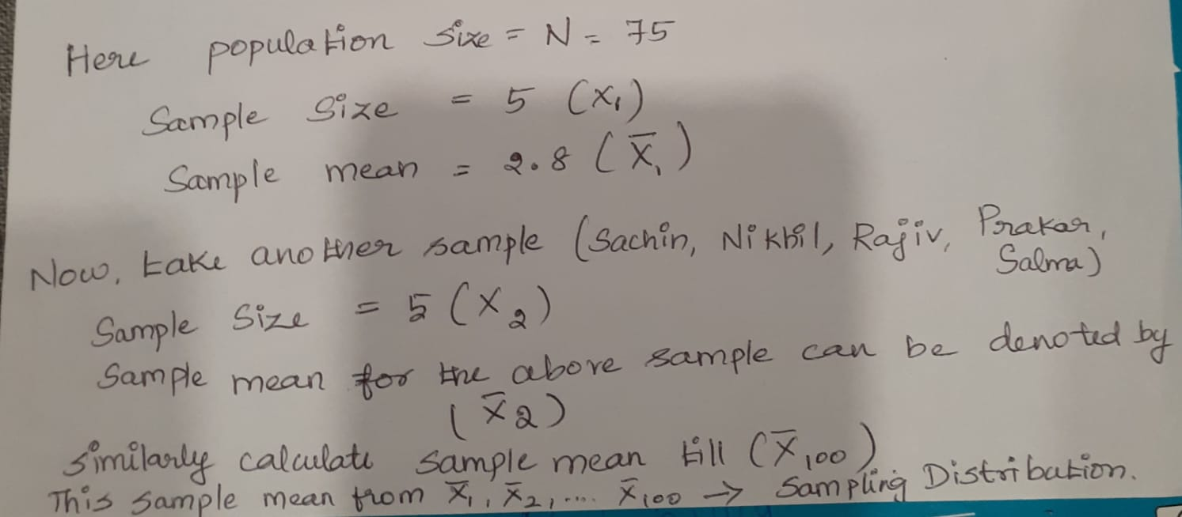

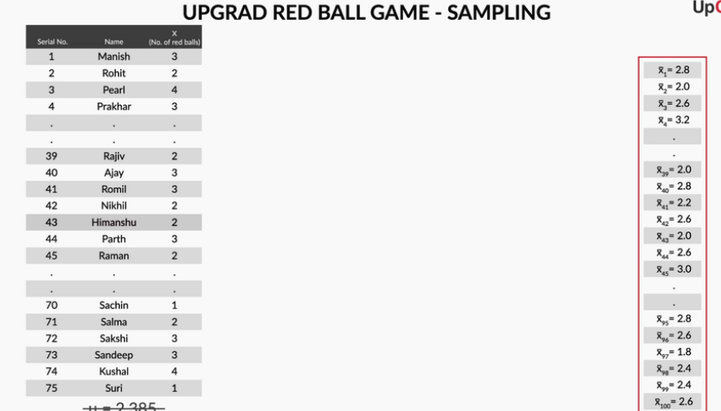

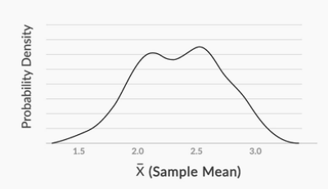

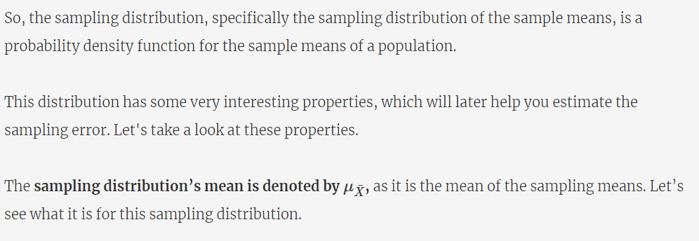

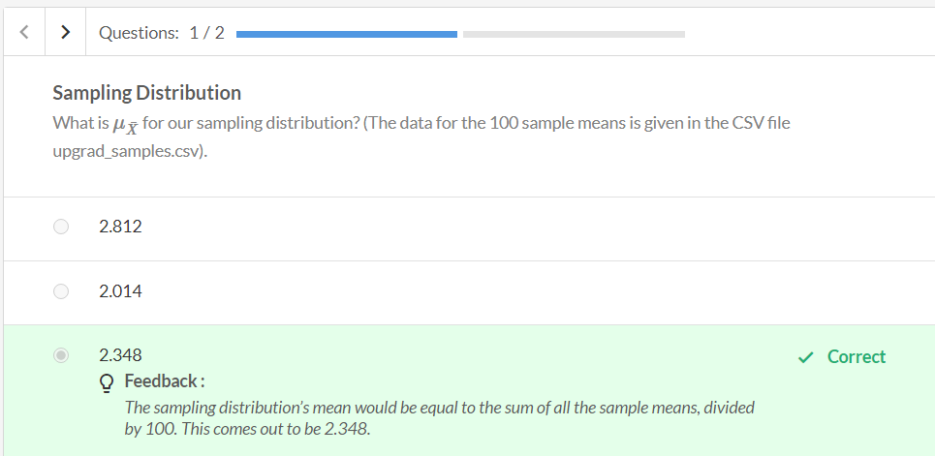

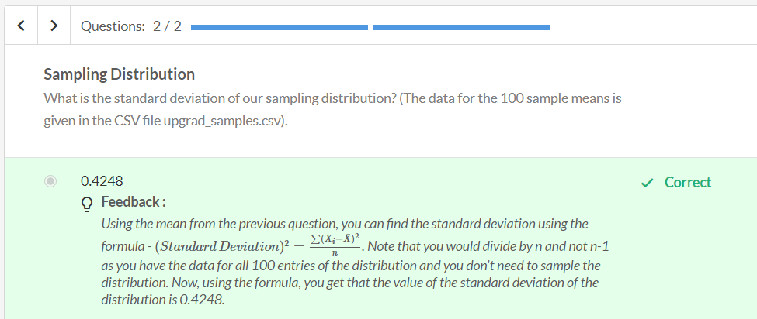

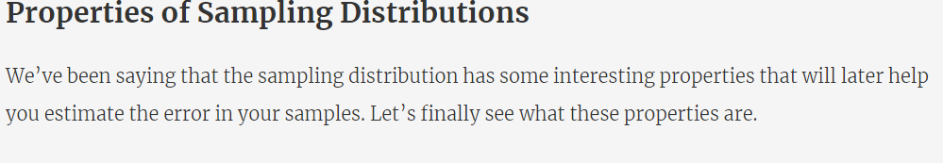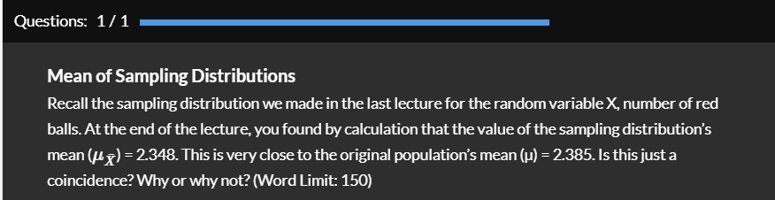



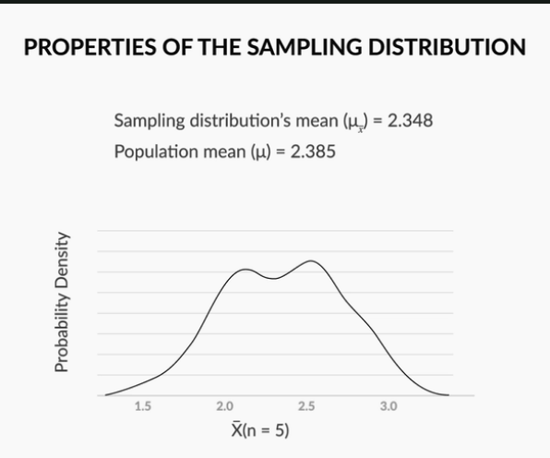

In the previous session we have taken the sample size of 5(each sample has 5 elements). For the we got the sample distribution mean value as 2.348. Refer the excel(Inferntial Statistics - UpGrad Samples.xlsx)

Overall population mean is 2.385. Now these sample distribution mean and population mean have slightly different values.

Lets increase the sample size to 20(contains 20 elements).

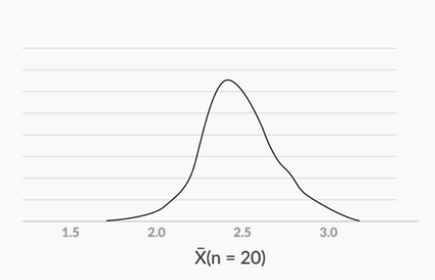

The Probability density distribution is less fat and more concentrated towards the centre than with sample size of n =5(contains 5 elements). This curve is narrower.

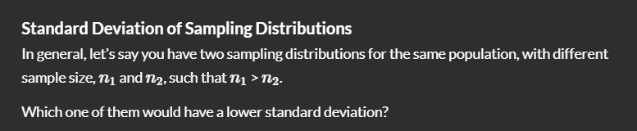

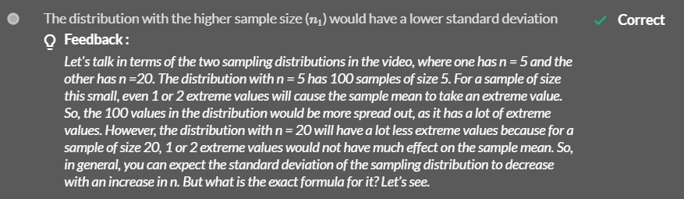

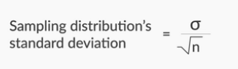

Where sigma = Standard deviation of the population and n is the sample size.

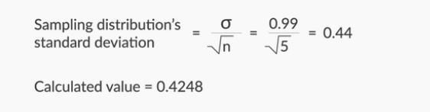

Now, the Sampling distributions standard deviation is 0.44. This value is now almost equal to the value which we have calculated(0.4248)

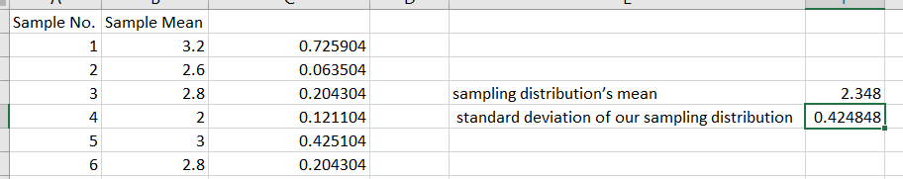

Refer the excel -Inferntial Statistics - UpGrad Samples.xlsx

Now, lets see the curve for various sample size.

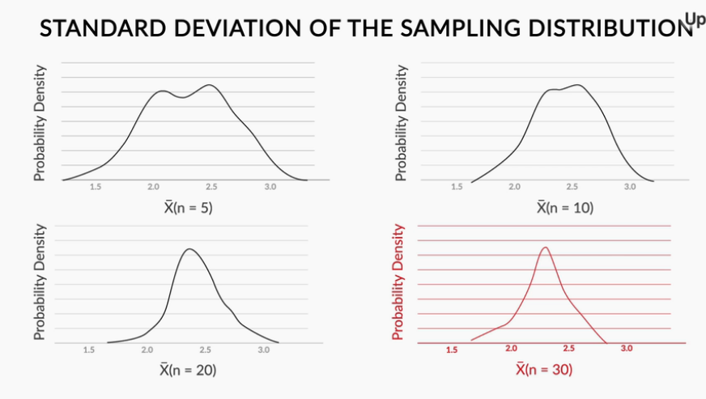

If the sample size is less, the curve is fatter, which means the values are farther apart(scattered). If the sample size is more, the curve is narrow, which means the values are lie close.

If the standard deviation(SD) is small(curve is narrow and the sample size is high) it means the sample mean value lie close to the population mean. Thus we can infer that our population mean is likely to be more accurate.

If the SD is high(curve will look fatter and the sample size is low) our sample mean value is

distributed widely around the population mean. So it is difficult to infer the accuracy of the population mean.

So, 

At this point,

1.we need to find the range in which the population mean is likely to lie.(Say if our

population mean is 0.256 whether we can say as +/-3,+/-1,+/-10 and so on.)

2.Next we need to identify how accurate/how we are confident at the inference. As our inference is based on the sample size we are not sure about the value/ range of our population mean.

Lets see how to verify those.

Recap of formulas

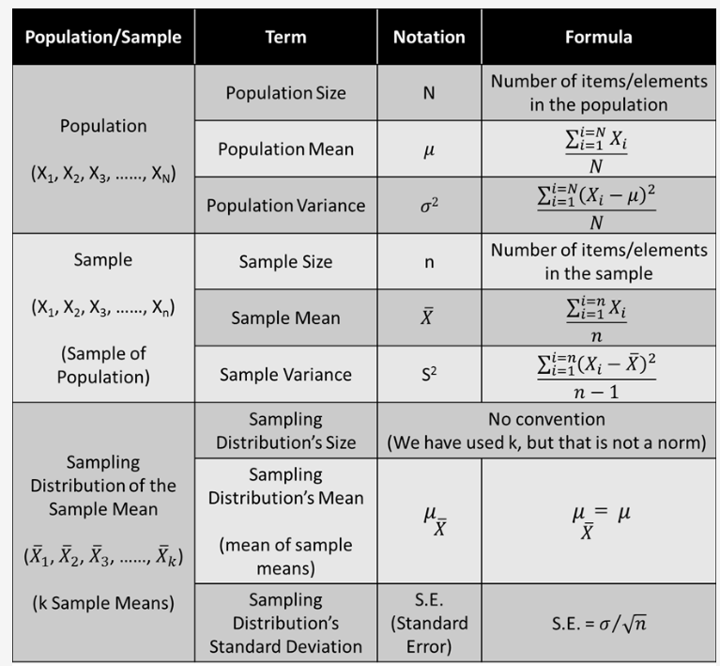

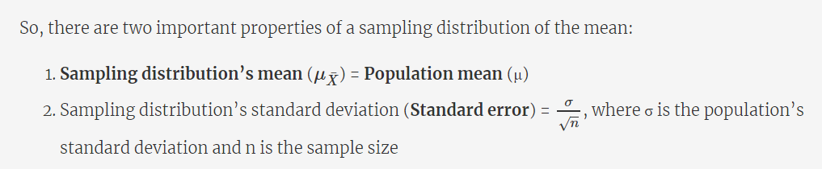

# Central Limit Theorem

You understood the third property of sampling distributions, which talks about their shape. Basically, it says that for n > 30(each sample has 30 or more elements), the sampling distributions become normally distributed.

If the sample size reaches 30, (refer the graph above). It becomes normally distributed.

If sample size less than 30, the curve approximately looks like normally distributed.

Let's recall all the three properties that you have learnt so far for sampling distributions.

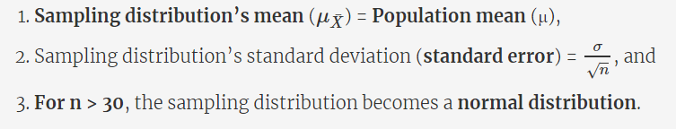

This is called **Central Limit Theorem**

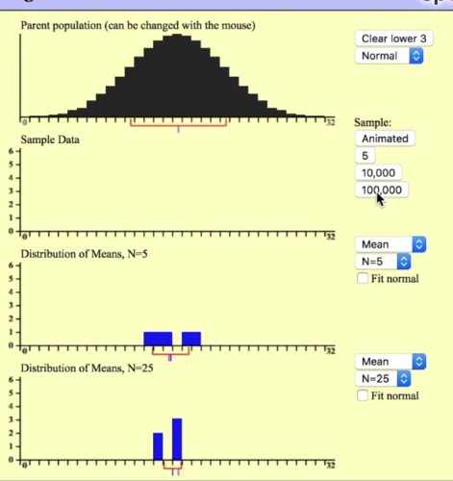

Here, we have taken five samples (in the third figure) and 25 samples(fourth figure) each of size 5.

Now, in the next step lets increase the sample size.

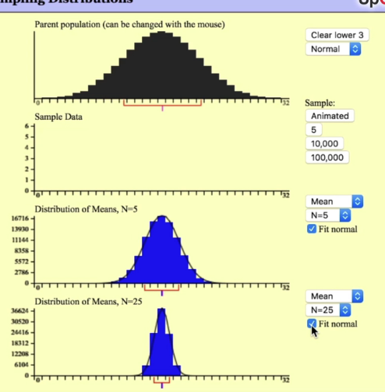

Here, we have taken five samples (in the third figure) and 25 samples (fourth figure) each of size 10000.

We get a normally distributed curve. This satisfies the third property of our central limit theorem.

In the above figure, (refer 1st diagram of the population) the distribution of the population is normal.

Now, lets change to some other distribution and find what happens to our sampling distribution.

Distribution – Skewed (refer 1st diagram)

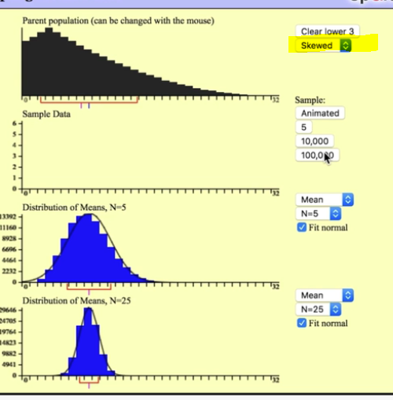

Distribution – Uniform (refer 1st diagram)

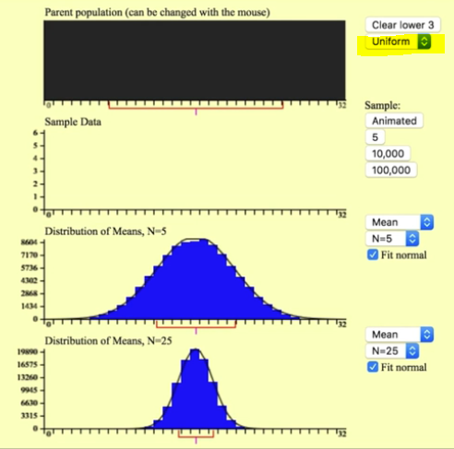

So what our Central Limit Theorem says,

**The central limit theorem tells us that no matter what the distribution of the population is, the shape of the sampling distribution will approach normality as the sample size (N) increases.**

Lets verify all these using the below demonstration.

CLT v0.1.ipynb – Refer this jupyter notebook for clear explanation

**Summary: Central Limit Theorem - Part I**

Let’s summarise everything that has been taught so far in this session, and then, you can move on to the rest of the session.

First, you saw how instead of finding the mean and standard deviation for the entire population, it is sometimes beneficial to find the **mean**and **standard deviation** for only a small representative **sample**. You may have to do this because of time and/or money constraints.

For example, for an office of 30,000 employees, we wanted to find the average commute time. So, instead of asking all employees, we asked only 100 of them and collected the data. We found the mean to be 36.6 minutes and the standard deviation to be 10 minutes.

However, it would not be fair to infer that the population mean is exactly equal to the sample mean. This is because the flaws of the sampling process must have led to some error. Hence, the sample mean’s value has to be reported with some **margin of error**.

For example, the mean commute time for the office of 30,000 employees would be equal to 36.6 + 3 minutes, 36.6 + 1 minutes, or 36.6 + 10 minutes, i.e., 36.6  minutes + some margin of error.

However, at this point in time, you do not exactly know how to find what this margin of error is.

Then, we moved on to sampling distributions, some of the properties of which would help you find this margin of error.

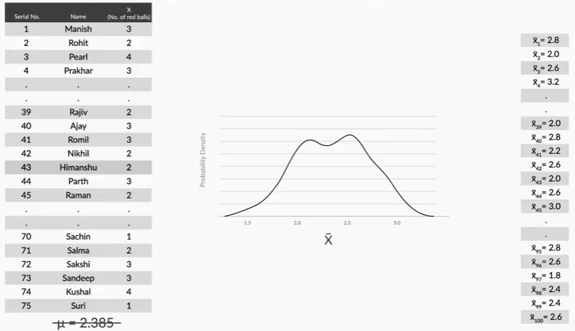

**Figure 4 - Creation of Sampling Distribution**

We created a sampling distribution, which was a probability density function for 100 sample means with a sample size = 5.

A sampling distribution, which is essentially the distribution of the sample means of a population, has some interesting properties, which are collectively called the **central limit theorem**. It states that no matter how the original population is distributed, the sampling distribution will follow these three properties:

1. **Sampling distribution’s mean** () = **Population mean** (),
2. Sampling distribution’s standard deviation (**Standard error**) = , where  is the population’s standard deviation and n is the sample size, and
3. **For n > 30**, the sampling distribution becomes a **normal distribution**.

To verify these properties, we performed sampling using the data collected for our upGrad game from the first session on inferential statistics. The values for the sampling distribution thus created ( = 2.348, S.E. = 0.4248) were quite close to the values predicted by theory ( = 2.385, S.E. = 0.44).  
To summarise, the notations and formulas for populations, samples and sampling distributions are as follows:

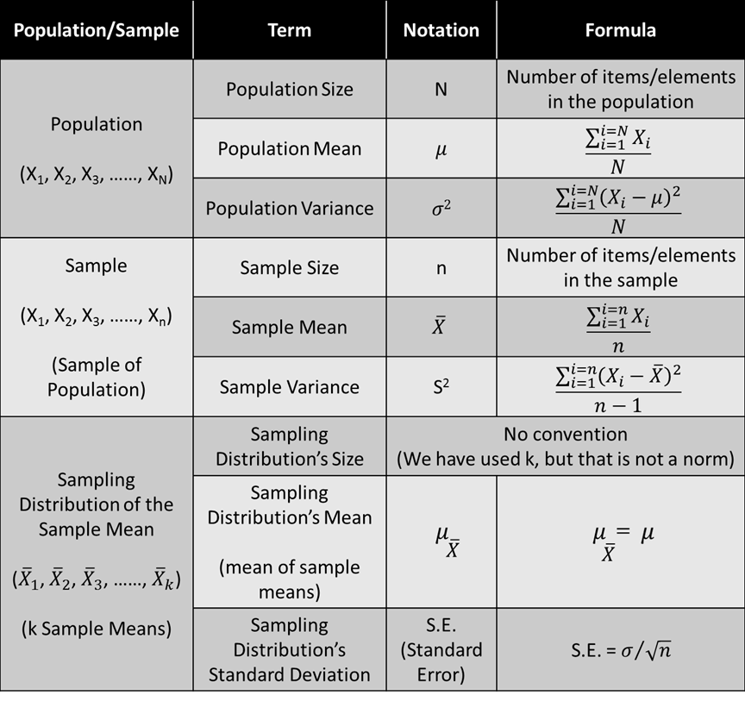

**Figure 5 - Commonly Used Notations and Formulae**

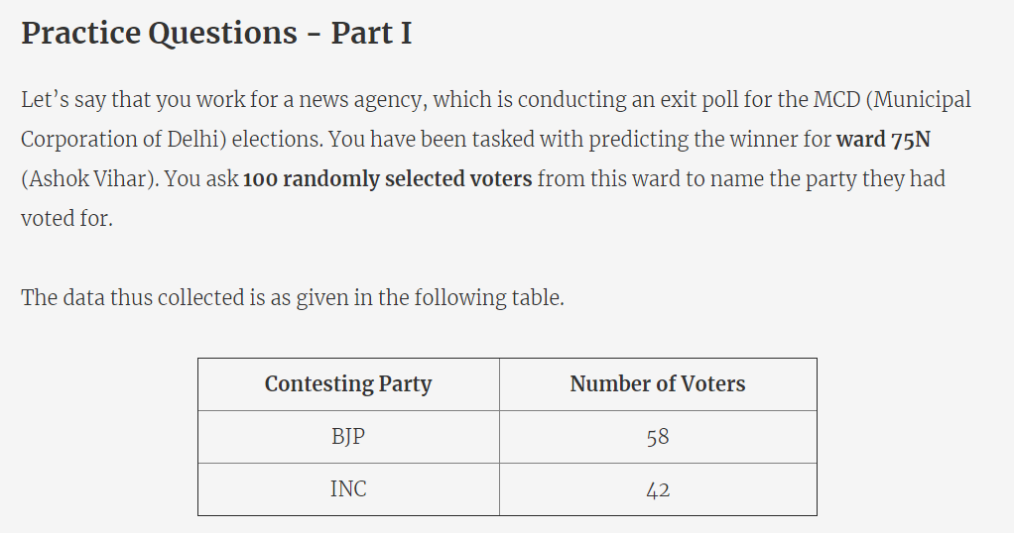

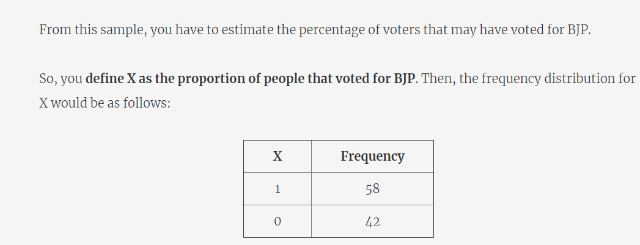

Calculate the mean and Standard deviation for the people who voted for BJP.

Refer the below Excel – Practice_Questions_BJP_and_INC.xlsx

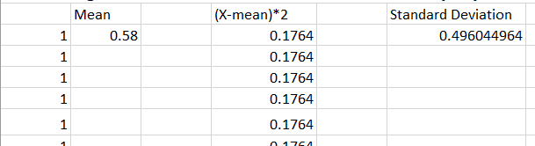

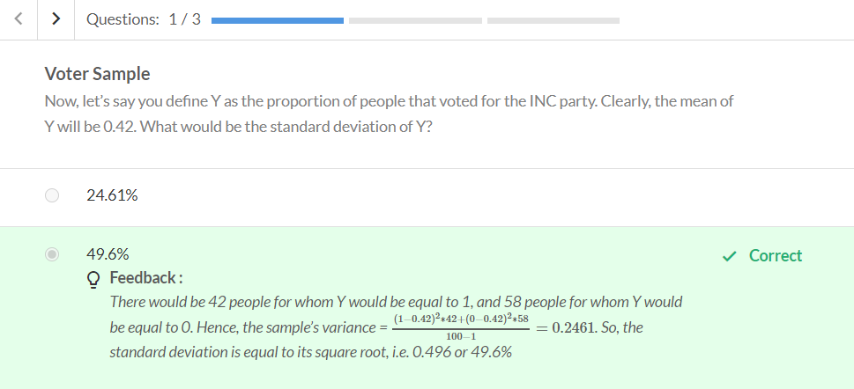

Refer the excel for calulating mean and SD for the people who have voted for INC.

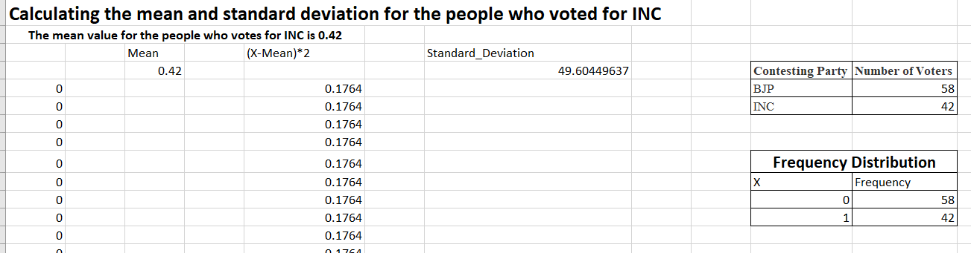

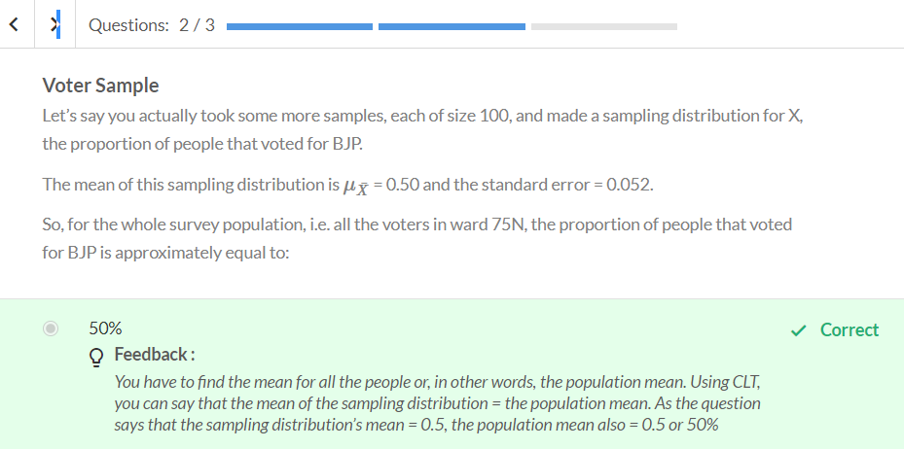

Our first property of CLT theorem - used to answer the second question.

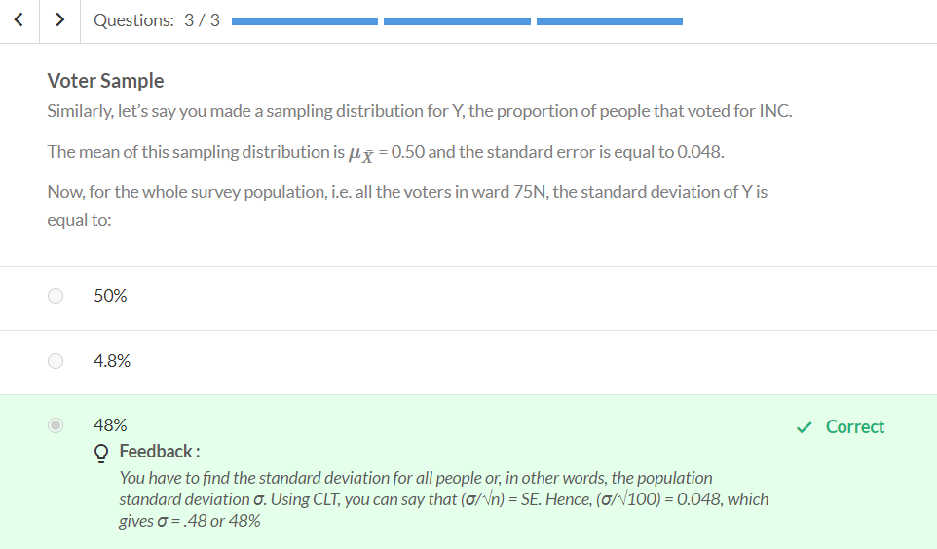

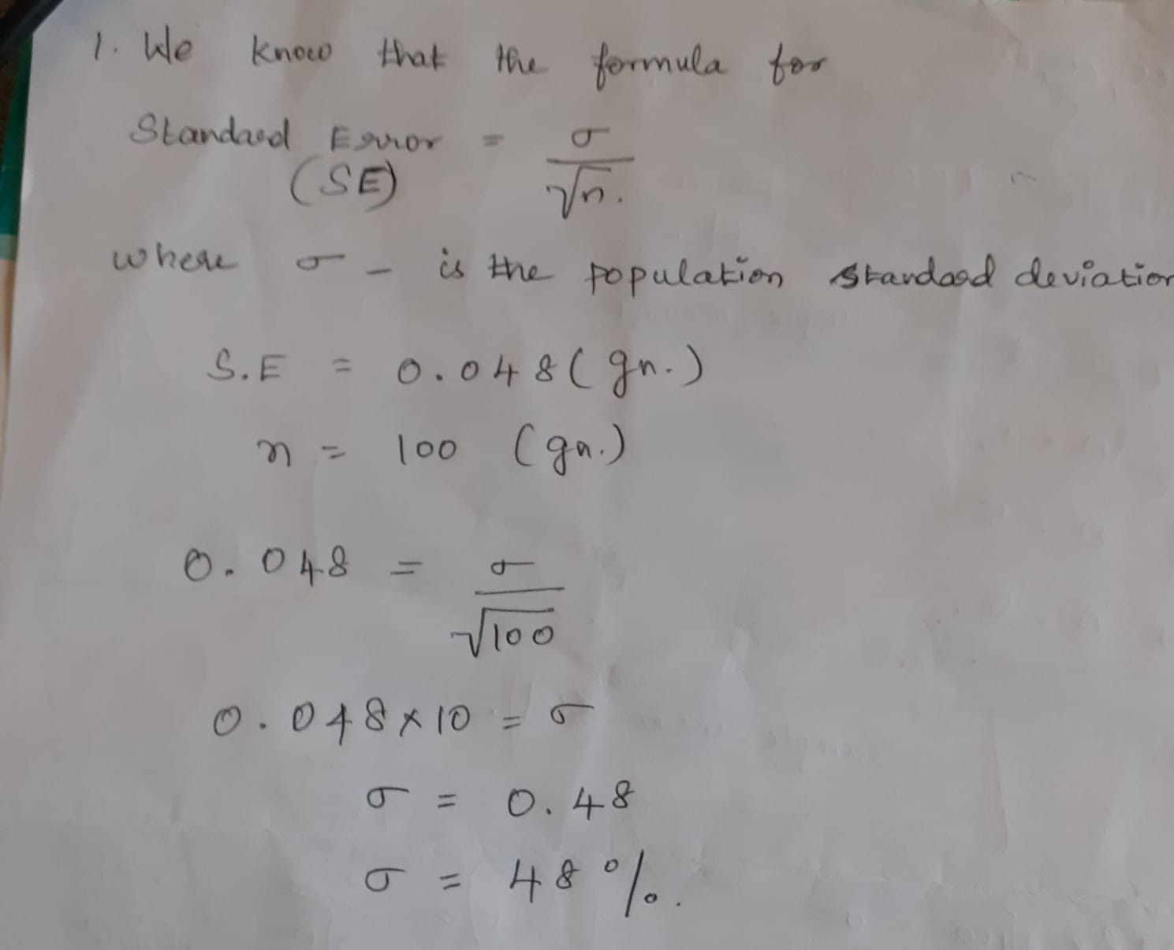

Estimating Mean Using CLT : 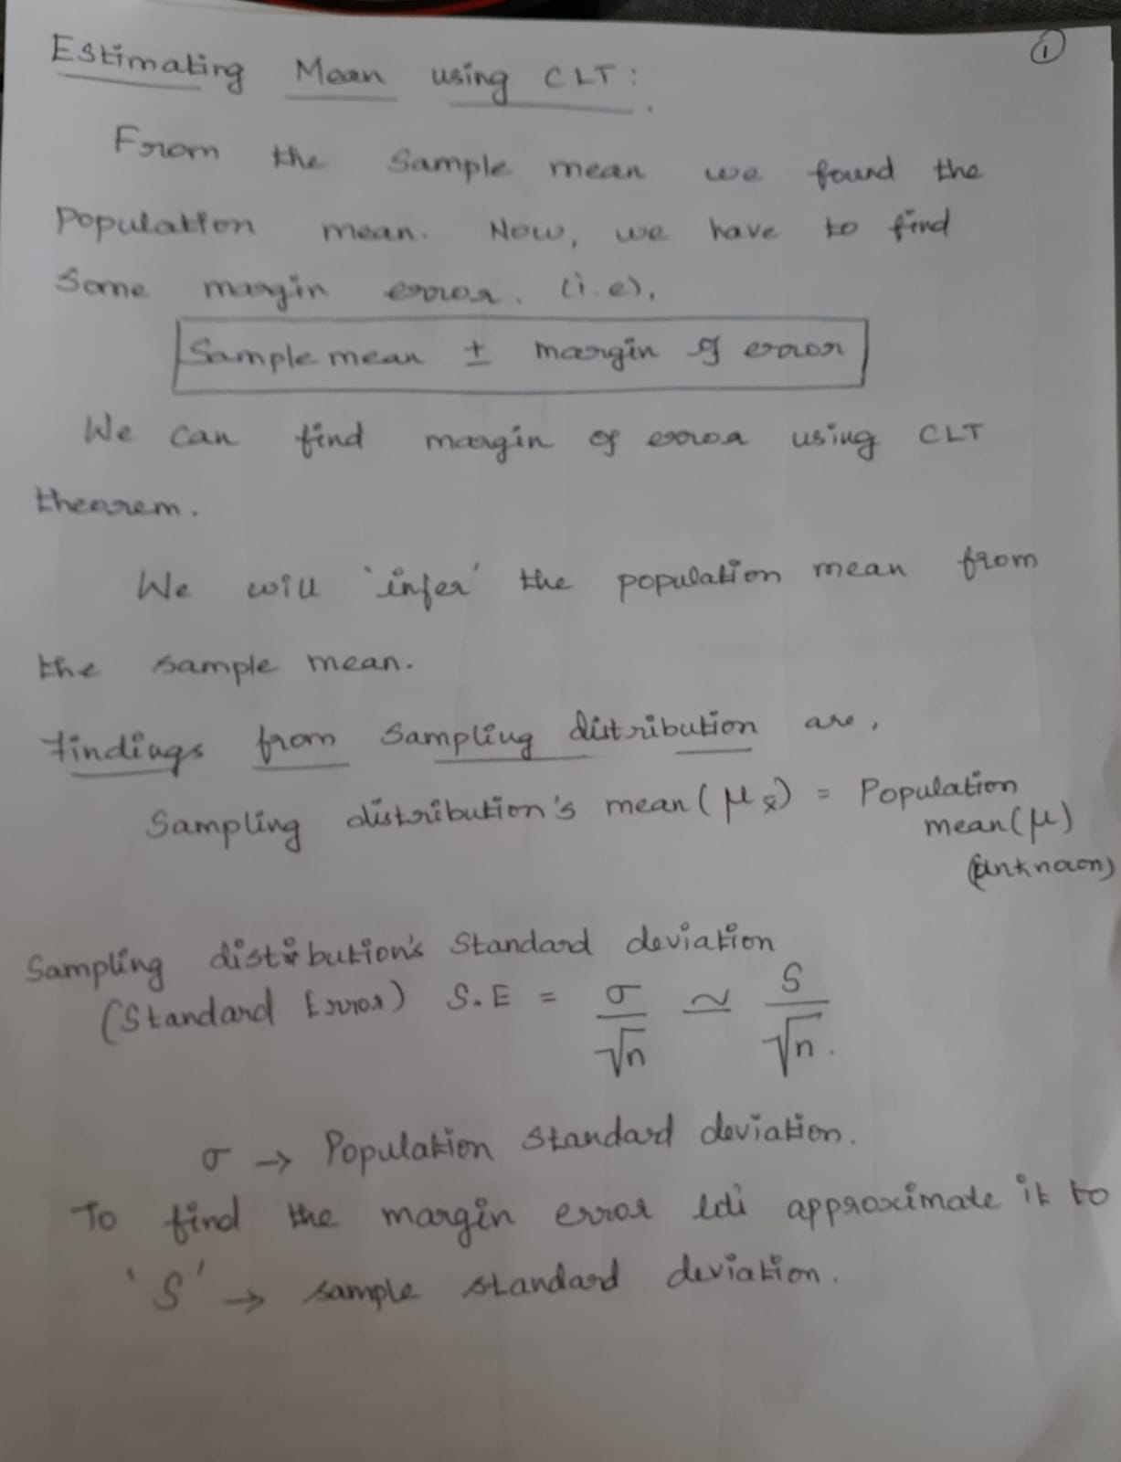

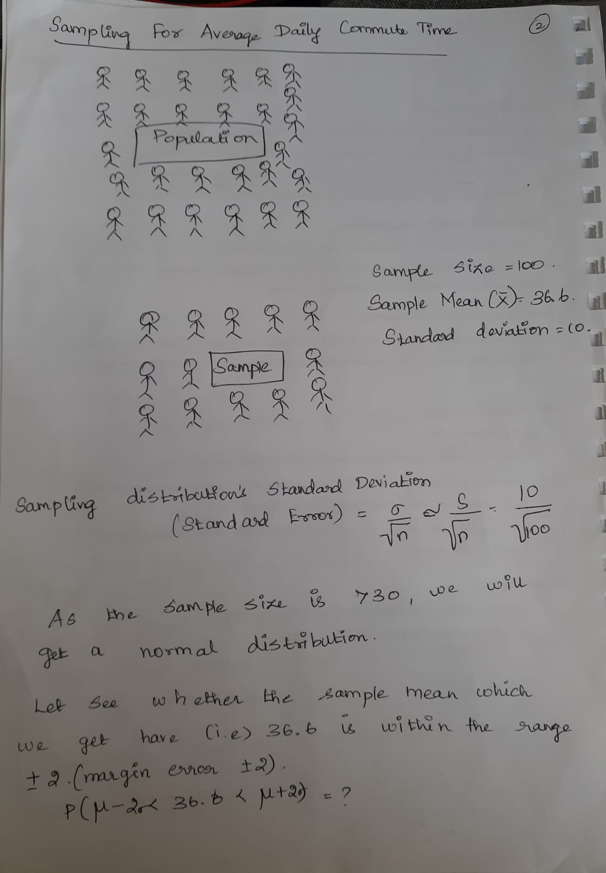

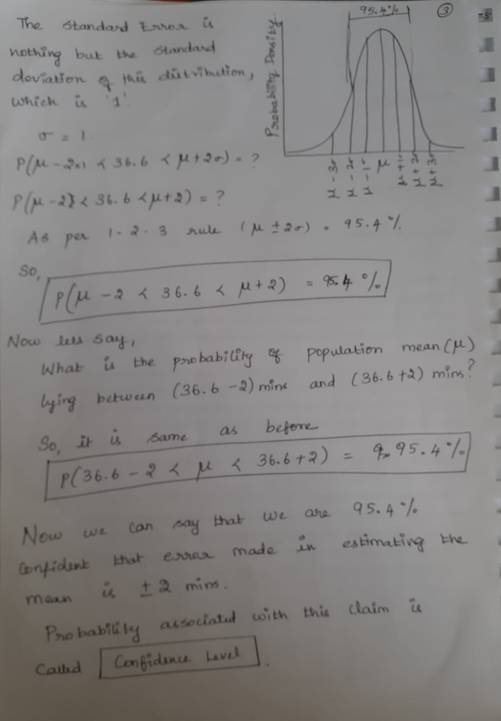

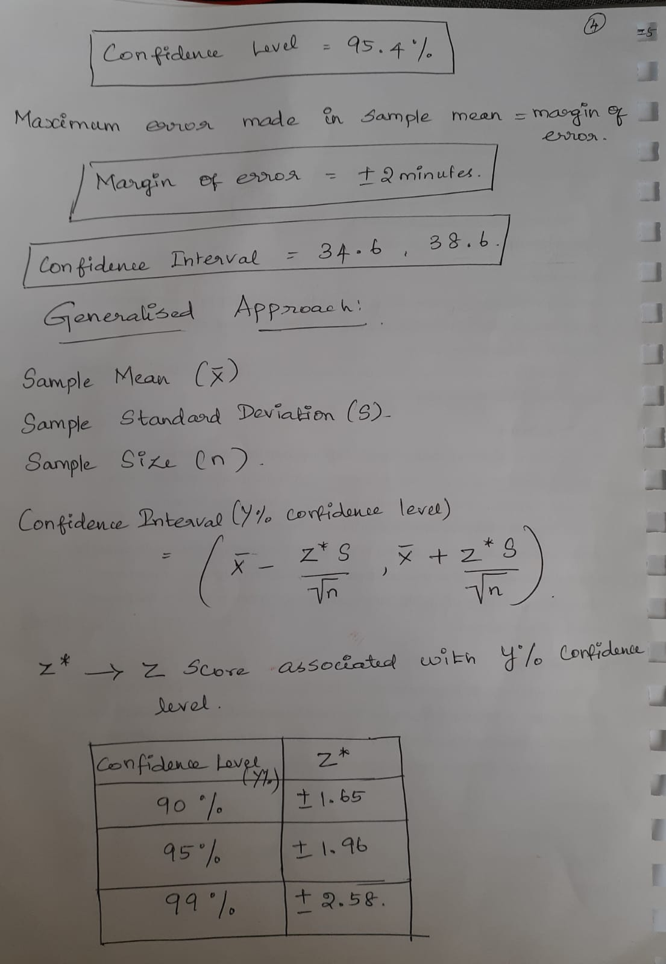

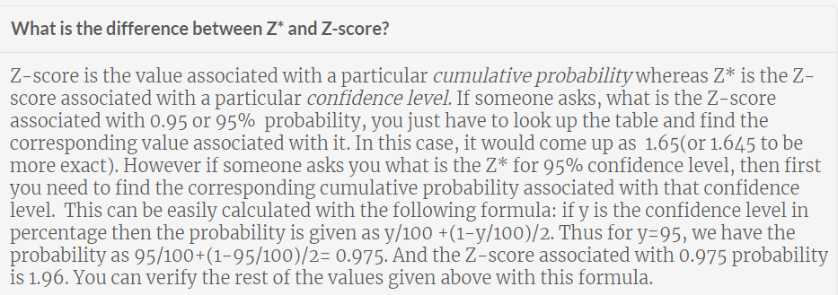

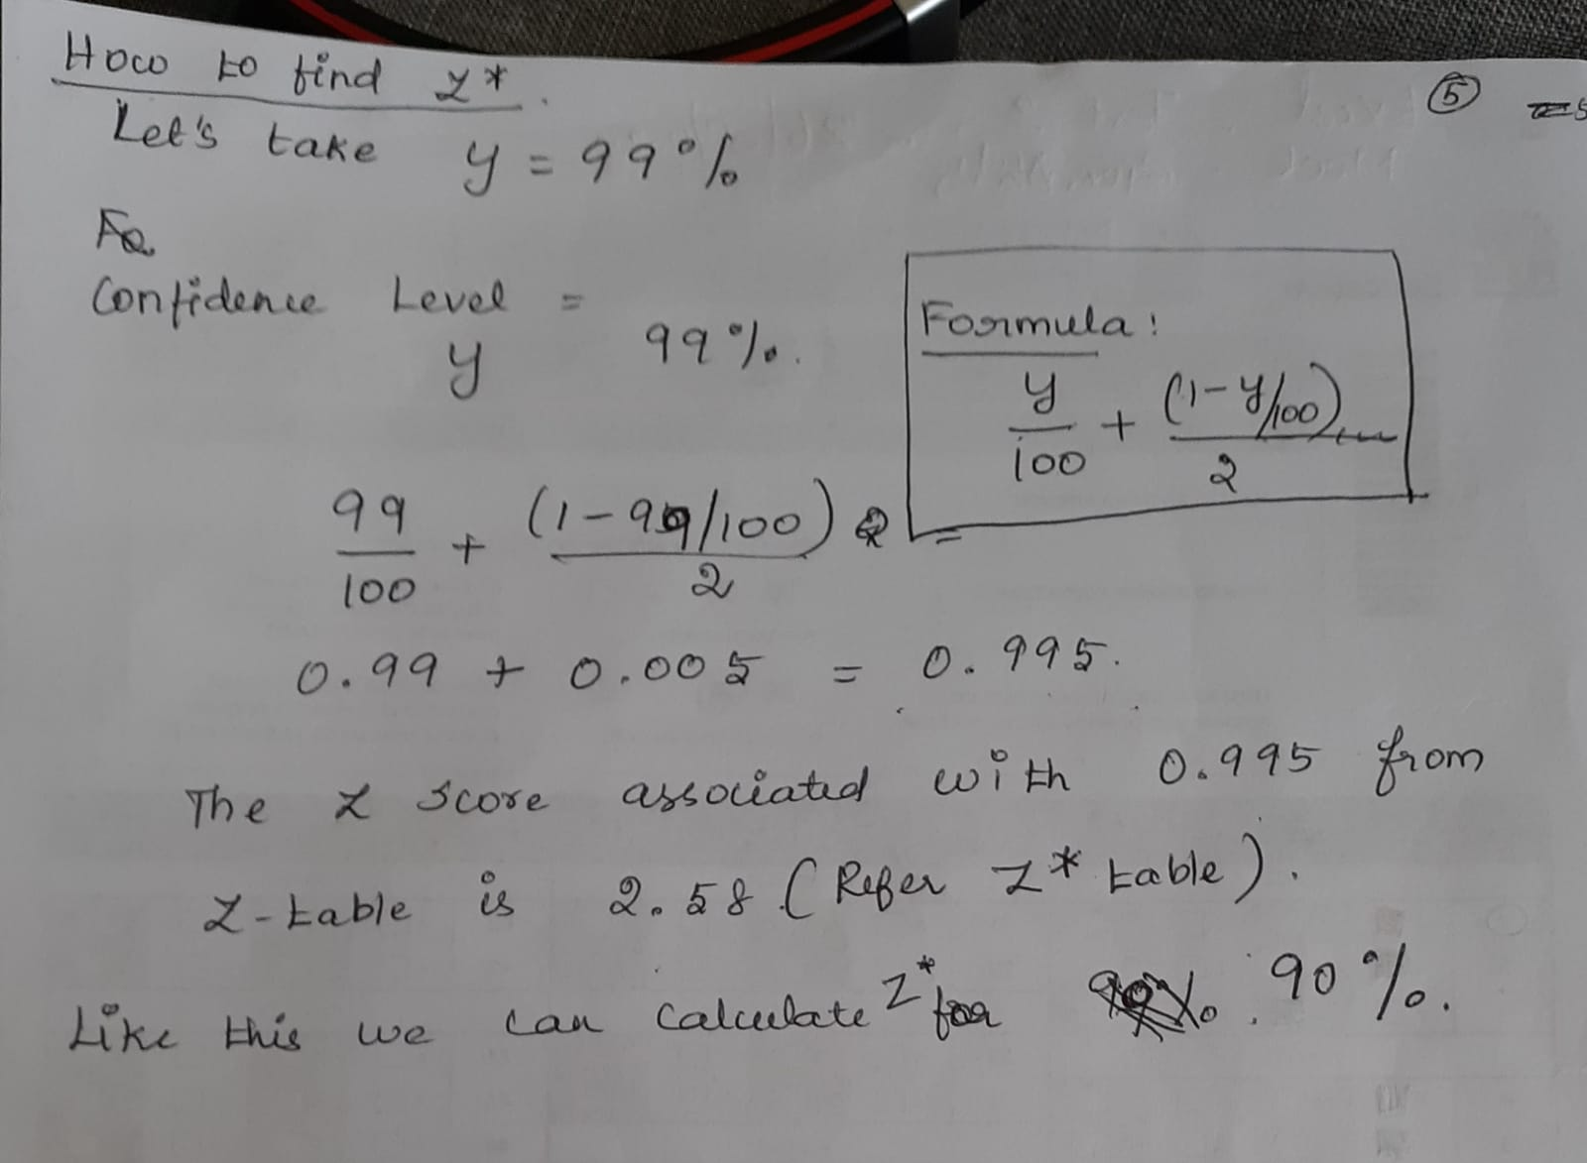

# Confidence Interval - Example

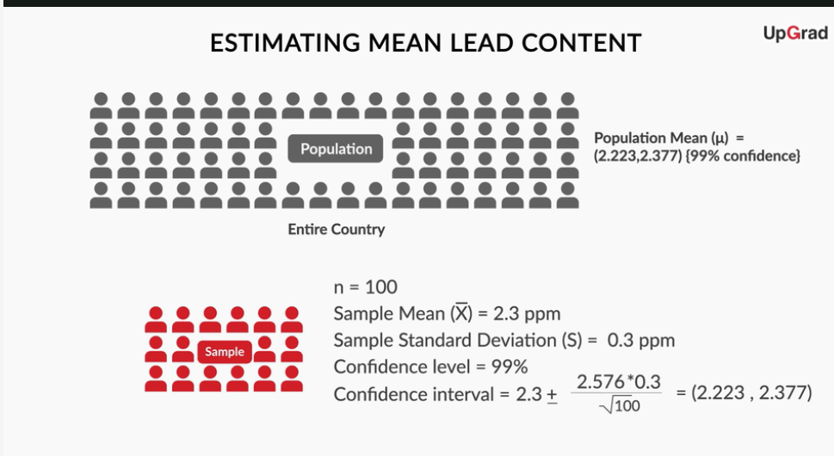

Let’s consider another example of how you can use confidence intervals to make a decision. Recall the Facebook example discussed in the last session. Let’s find the 90% confidence interval (confidence interval for a 90% confidence level) for that case.

Recall that 50.5% of the 10,000 people surveyed preferred feature B to feature A. So, if X = the proportion of people that prefer feature B to feature A, then, for this sample,  = 0.505 (50.5%) and n = 10,000. In addition to this, you've been told that the sample’s standard deviation S = 0.2(20%).

Also, you know that the actual population mean  lies between  + margin of error. However, now it is vital for us to find this margin of error.

If this margin of error is, say, 1%, then that means that the population mean , which is the proportion of people that prefer feature B to feature A, lies between the range (50.5 - 1)% to (50.5 + 1)%, i.e.,  49.5 % to 51.5%. This means that you cannot say with certainty that  would be more than 50%. So, even though the proportion of people that prefer feature B to feature A is more than 50% in our sample, you would not be able to say with certainty that this proportion would be more than 50% for the entire population.

On the other hand, if the margin of error is, say, 0.3%, then you will be able to say that the population mean lies within (50.5 - 0.3)% and (50.5 + 0.3)%, i.e., 50.2% to 50.8%. So, you will be able to say with certainty that the proportion of people that prefer feature B to feature A is more than 50% in our sample and for the entire population too.

Now, the margin of error corresponding to a 90% confidence level would be given by 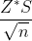 = 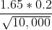 = 0.0033 (0.33%), and the population mean lies between 50.17% and 50.83%.  
Hence, you can say that feature B should replace feature A with 90% confidence.

***Practice Questions***

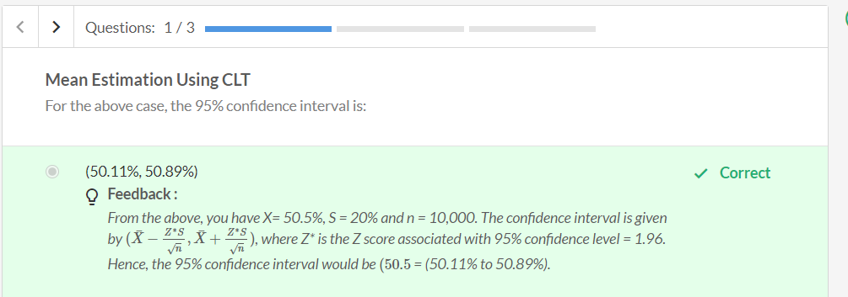

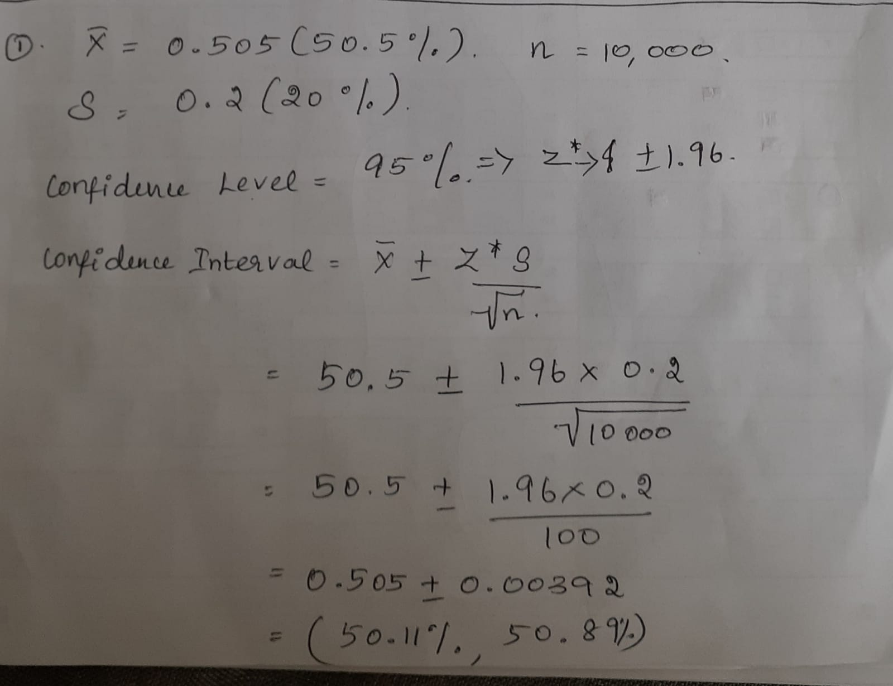

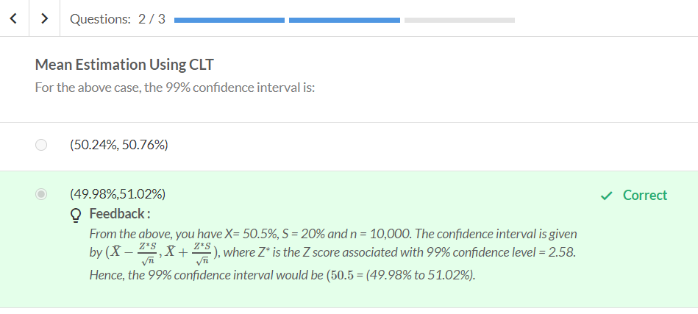

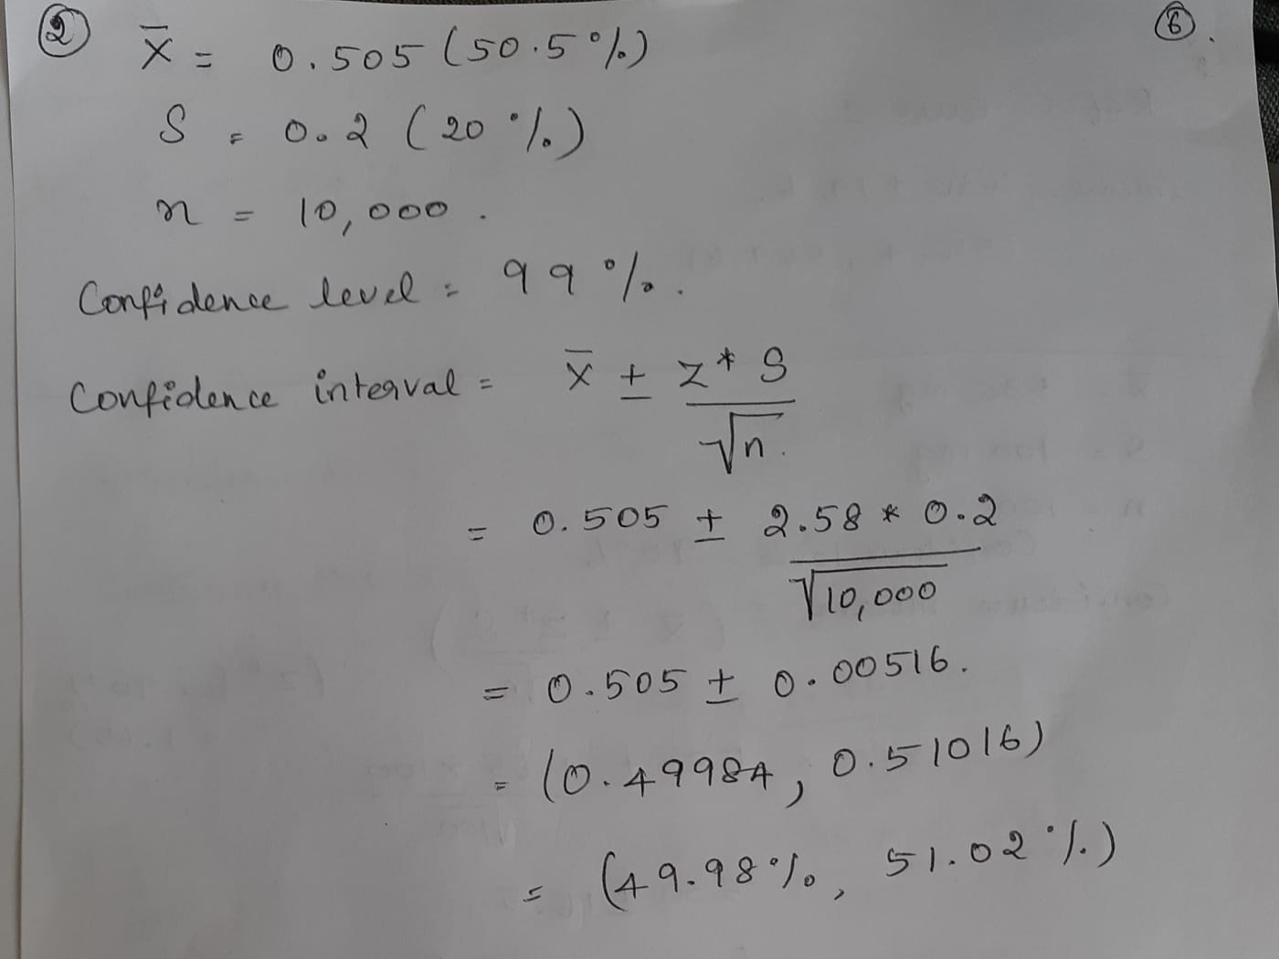

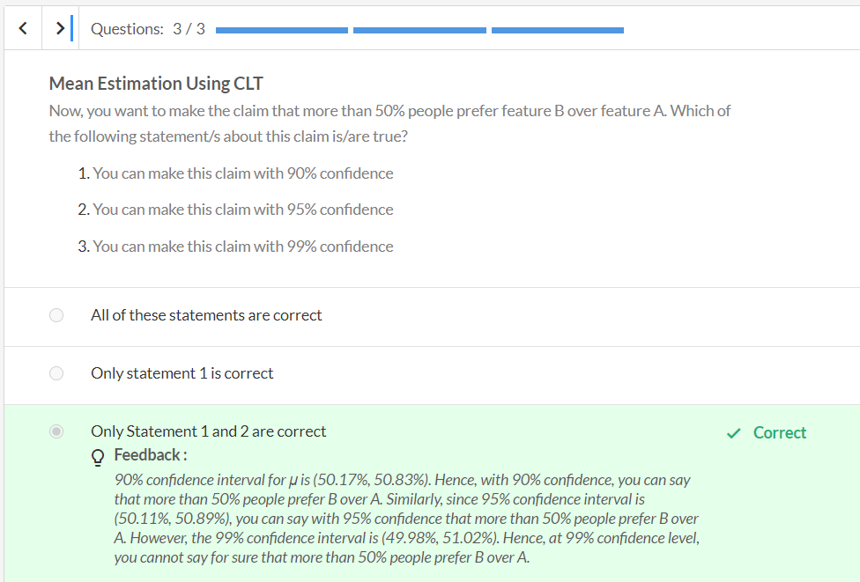

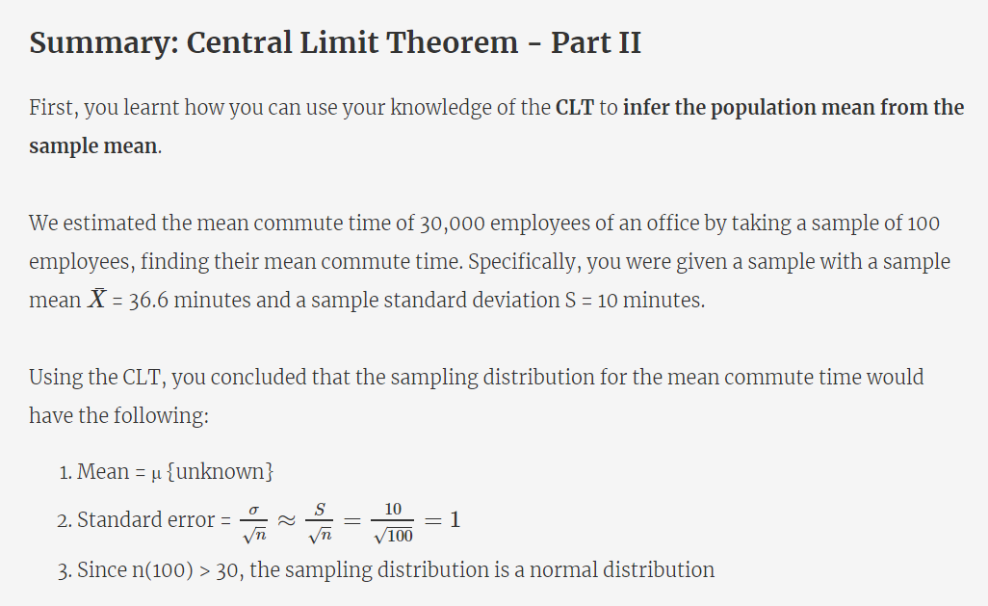

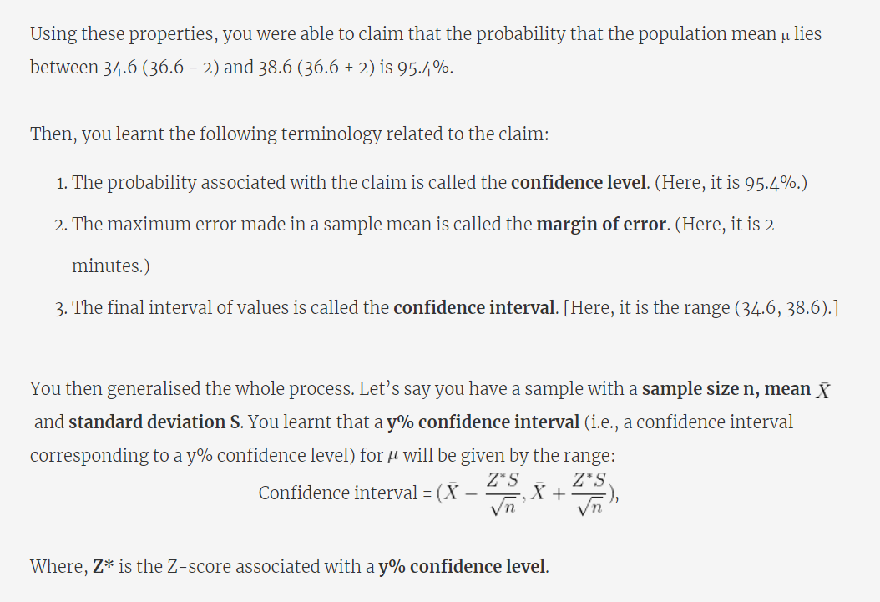

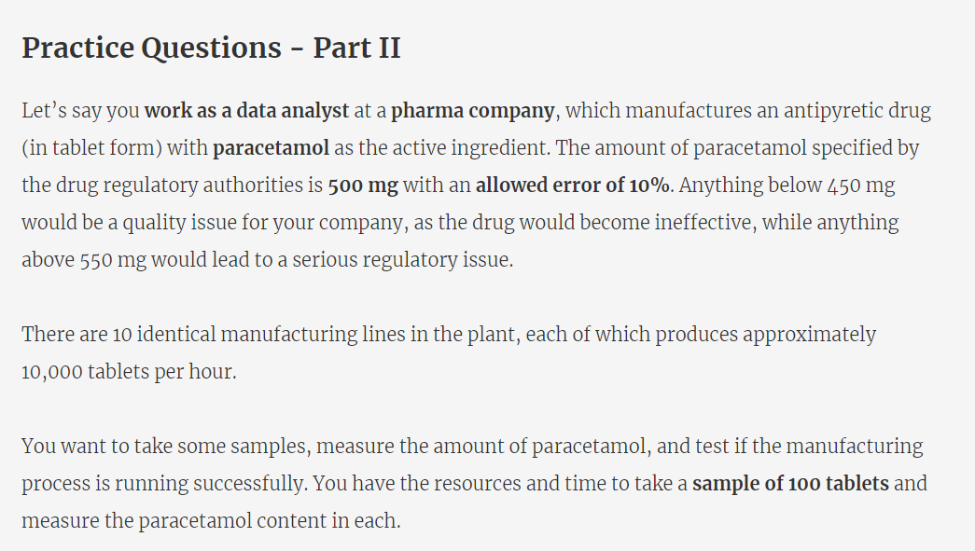

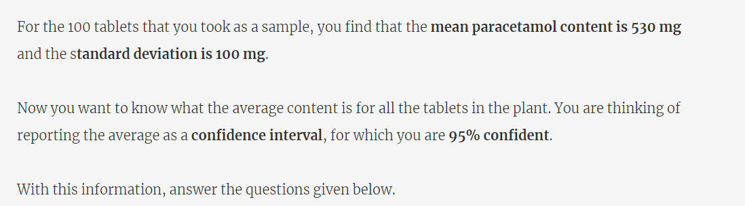

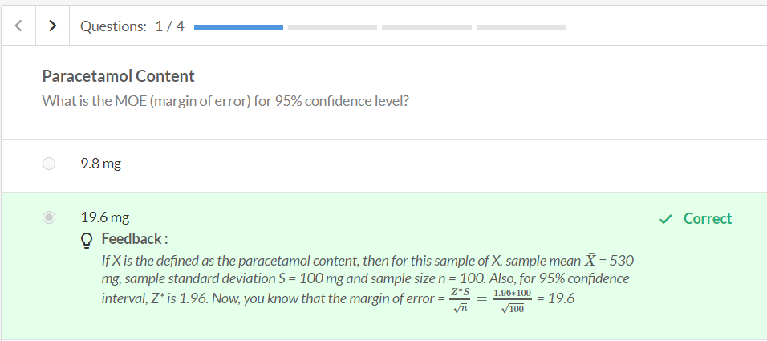

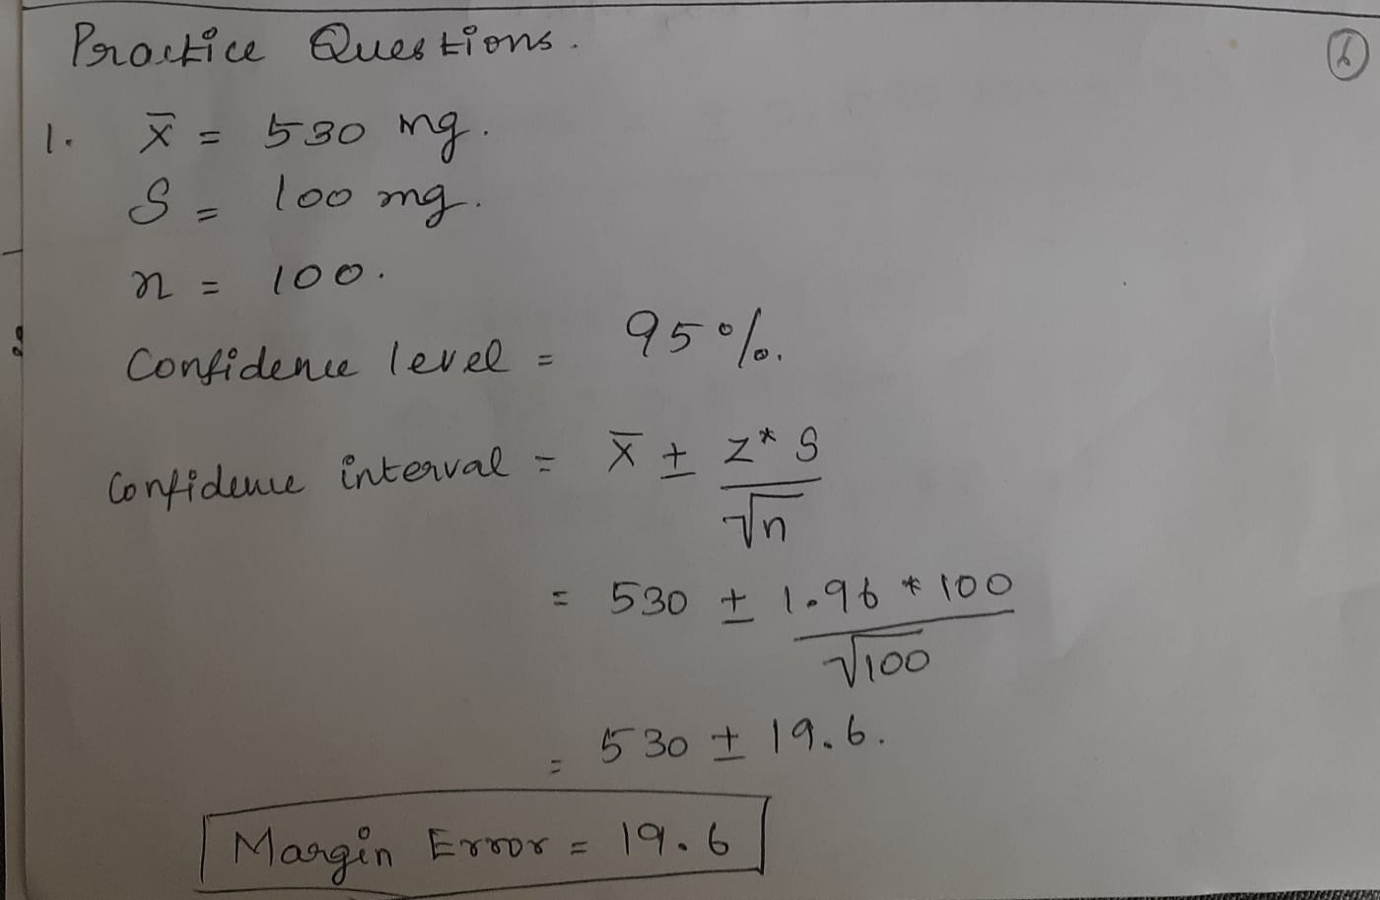

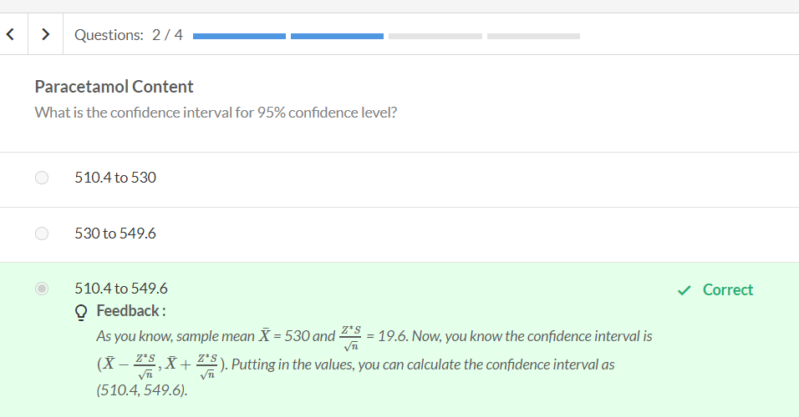

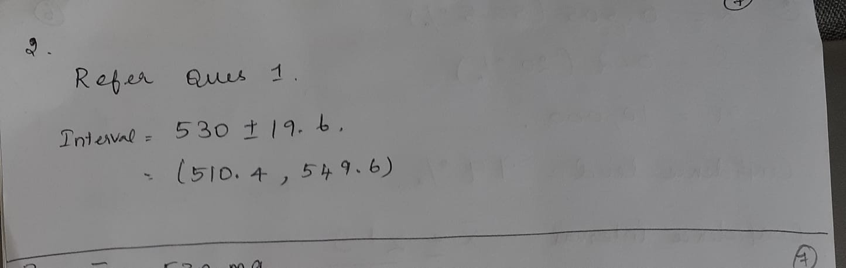

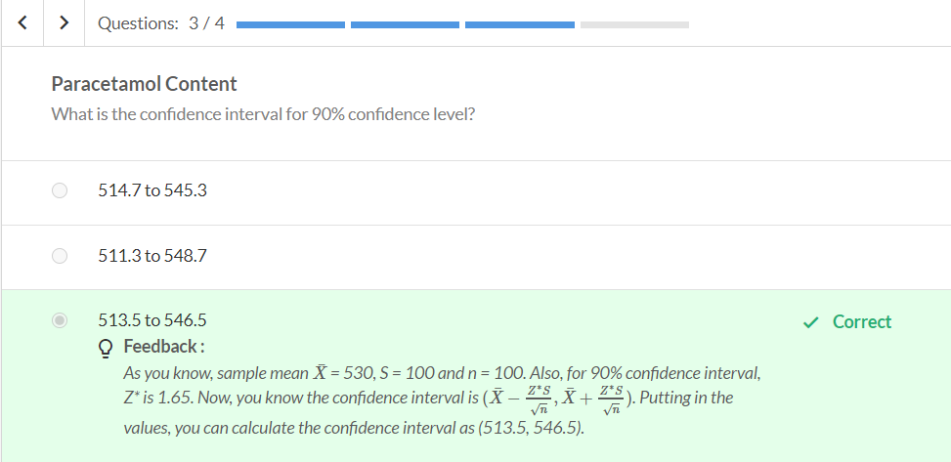

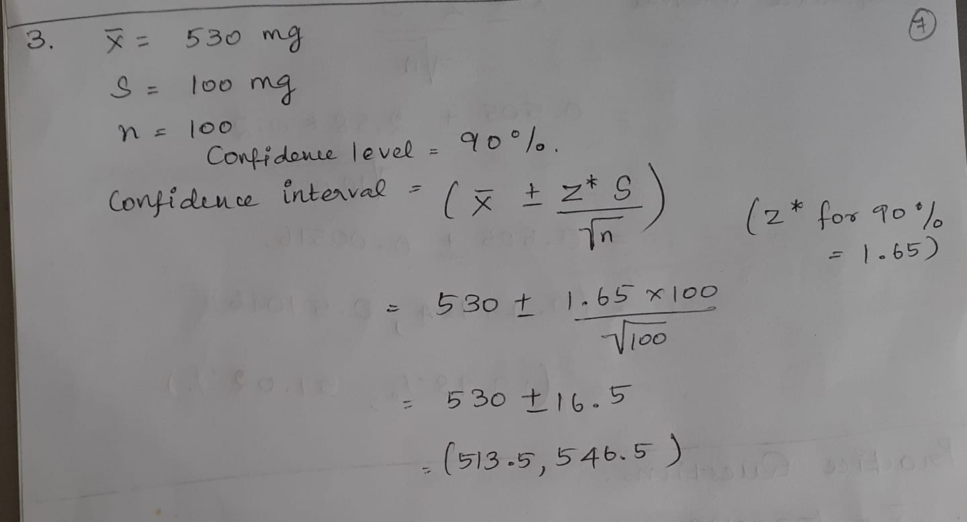

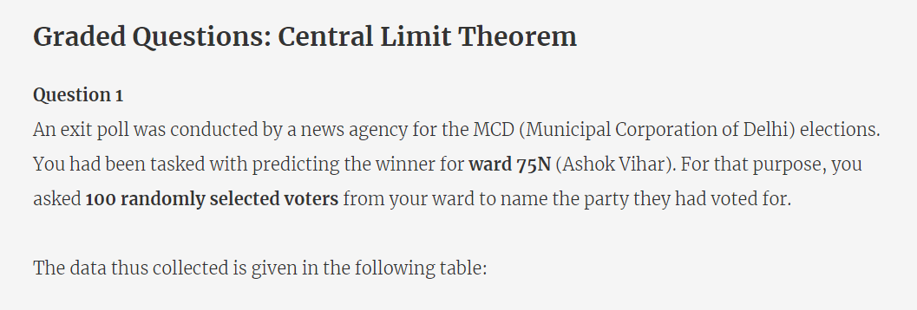

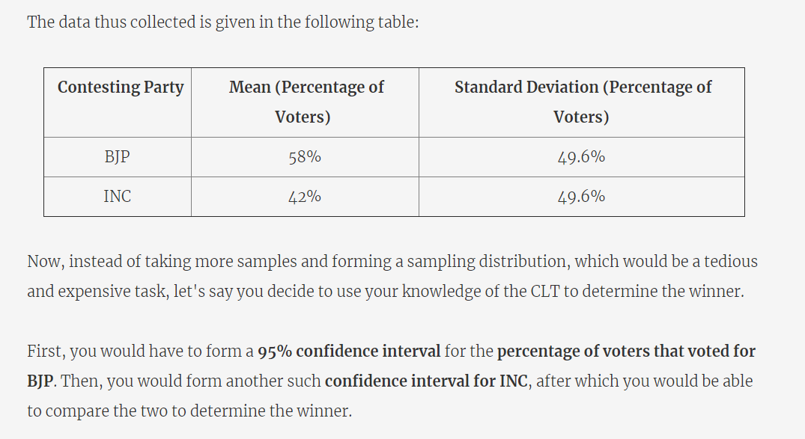

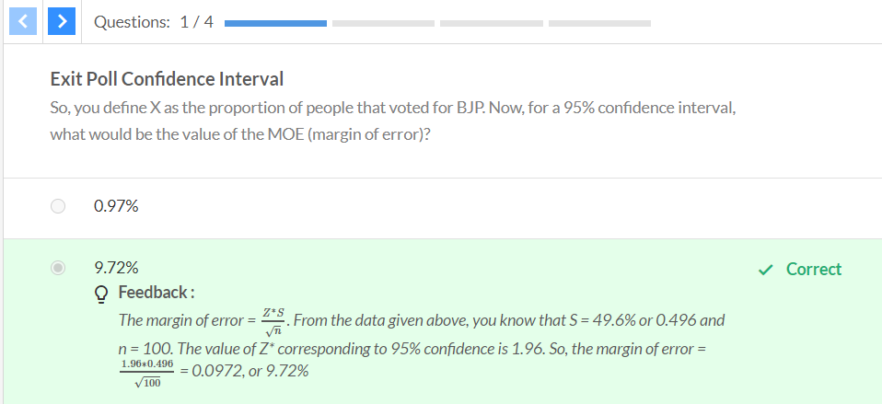

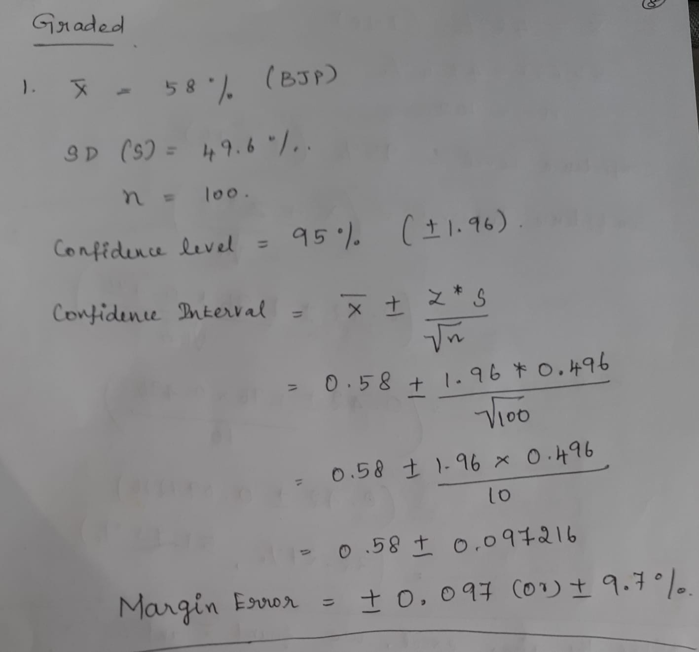

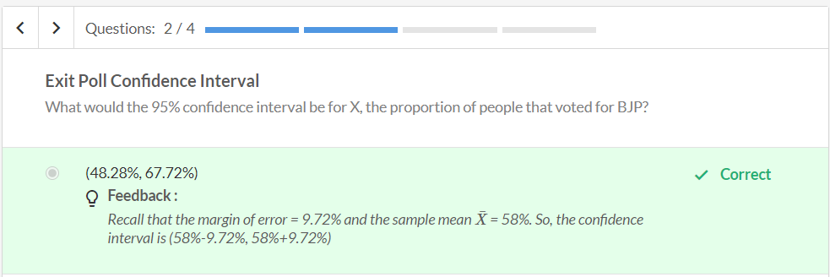

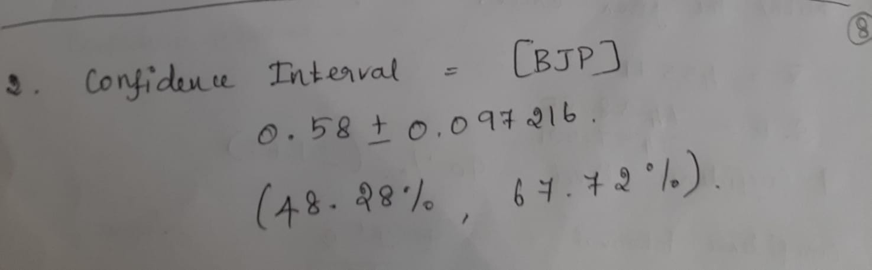

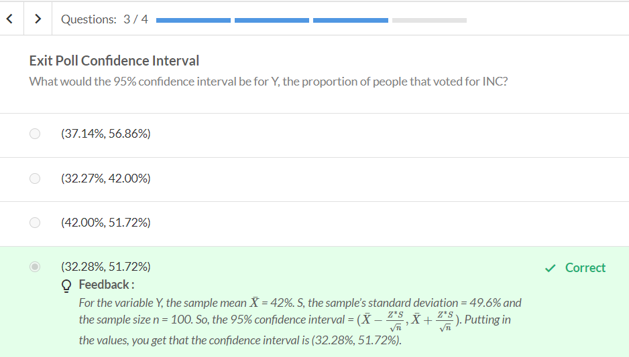

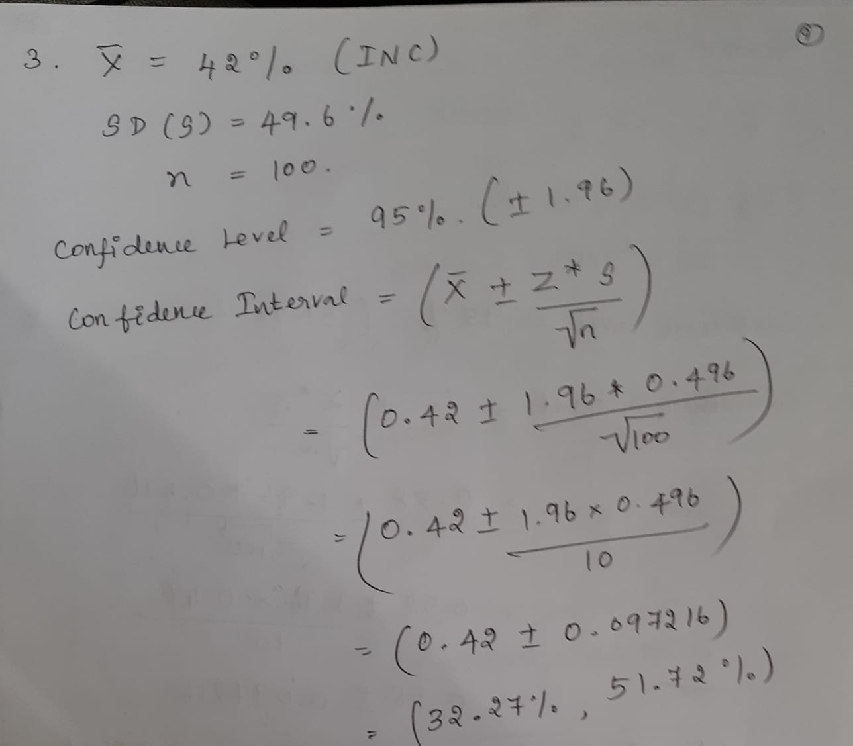

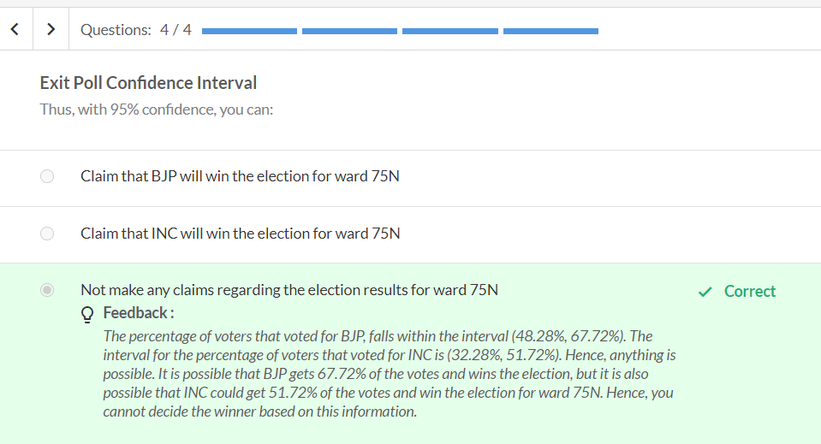

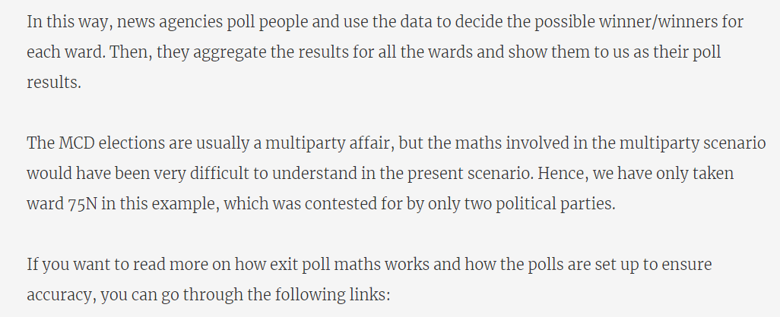

<https://mathforgrownups.com/exit-polling-a-statistics-refresher/>

<https://warwick.ac.uk/fac/sci/statistics/staff/academic-research/firth/exit-poll-explainer/>

